Database Optimization:

Transaction: A transaction is a collection of queries that are treated as a single unit of work

So an example of that is an account deposit. If you want to really deposit some money from one account to another account. Then you really need to first select the money from the first account. Check if that guy or gal has enough money in their account. And then once you select that, you do an update to that account to deduct the $100. And then the second update will be to deposit the the money in the other account, which is increase by $100. So a read update, update. This is a transaction that is consisting of three different queries.

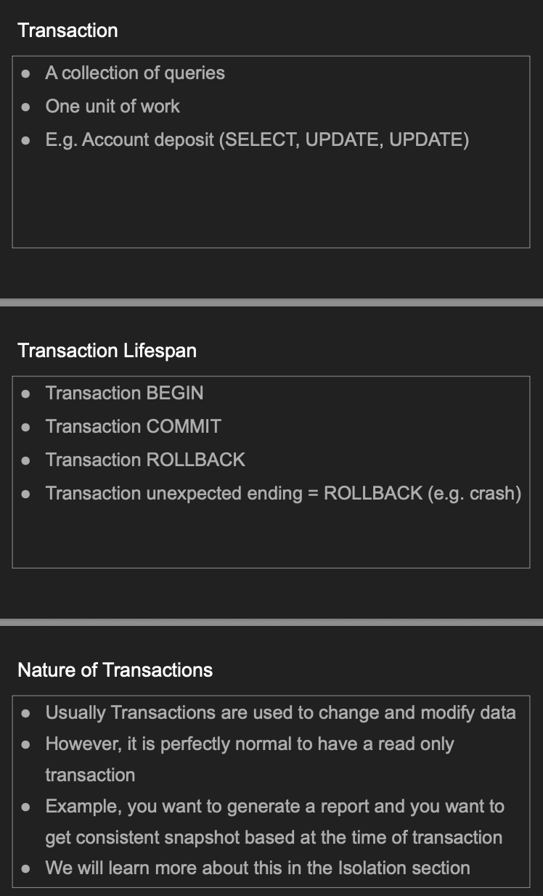

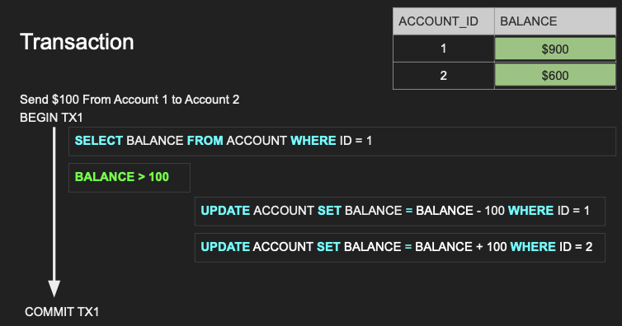

Atomicity:

An atom should be one unit and cannot be split, right? So if if you have a transaction with 100 queries, all these 100 queries should succeed. If any of these 100 queries fail, all the 100 or anything that is successful in the query should be rolled back.

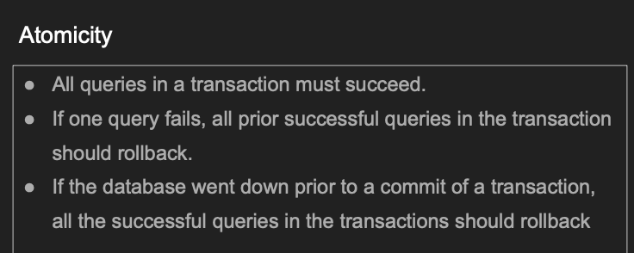

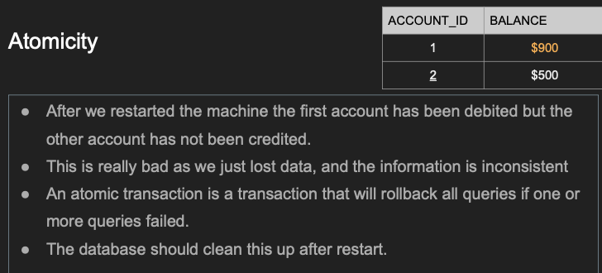

Isolation:

Dirty Reads:

In SQL, a **dirty read** occurs when a transaction reads data that has been **modified by another transaction but not yet committed** making it **unreliable** or **"dirty"**.

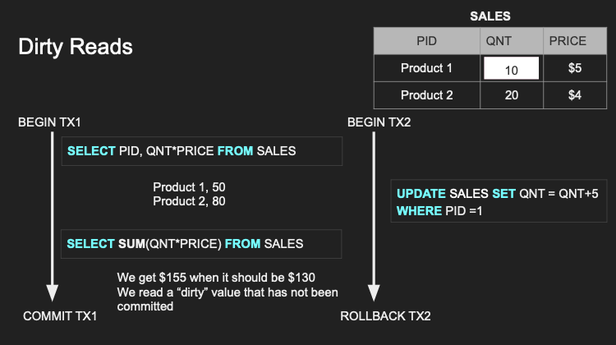

Non Repeatable reads:

A **non-repeatable read** occurs when a transaction reads the same row twice and gets **different values each time** because **another transaction modified and committed the data in between** the two reads.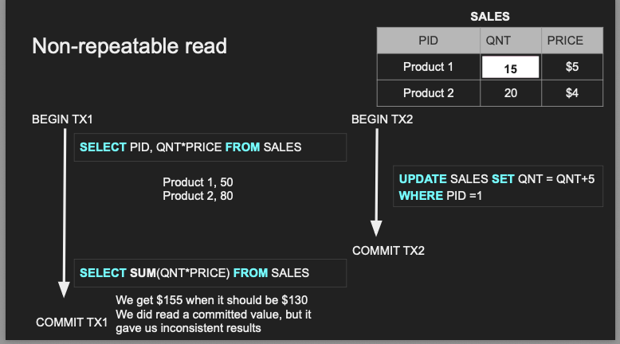

Phantom reads:

A **phantom read** occurs when a transaction executes the same query twice and **sees a different set of rows** the second time because **another transaction inserted or deleted rows** that match the query's conditions.

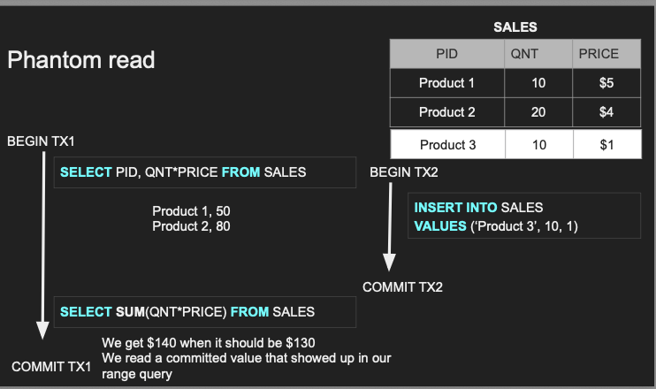

Because a new row that **wasn’t there before appears "out of nowhere"** — like a phantom — even though the query condition hasn't changed.

Lost Update:

A **lost update** is a concurrency issue that occurs when **two transactions read the same data and then update it**, but the **last update overwrites the first one without knowing it happened**, causing one update to be **"lost."**

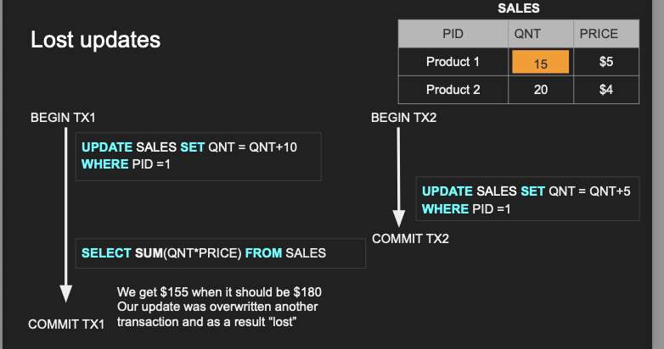

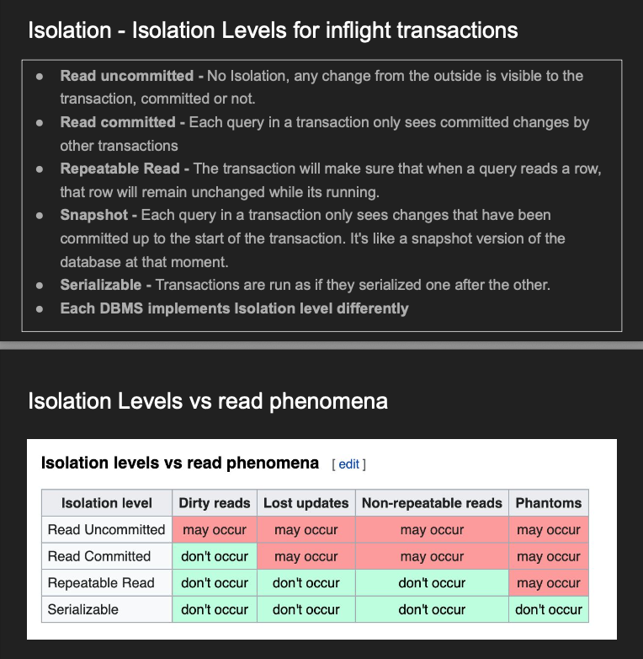

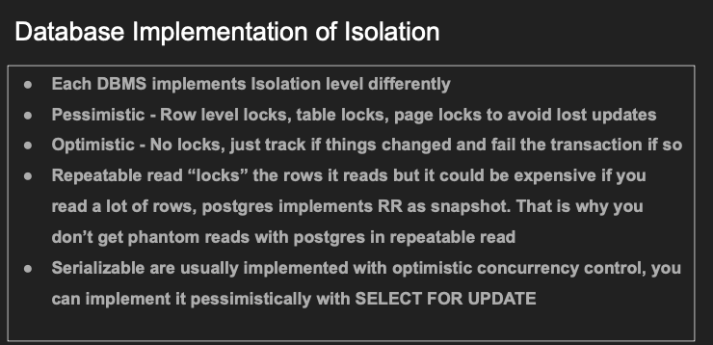

**Isolation** ensures that **concurrent transactions do not interfere** with each other. Each transaction is executed as if it were the **only one running**, even if multiple transactions are happening at the same time

Consistency:

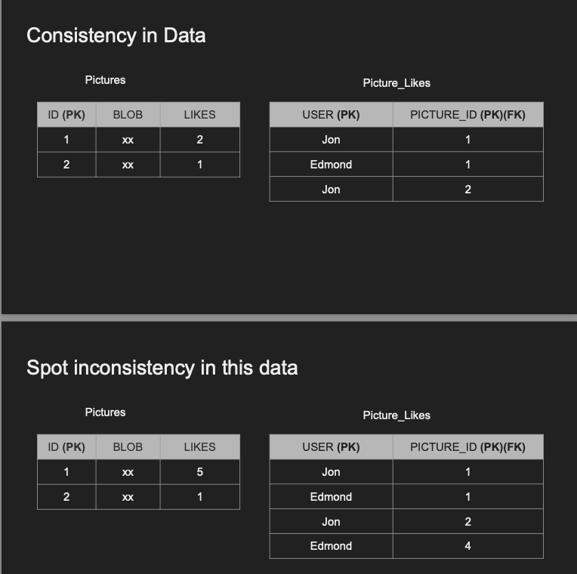

So in summary, consistency are two types consistency in the data which are enforced by the referential integrity, right? Thinks that is persisted in the data and there is no eventual consistency coming out of that because your data will become kind of corrupt based on what you define by corruption here. And the different type is consistency and read. The consistency in read is when you update a value and then a transaction tries to read that value after it was committed, you get the old version and that's an inconsistent result, right? So it was most databases heal from this kind of inconsistency by eventual consistency. So that means as there the replication process completes. You will eventually get the final result effectively from from that read. And this can be enforced by by something called synchronous replication

Durability:

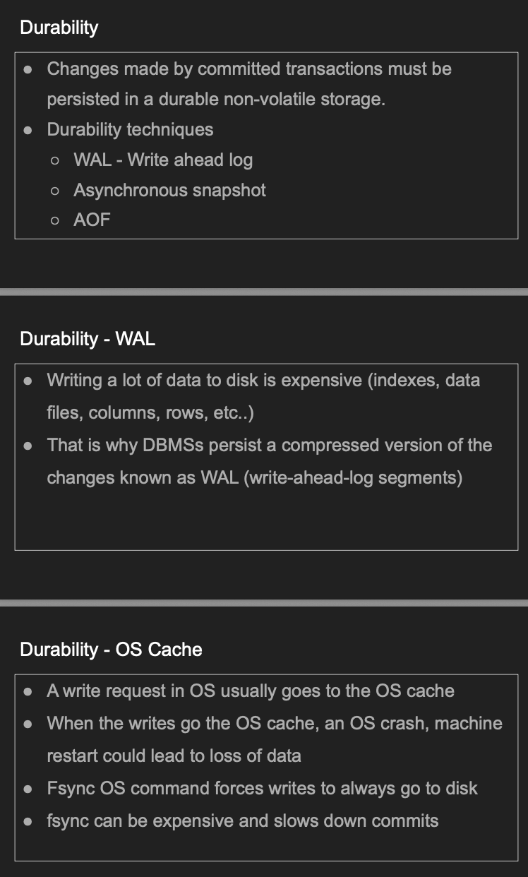



How DB Stores data:

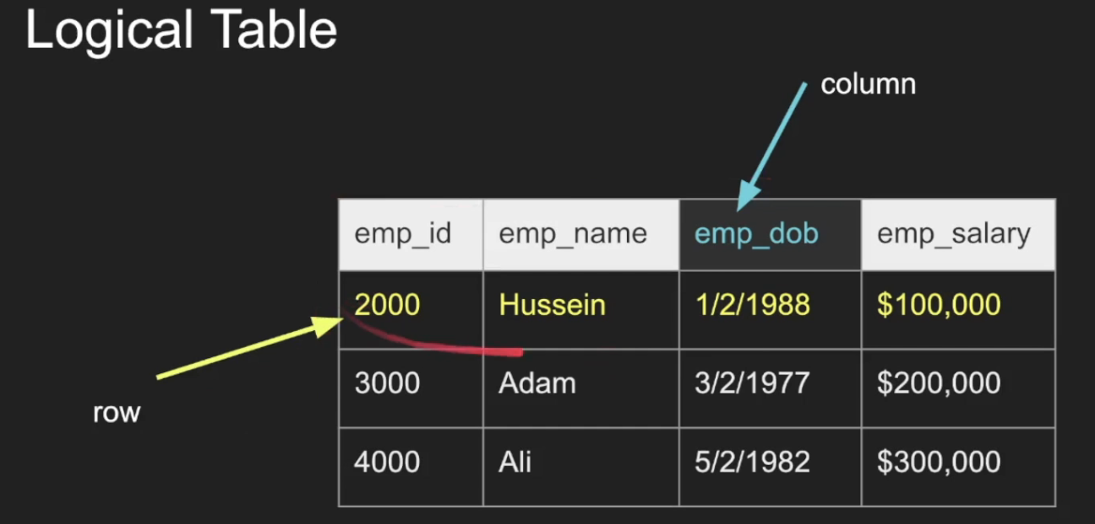

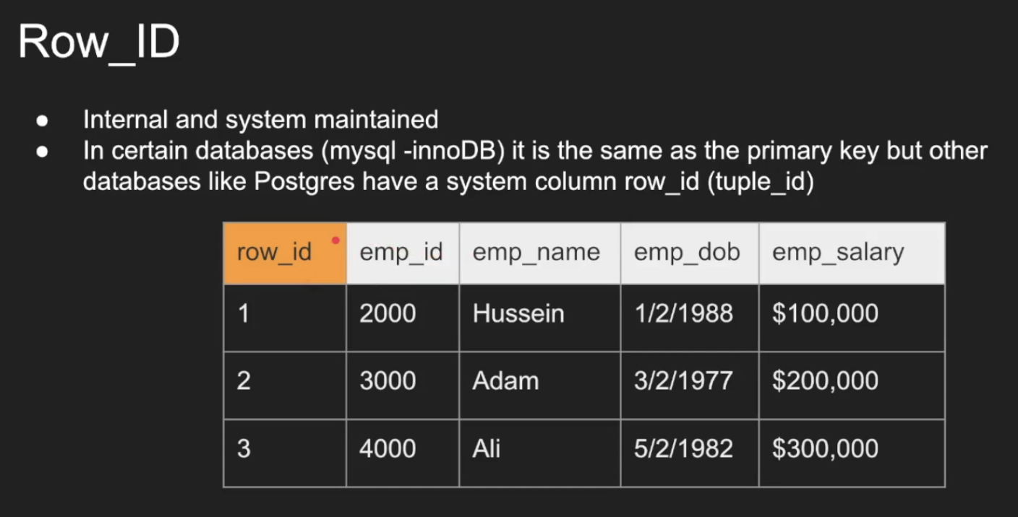

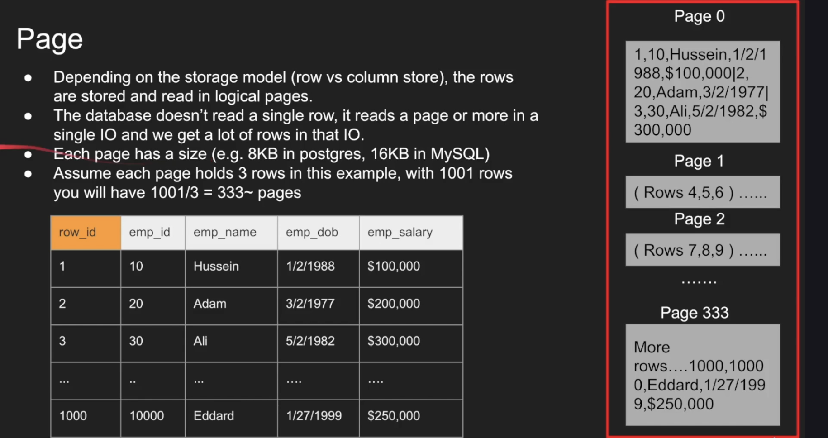

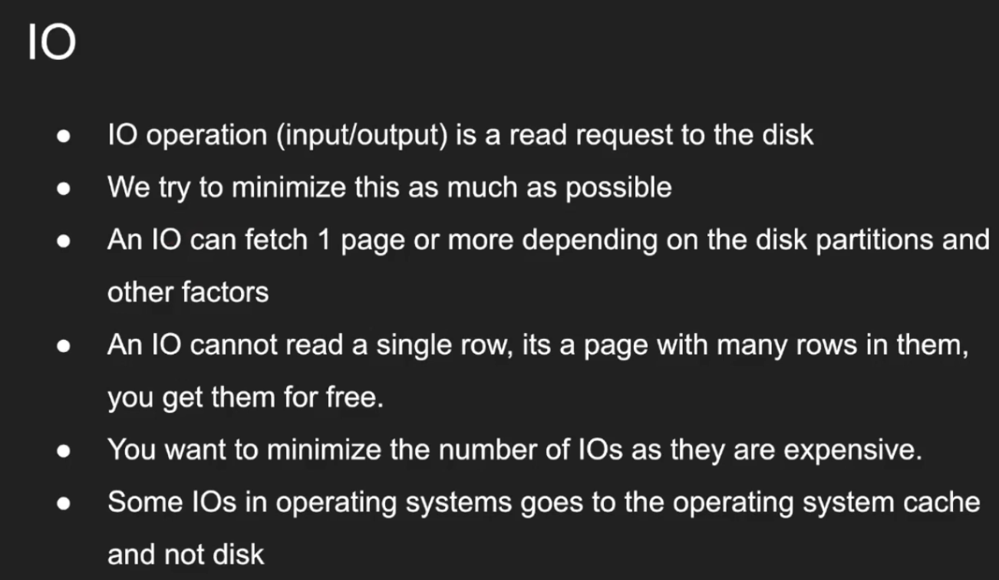

Heap:

A heap is a collection of pages that represent points to your data table.

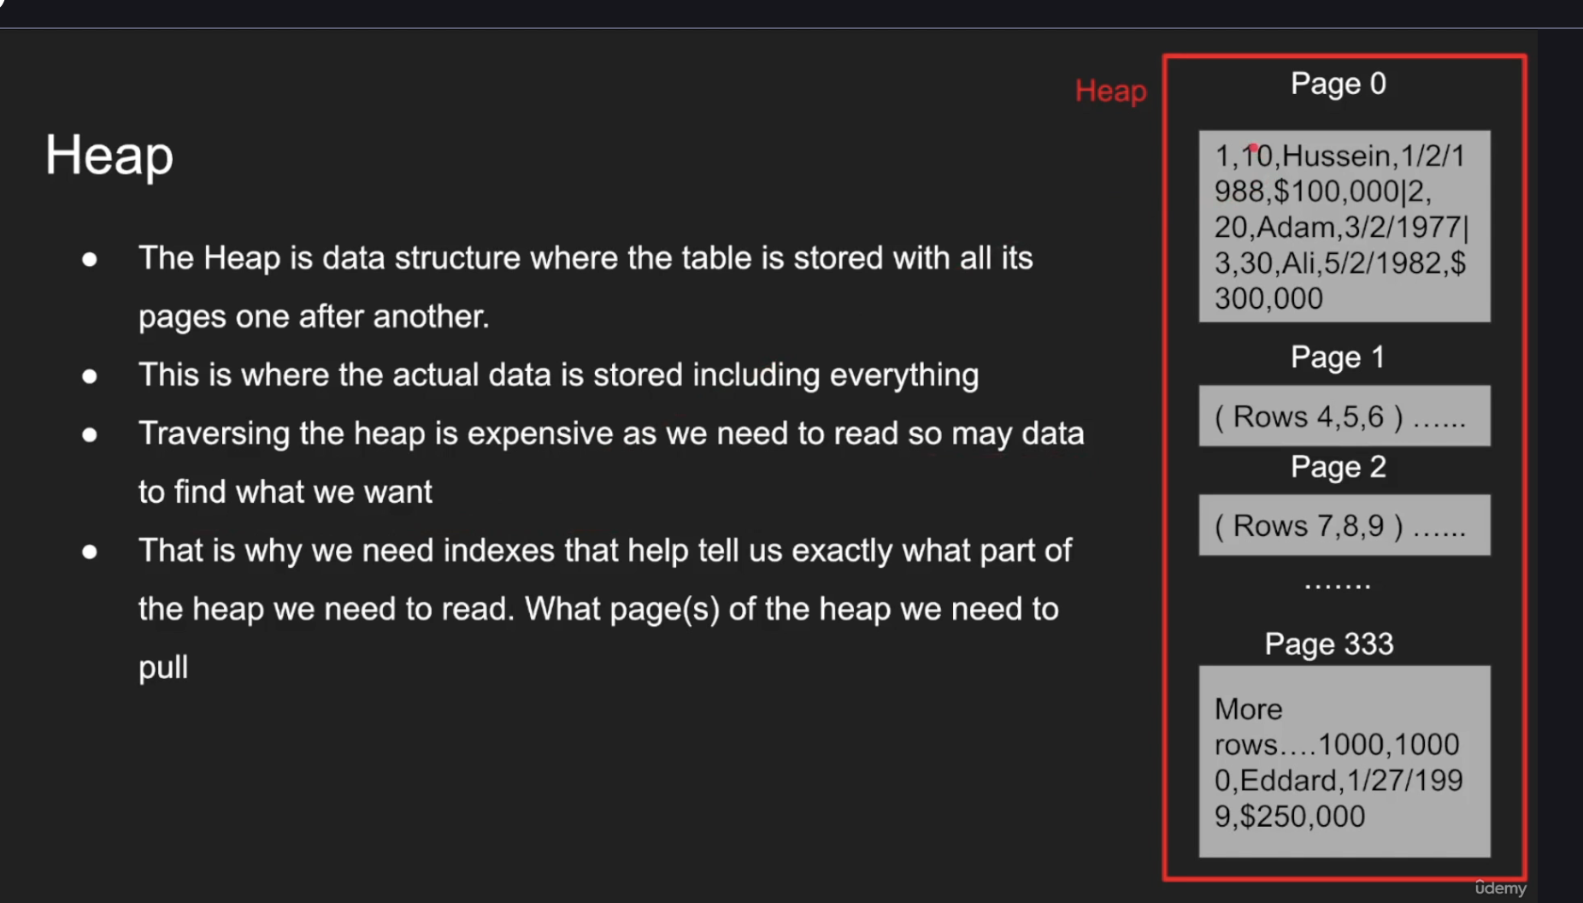

Index is nothing but another data structure, no magic. It's just a bunch of other data structure that helps you pinpoint exactly where to go into the heap so you can fetch the information in an efficient manner.

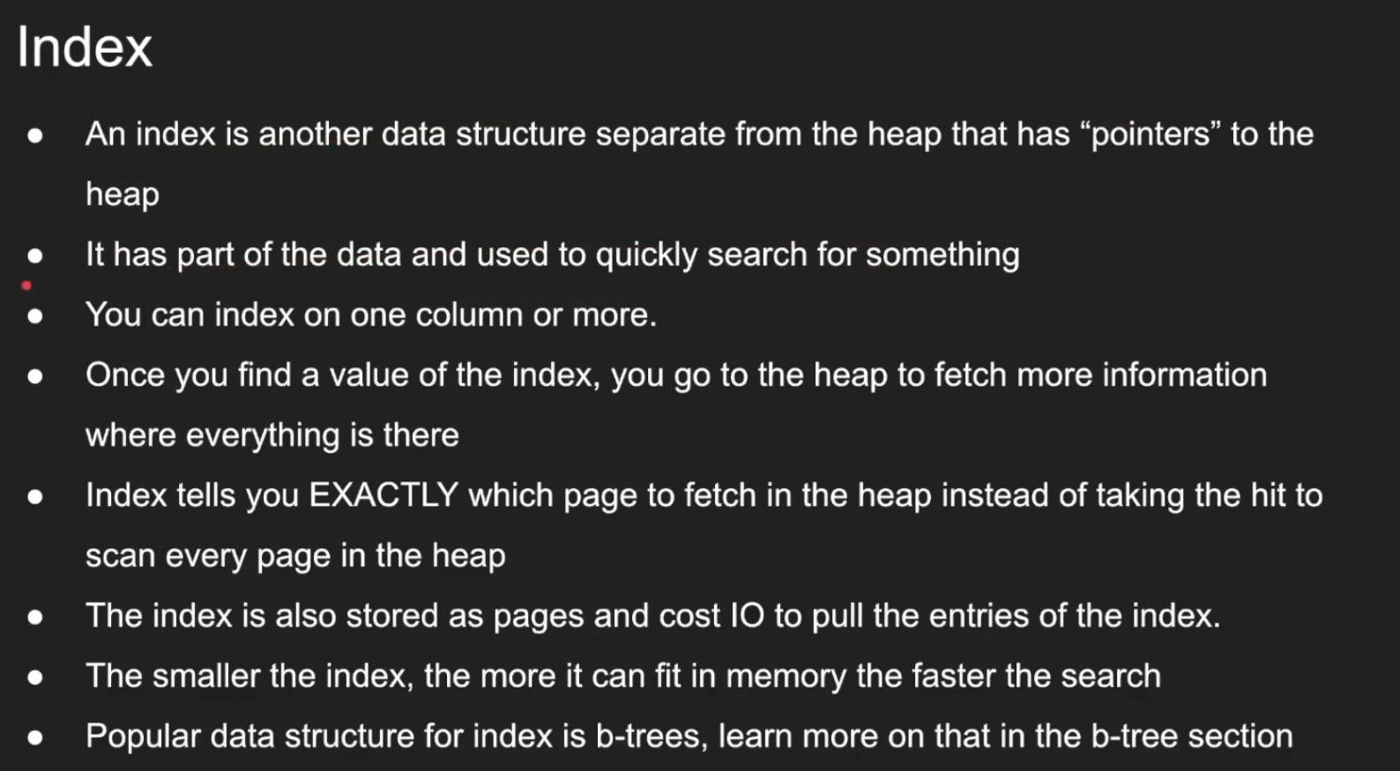

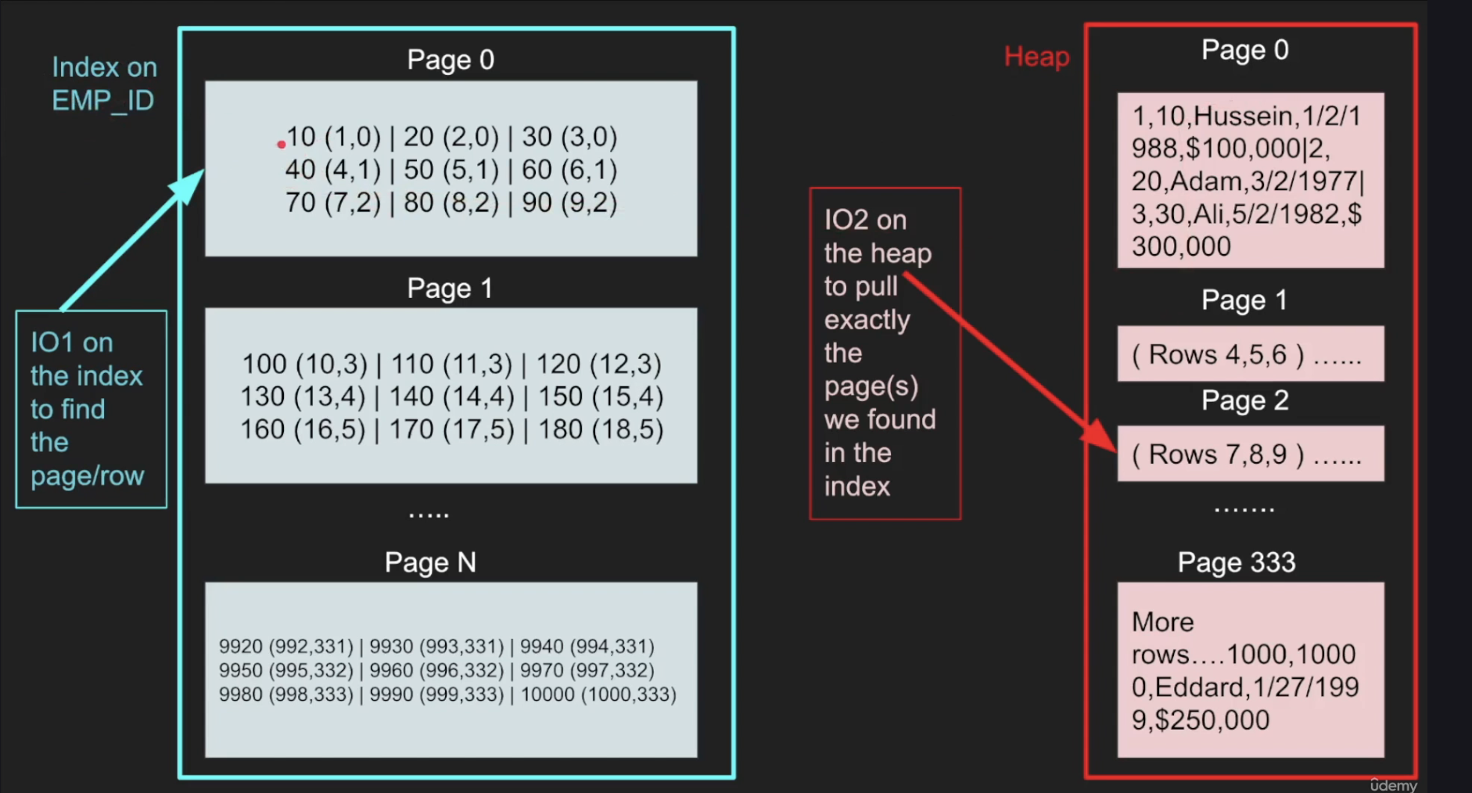

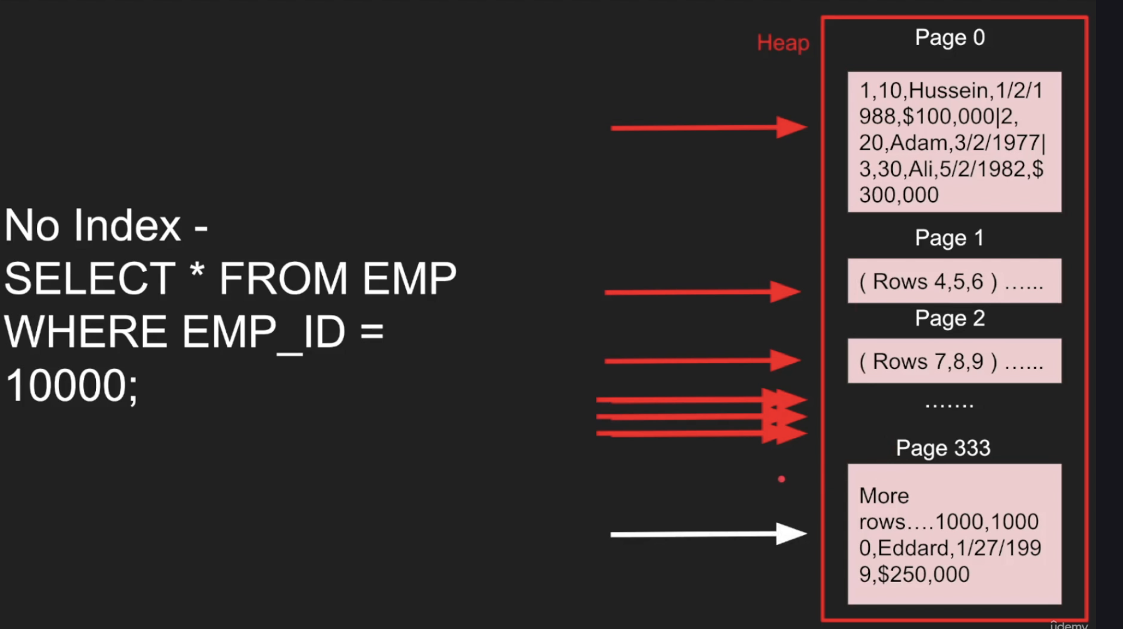

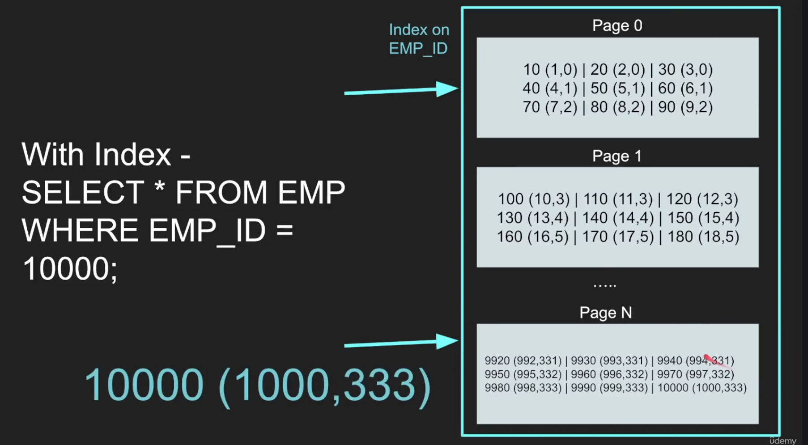

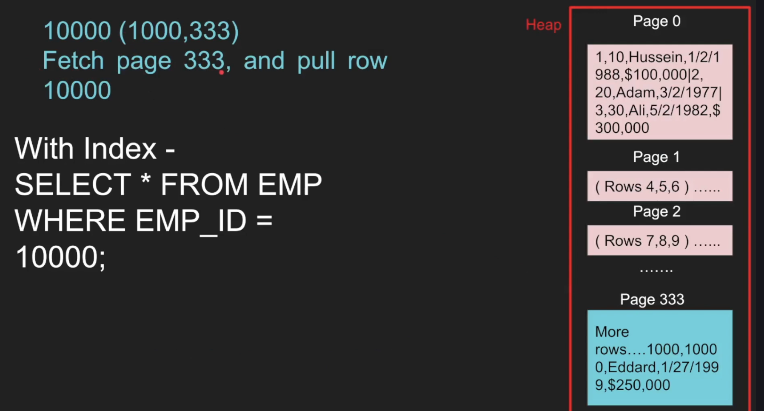

So let's say I don't have an index, I only have an heap and I want to do a select star from employee table where employee ID equals 10,000. Well, in this case, guess what? Employee ID doesn't have an index, right? So what do I do? Well, I don't have a choice. I have to go. Query Page zero is is how many rows do we have? We have row ID one, which is ten, 20 and 30, employee ID, ten, employee ID, 20 and 30. So none, none, none. Discard the page. Go to the next page. Page 1456. Nope. 789. Nope. Up until doing a fetching all these pages. This is so expensive. Some some databases does a parallel threading multiprocessing to kind of walk this structure from by using multiple threads from down and bottom, from down to top and in parallel to scan. But in general it is expensive because the last page happened to be the one that had employee 10,000. So we did a lot of queries to fetch that. So that's, that's without index, let's do it with an index. So now the query with the index in this case, we're going to query employee ID 10,000 and here's where the B3 query actually takes place and it goes through a tree until we find exactly the page that we need to look at and one at the moment we find the page in the index. Oh, this is page N, We go to the page and then we find that Exactly. Employee 10,000. Right? And this is a row id 1000 and it's page 333. So once I got that tuple, that information, now I go to the heap and I say, okay, go page three, three, three and pull row 10,000 and return it to the user so immediately we know where to which page to pull, and immediately we get all the information. And then finally, I have some notes here that I just added so we can discuss. And this lecture, sometimes the heap table can be organized around the single index, right? So we did show that index is a separate data structure from the heap, but sometimes the heap, as you can see, as you saw in this lecture, is not really organized. It's not ordered. Right. But the heap can be ordered around the index. And in that case, it's called a cluster index. And I talk about it in this lecture as well in this course. Sorry. And it's called also called the the Oracle terminology. It's called Iot or sorry, it's called index organized table Iot. Right. So just fixed it. So yeah. So this is called an Iot, right? An index organized table where you have the table organized around a single index effectively. And this is called a cluster index, right? And it has a pros and cons can go can I can't go go into this in this lecture, but I'm going to talk about it in other lectures as well. Primary key is usually what is called a primary as a cluster index unless otherwise specified. And whenever you hear the term primary key, that means. Is it a cluster index? Usually unless it's Postgres. Postgres primary keys is just a secondary key, right? So MySQL DB always have a primary key, it's always have a clustered index. So if you define a primary key, the table will be organized around that index. So be very careful about what datatype you pick. I talked about this a lot. The idea of having, for example, a Uuid, which is truly random in a clustered index, just kills the performance when it comes to writing, because now if you insert a Uuid, a random thing, now the heap has to be organized around the index, which is your Uid, which is random. So you're going to be hitting multiple pages because every Uuid is random, so it will l will live in another completely random page. And this scattershot is very, very expensive. And I talk about it in many things and ask questions. Guys, if you want me to explore more of these Postgres have only secondary indexes and all indexes point directly to the row ID which lives in the heap. So this is different than the primary key, right? So in case of if you have a primary key where we have like a clustered index, the primary key itself is a kind of almost like a user defined field, right? But the any other index will point to the primary key here. But in Postgres, everything is a secondary index. We have this row ID, which is a system maintained field that every index point to the row ID, which means if you edit anything in Postgres, all the indexes get updated. That's a cost that you have to be to understand, right? It's just all makes sense once you understand these low level things. That's why I wanted to make this lecture. And finally, let's make a summary. We talked about what a table is. We talked about the row ID, which is really it's a system maintained field that some databases add, some don't, right? Some rely on an existing primary key that the user defined. We talked about page A page has just a fixed size, right? Some pages are dynamic, but let's talk about fixed size. Just easier to deal with. Fixed size pages eight K in Postgres, 16 K in MySQL and you can put rows in them, you can put columns in them, right? You can organize the page around columns, which is something I'm going to talk about in the next lecture. Right? I o gives you one or more pages. You don't, you don't get a row or a byte in an I. You get a lot of stuff. So the key here is if you do an I o and you get everything you want in a single i o that's the beauty. That's the efficient I o you want your i o to be efficient heap data structures. Right. We talked about that index data structure. B-trees We gave you some examples. All right, guys, I'm going to see you in the next one. Thank you so much.

Row vs Column Storages in DB:

We have this table

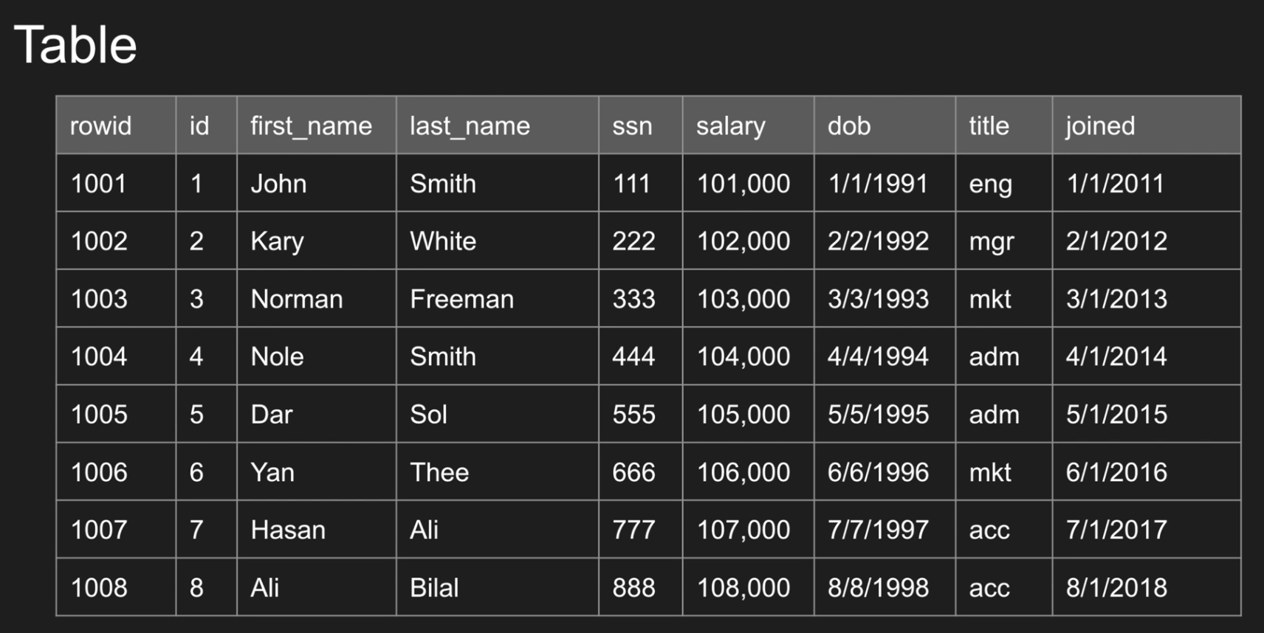

We will run these queries on both row & column based

In row based data is stored in sequential manner

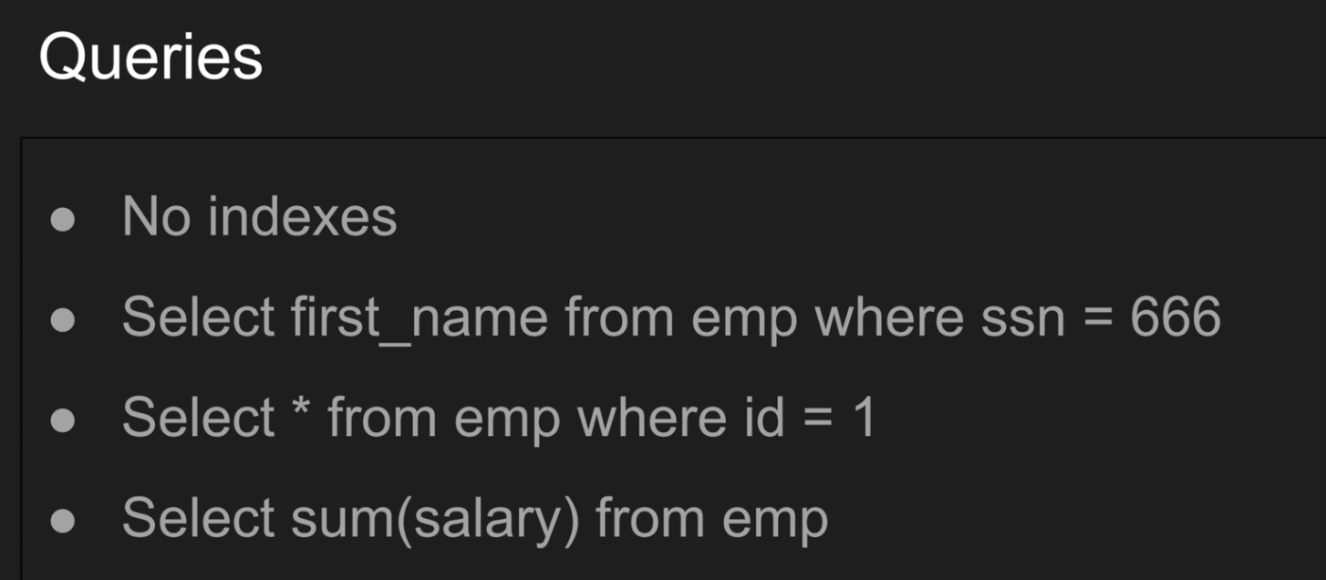

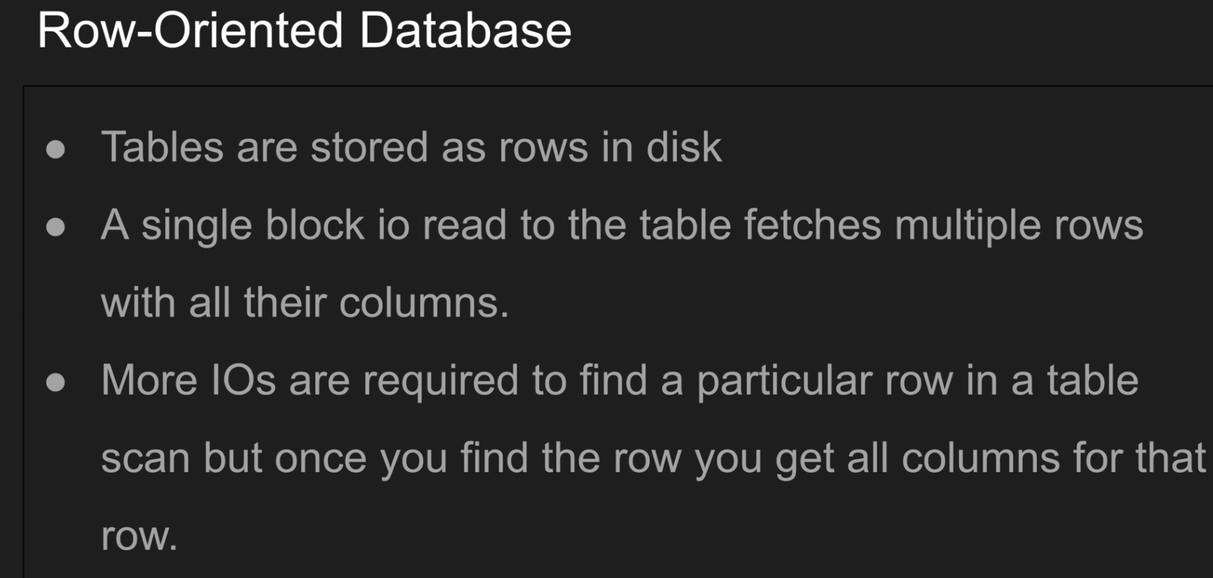

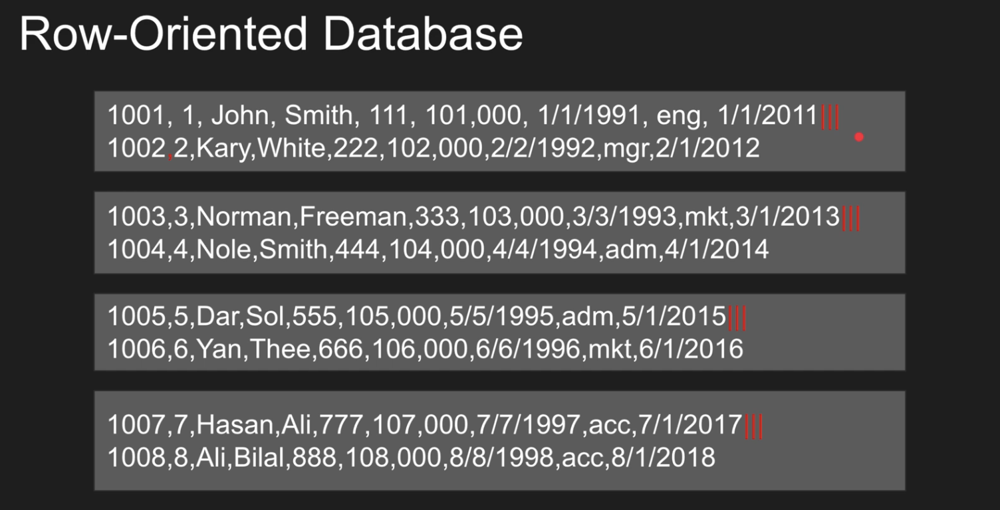

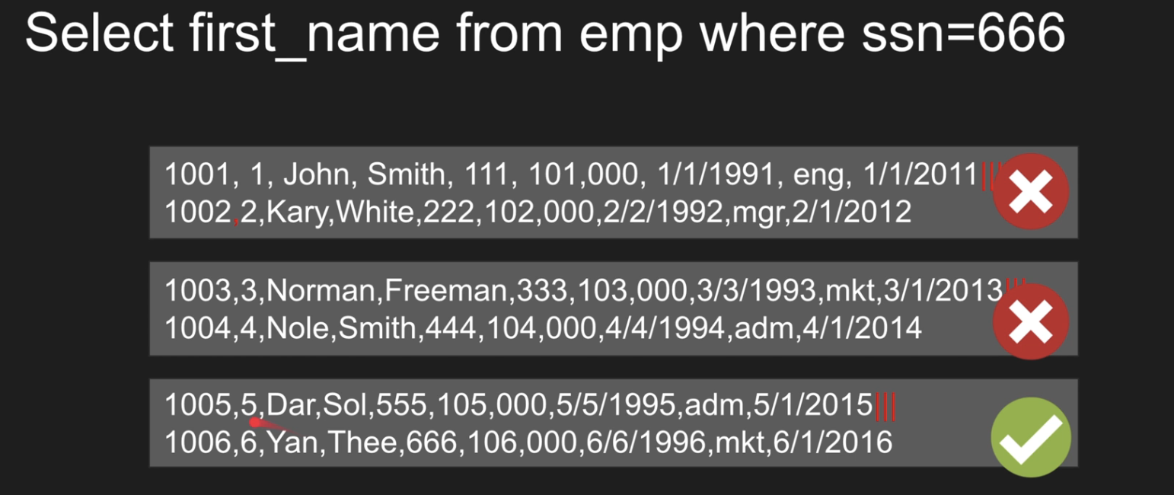

If we doing group by then we are pulling all rows:

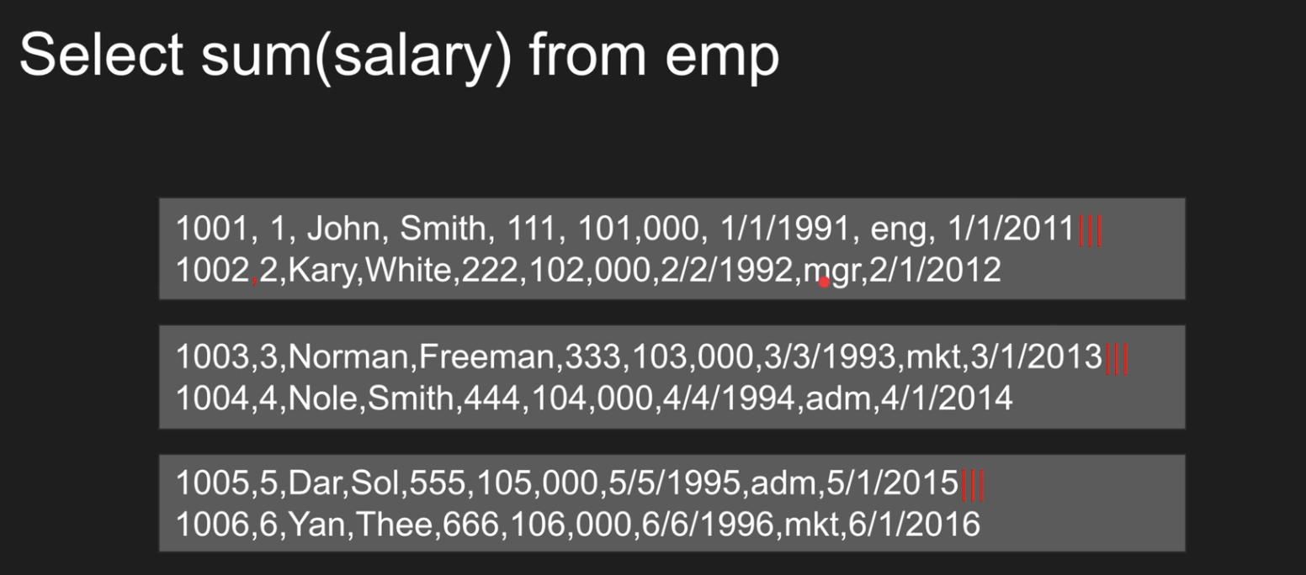

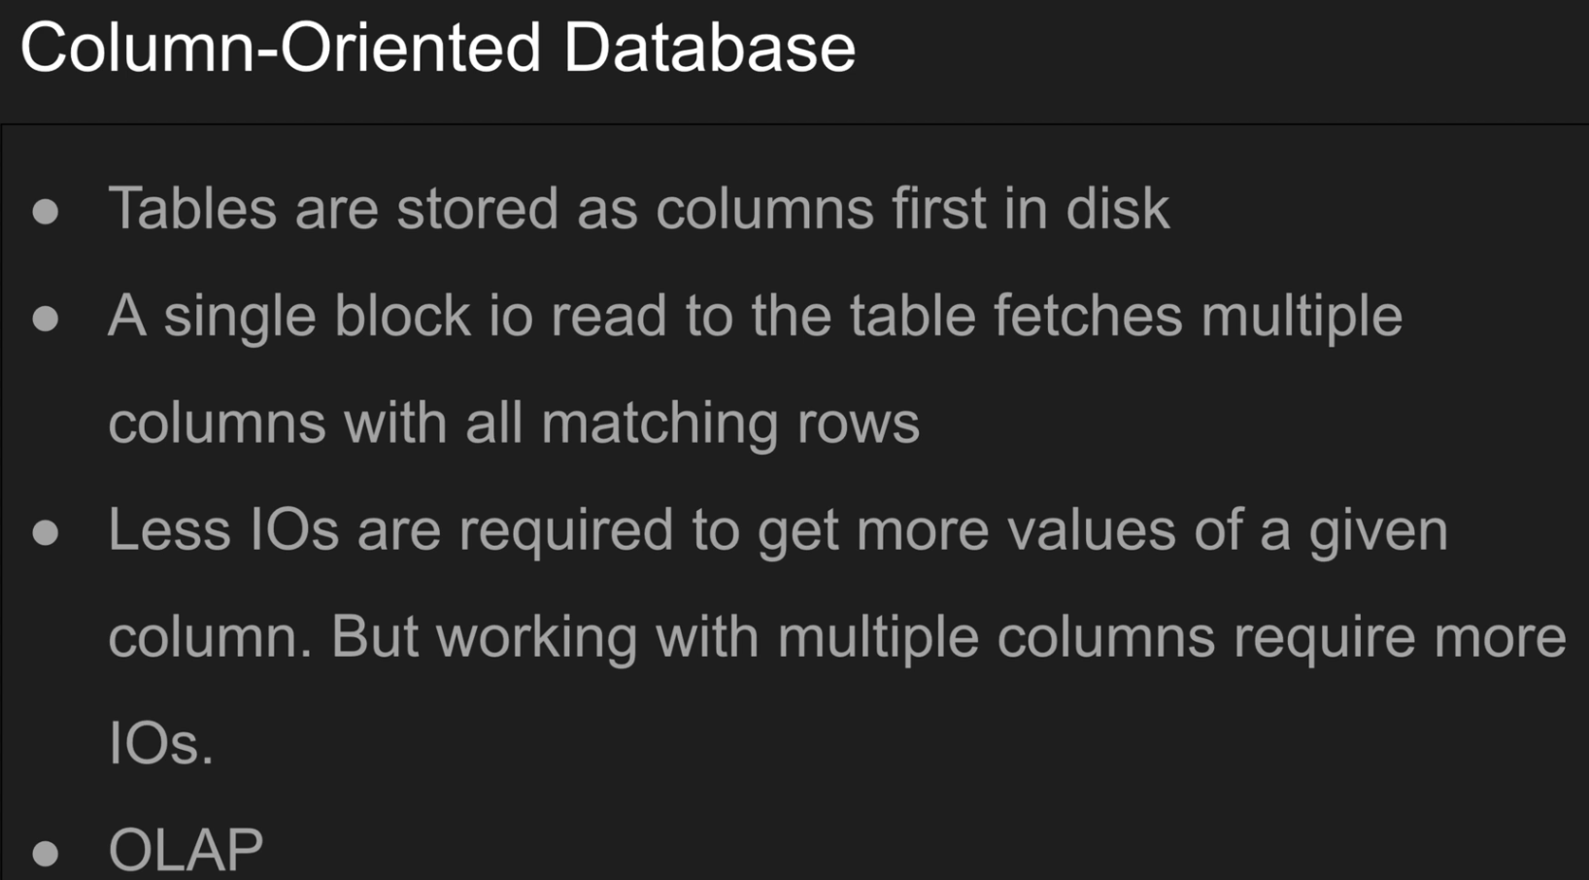

All values of a specific column is stored consecutively



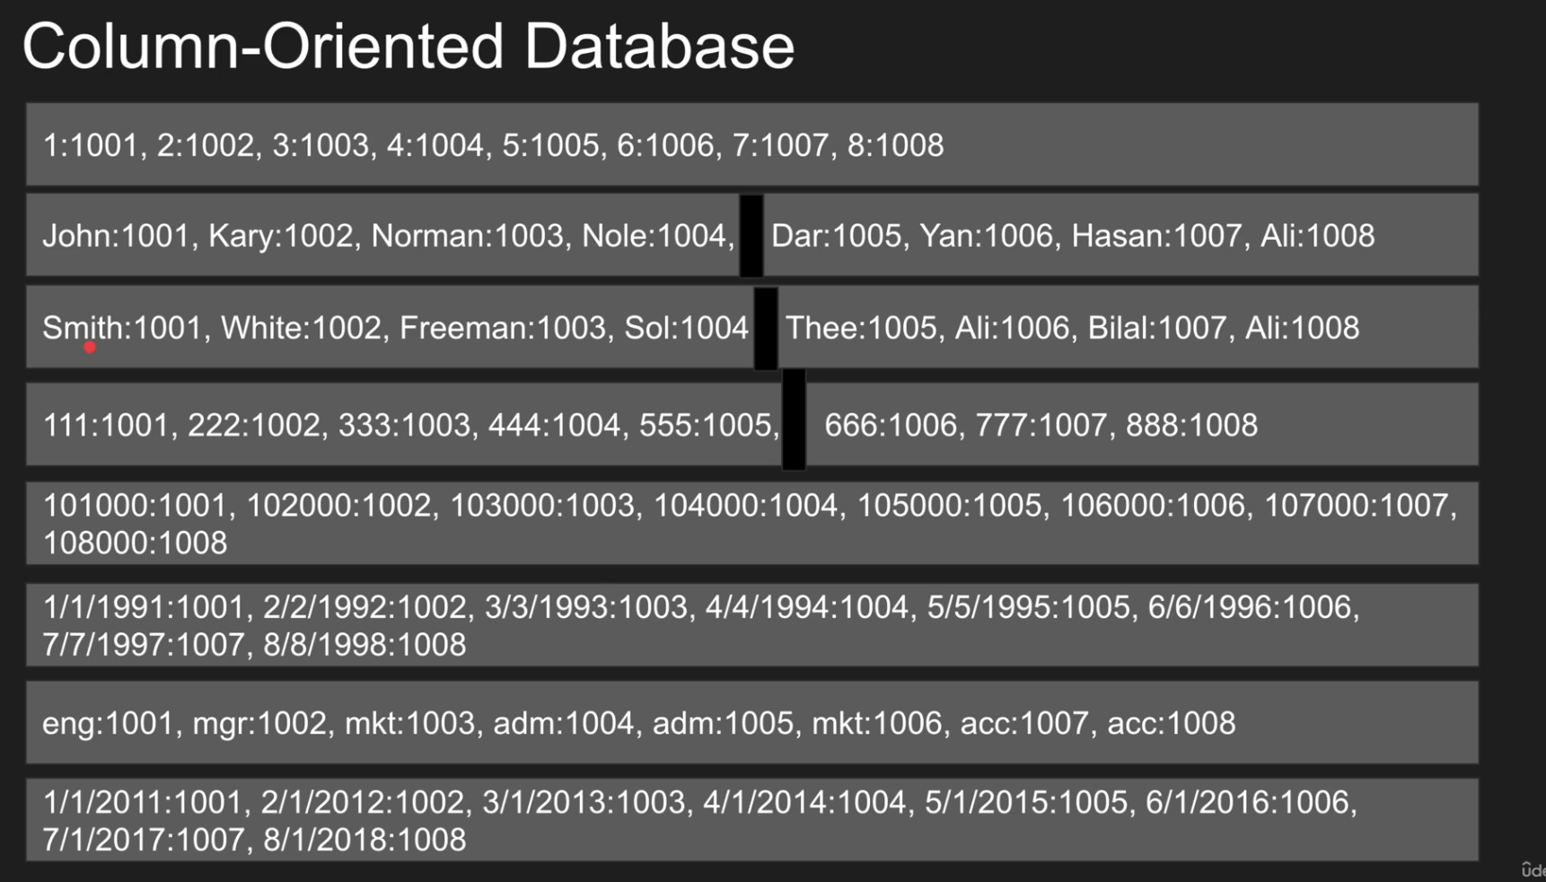

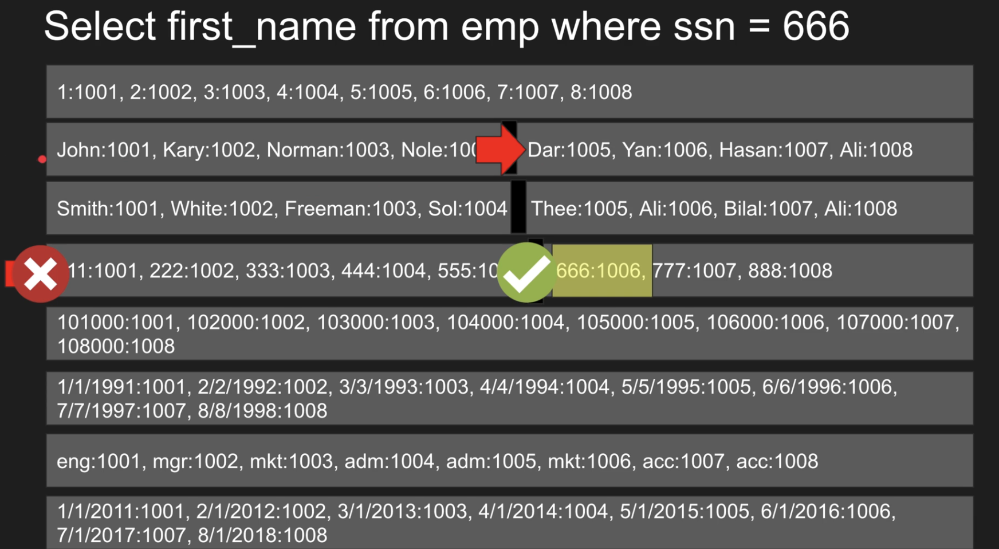

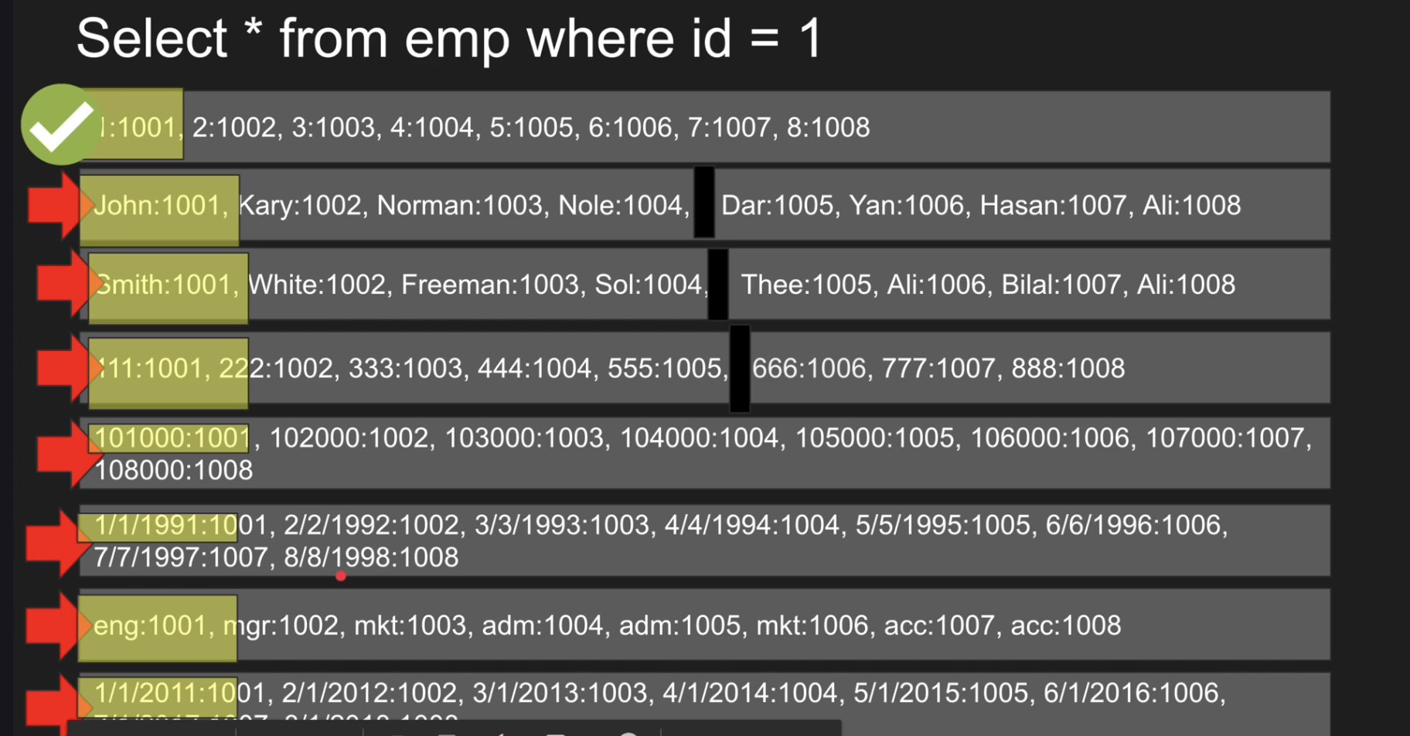

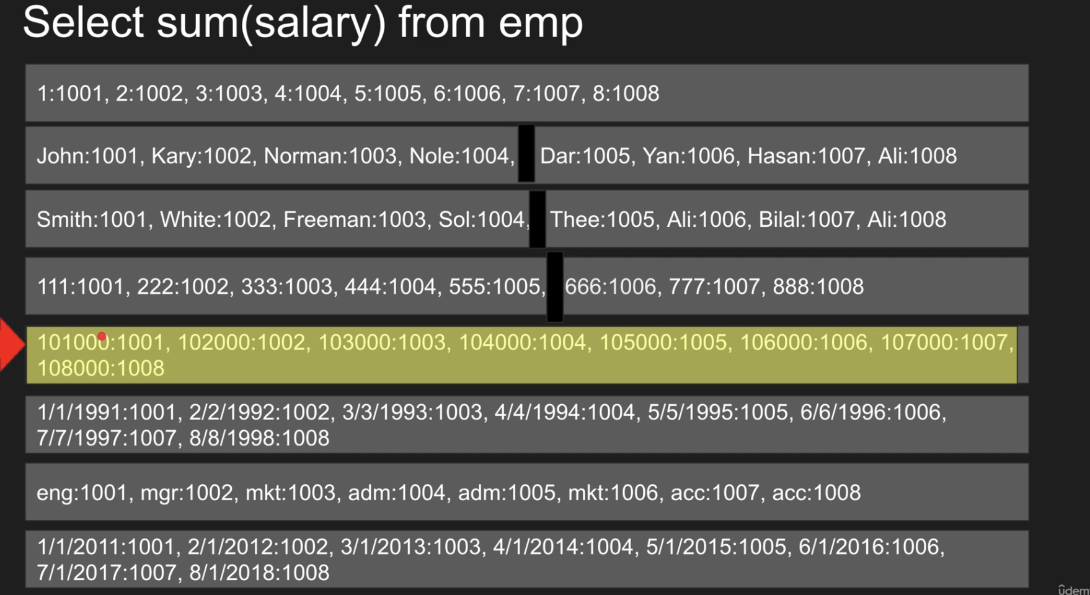

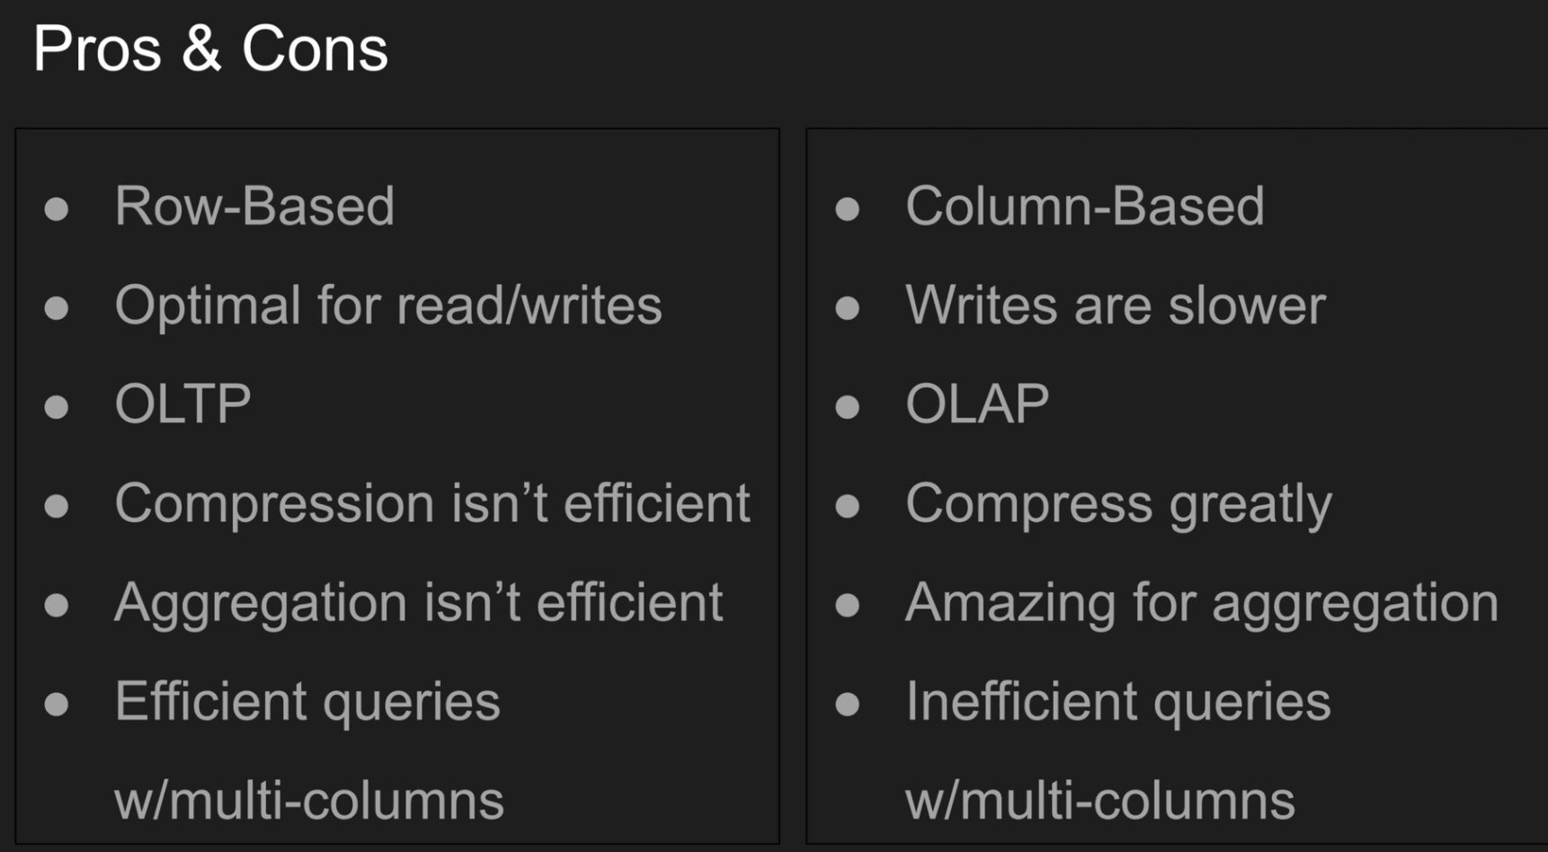

Create Dummy Table to test indexing:

docker run -e POSTGRES_PASSWORD=postgres --name pg postgres

docker exec -it pg psql -U postgres

create table temp (t int);

insert into temp (t) select random()*100 from generate_series(0,100000)

Indexing:

An **index** in PostgreSQL is a **data structure** (like a B-tree or hash) that allows the database engine to **find rows faster** without scanning the entire table.

Think of it like the **index in a book** — instead of flipping through every page, you can jump directly to what you need.

Suppose If I make name column as index and if I search with like ‘%%’ then indexing will not work

Explain Command:

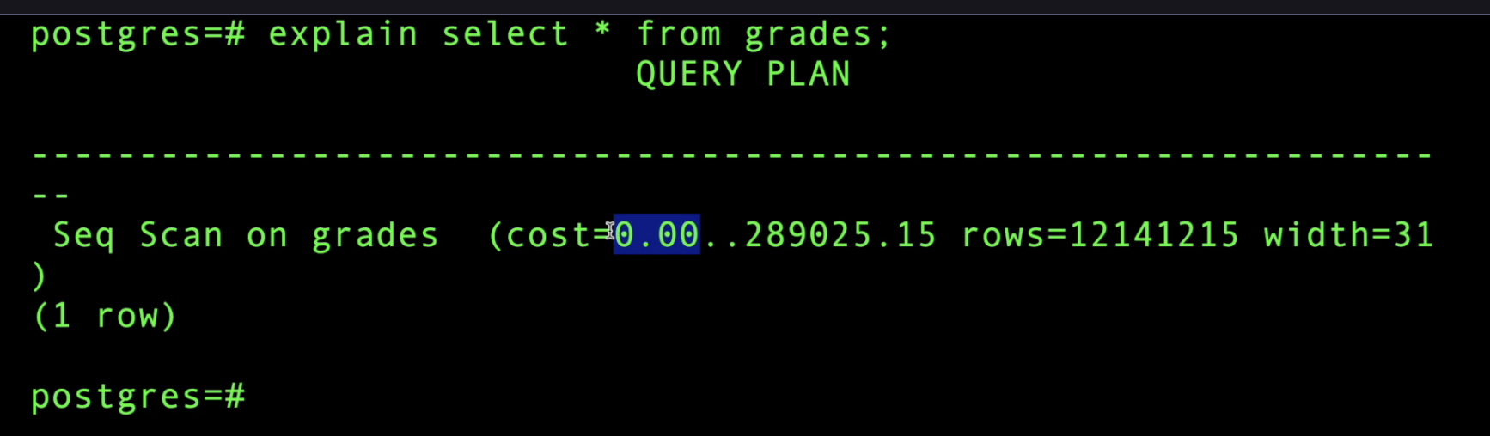

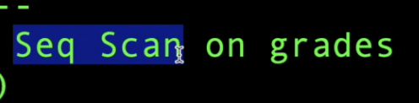 means full table scan, in postgres it used MVPP but it scans whole table

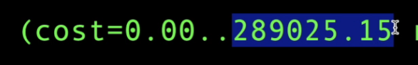

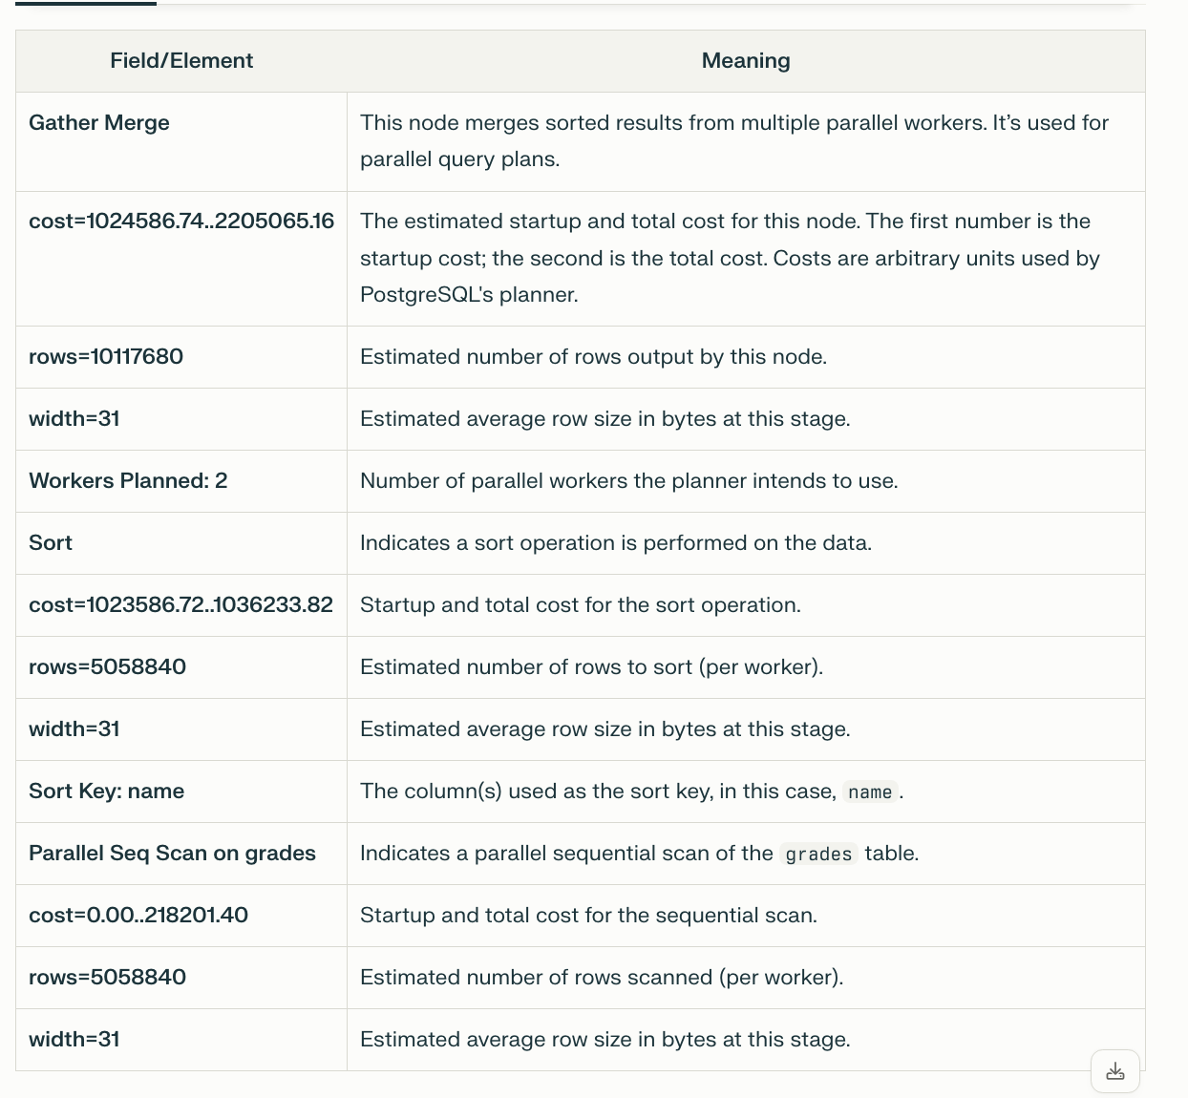

Seq scan vs index scan vs Bitmap index scan:

1. Sequential Scan (Seq Scan)

* **What it is:**  
  The database reads every row in the table sequentially, from the first page to the last, checking each row against the query’s filter conditions.
* **How it works:**  
  It scans all pages and rows in the table regardless of the query condition. Even if only one row matches, it still reads the entire table.

2. Index Scan

* + **What it is:**  
    The database uses an index to find the exact row locations that match the query condition and then fetches those rows from the table.
  + **How it works:**
    - First, it scans the index to find pointers (tuple IDs) to matching rows.
    - Then, it fetches each matching row individually from the table (random access).

3. Bitmap Index Scan (and Bitmap Heap Scan)

* **What it is:**  
  A hybrid approach that first builds a bitmap of all matching row locations from one or more indexes, then fetches the matching rows from the table in a more efficient, bulk way.
* **How it works:**
  + The Bitmap Index Scan scans the index and creates a bitmap (an ordered set) of matching row IDs.
  + The Bitmap Heap Scan uses this bitmap to fetch rows from the table, reading pages in bulk rather than random single-row lookups.
  + Multiple bitmap scans can be combined with BitmapAnd/BitmapOr operations to handle complex queries.

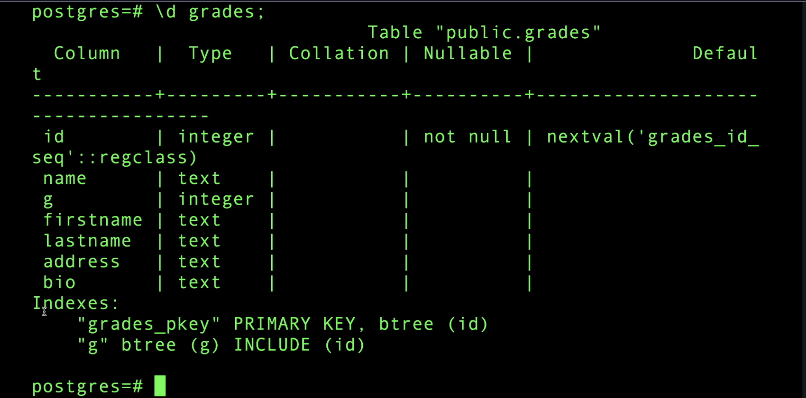

If 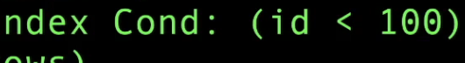 it will do index scan

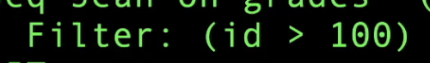 it will do seq scan as index scan is costly

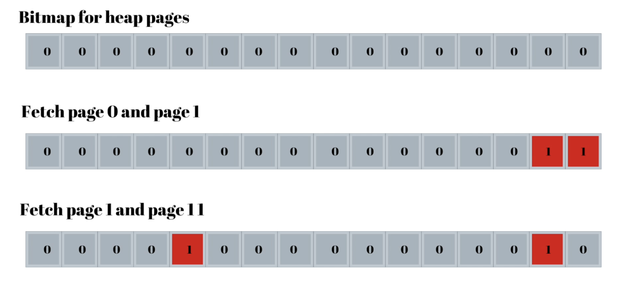

Here each bits represent pages and which pages has records it will set that to 1

Index Scan vs Index Only Scan:



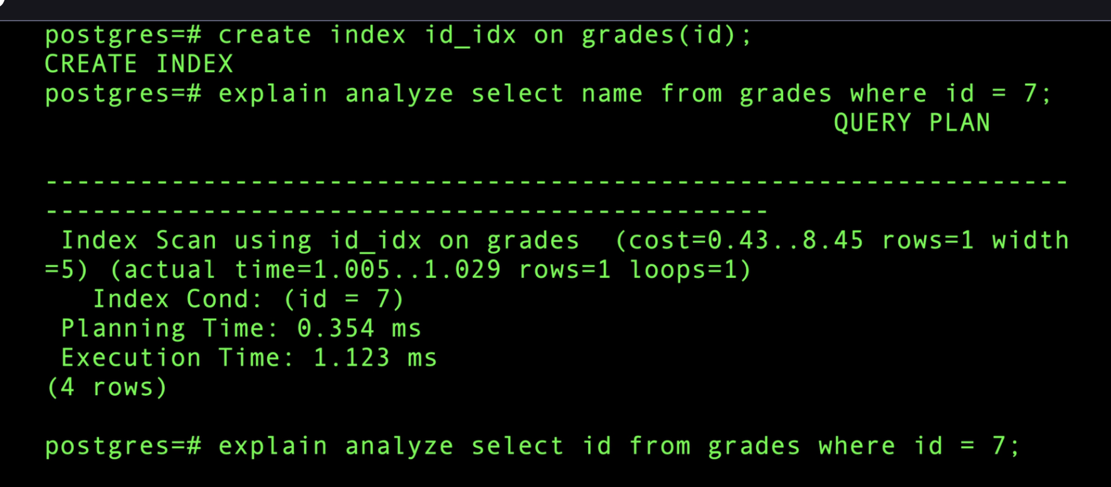

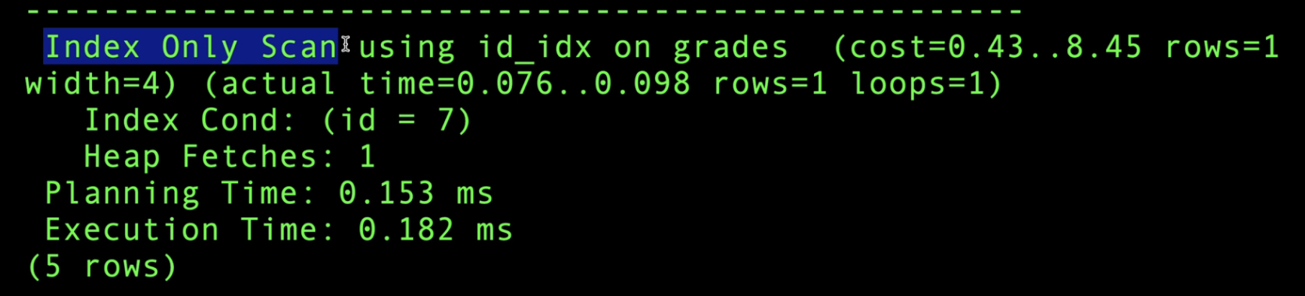

In first case it needs to go to table to get name records, but it second case it doesn’t need to go to table as id info already there in index

We can include additional column along with index



Indexing Optimization:

I will do indexing on both A & B

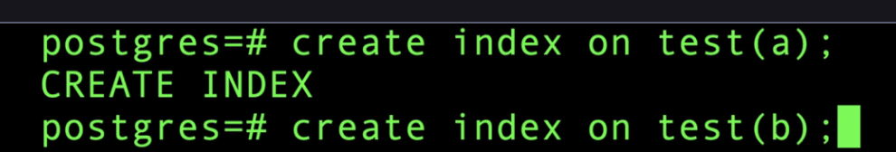

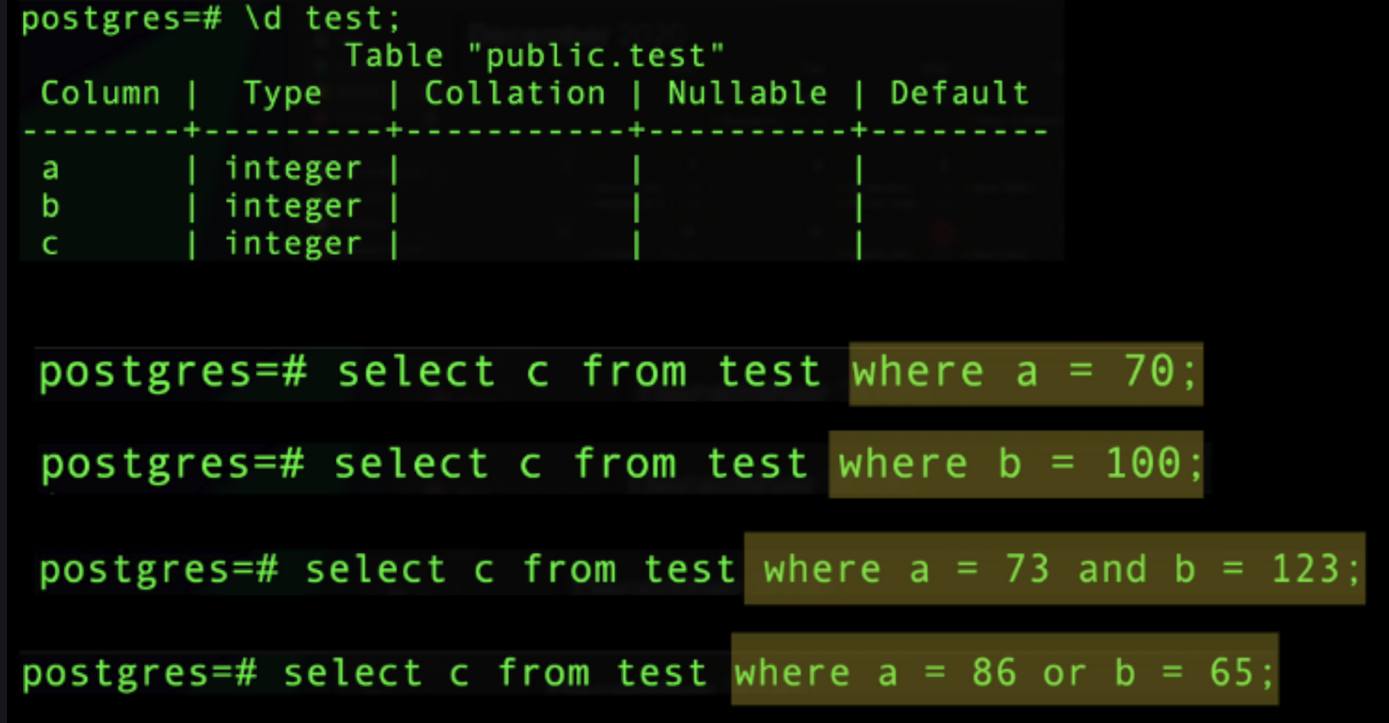

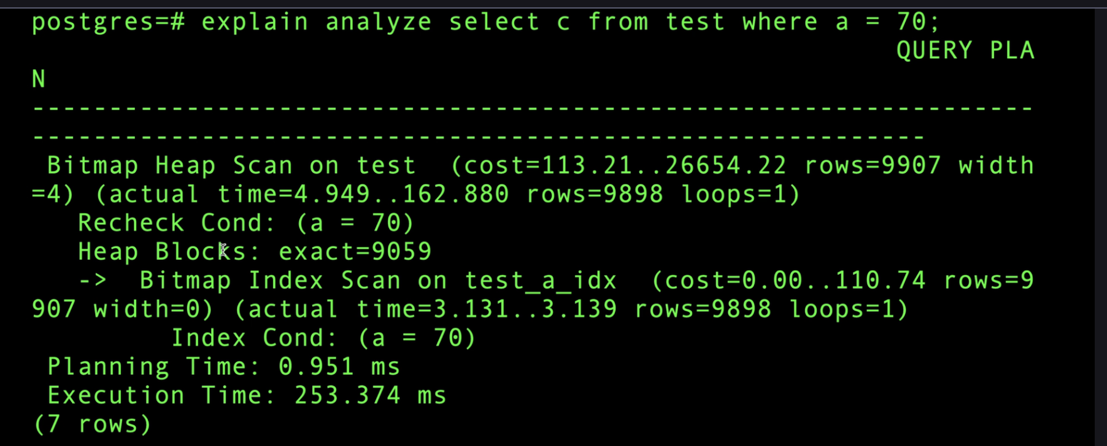

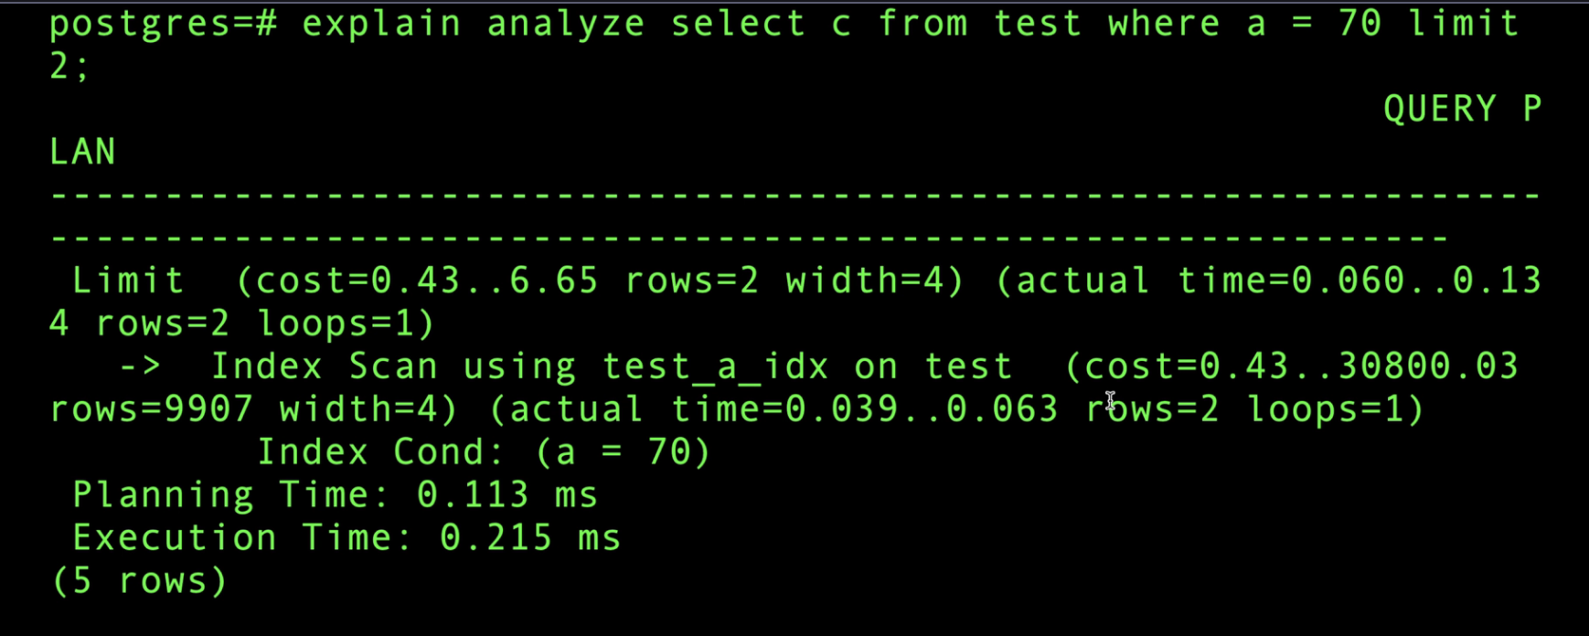

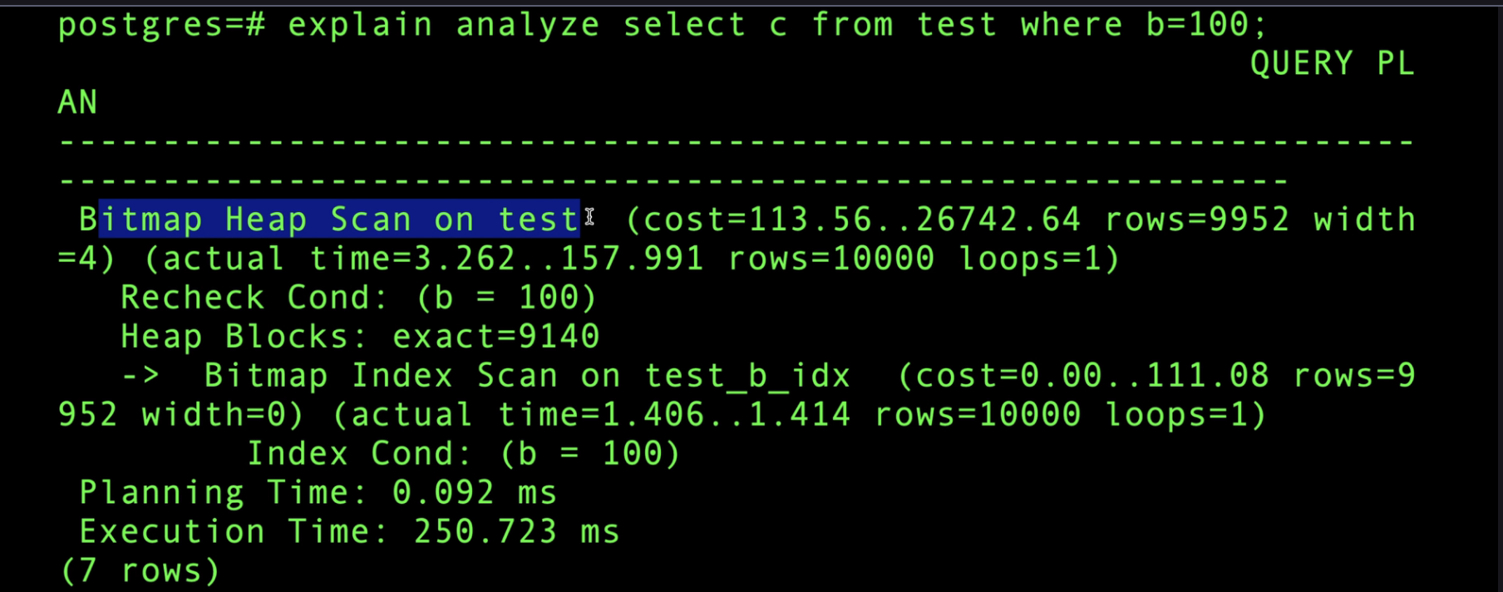

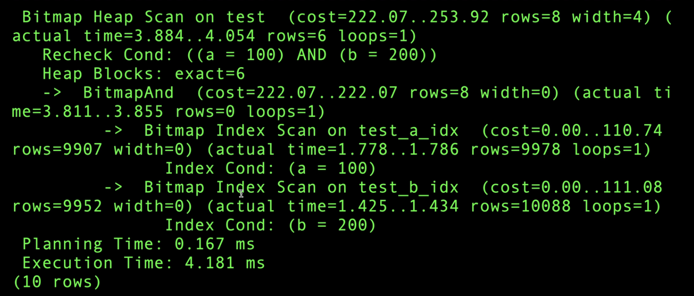

**composite** index:

A **composite index** (also called a **compound index**) is an index on **two or more columns** of a database table.

Since index is left to right if I do indexing on multiple columns like a & b, if I give filter with column a then indexing will work, if filter with only column b then indexing will not work

A & b will use index, but a or b will do full table scan

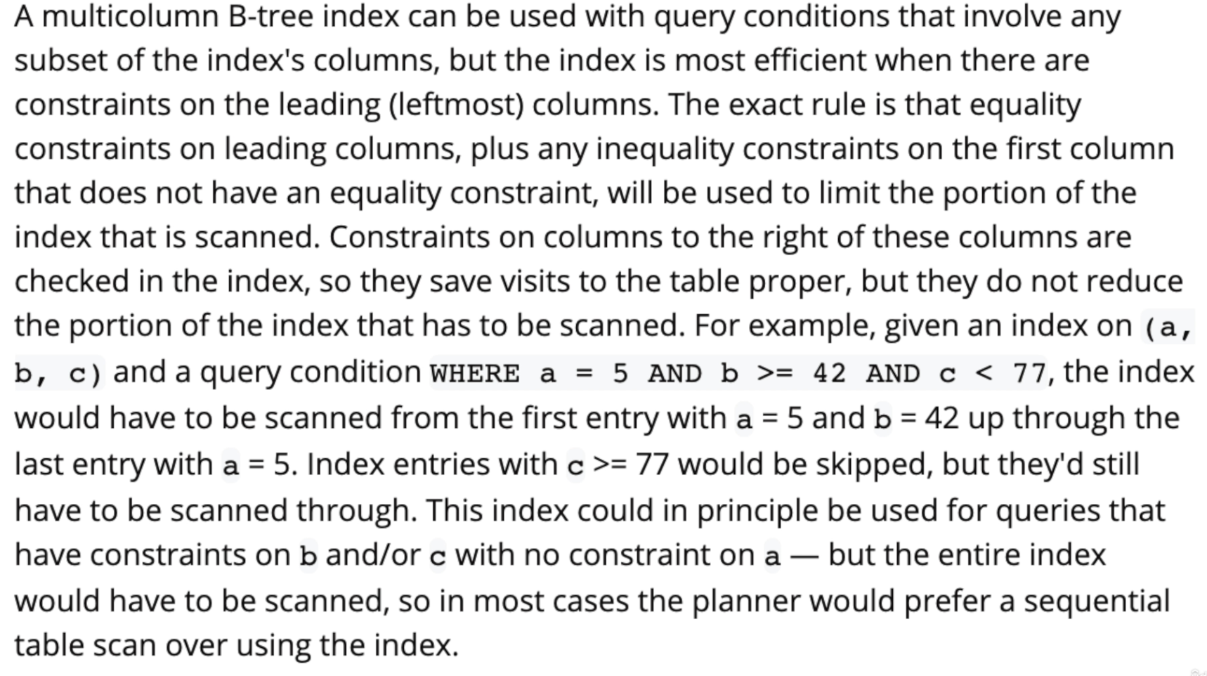

Index CONCURRENTLY:

CONCURRENTLY keyword in PostgreSQL (and some PostgreSQL-compatible systems like Trino through connectors) tells the database to **create or drop an index without locking the table for reads or writes**.

Bloom Filters:

Because anything, any time you want to avoid an expensive query to check if something exists or not or or if you want to do this query, but you're not sure if you're going to get a result or not. Bloom Filters are very useful because there are some disadvantages to this, but let's look at actually

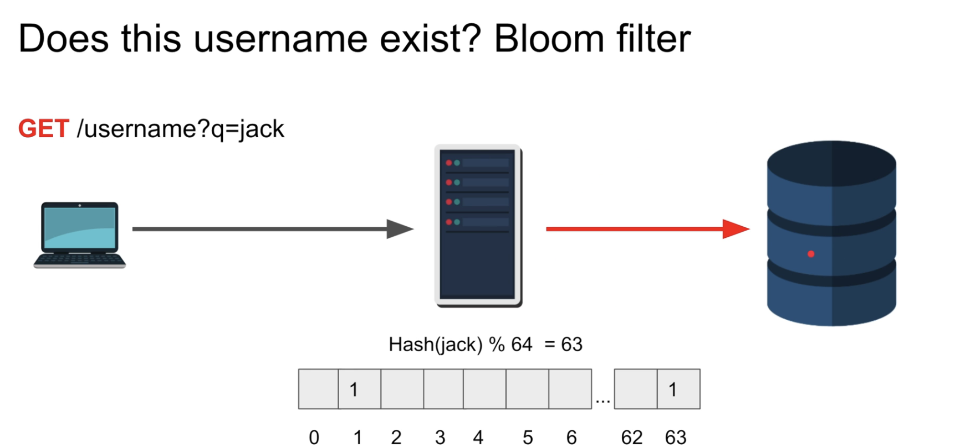

Working with Billion Records Table:

With indexing we run reduce load from billion to millions while filtering

We can go with partitioning on key

UUID on index performance

Indexing column should be sorted

B Trees & B+ Trees:

In order to find a particular item, we need to scan the entire table. And that's the original problem that that spurs the rest of the discussions here.

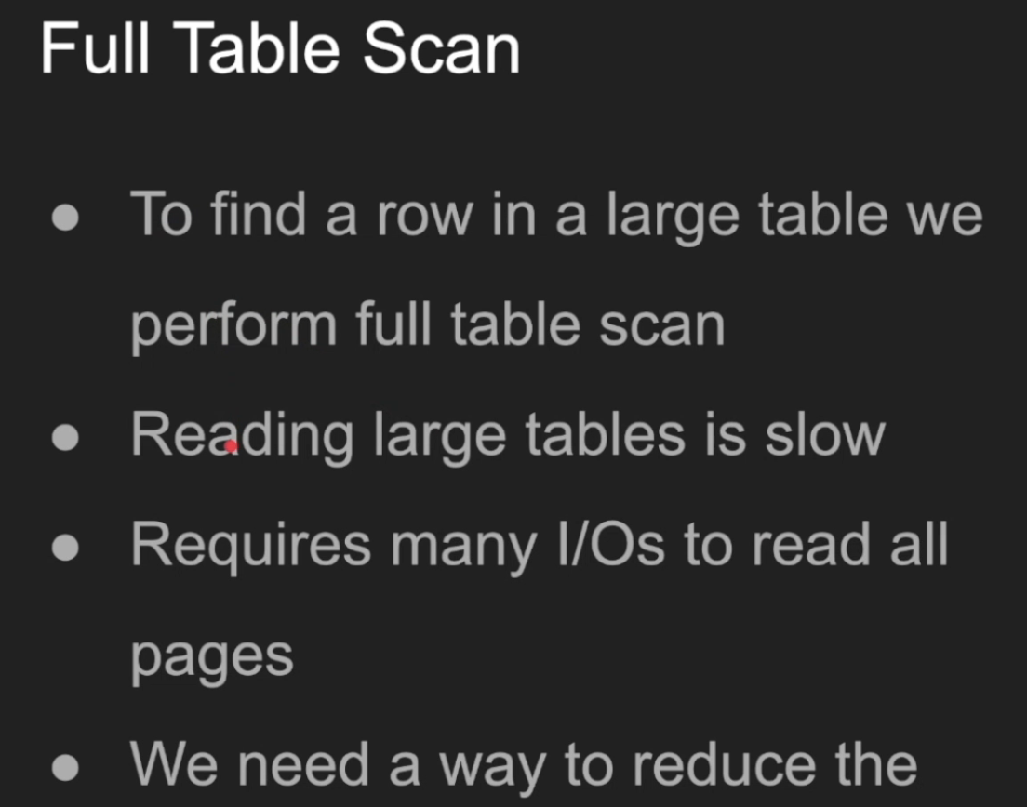

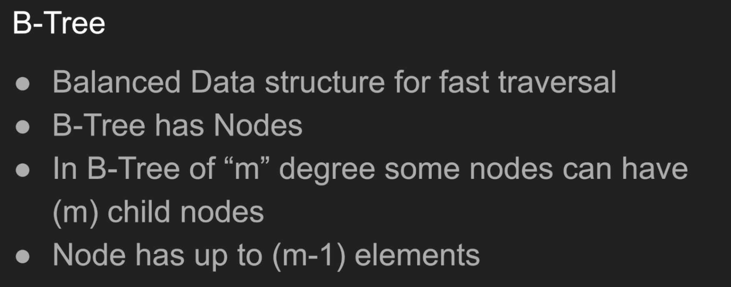

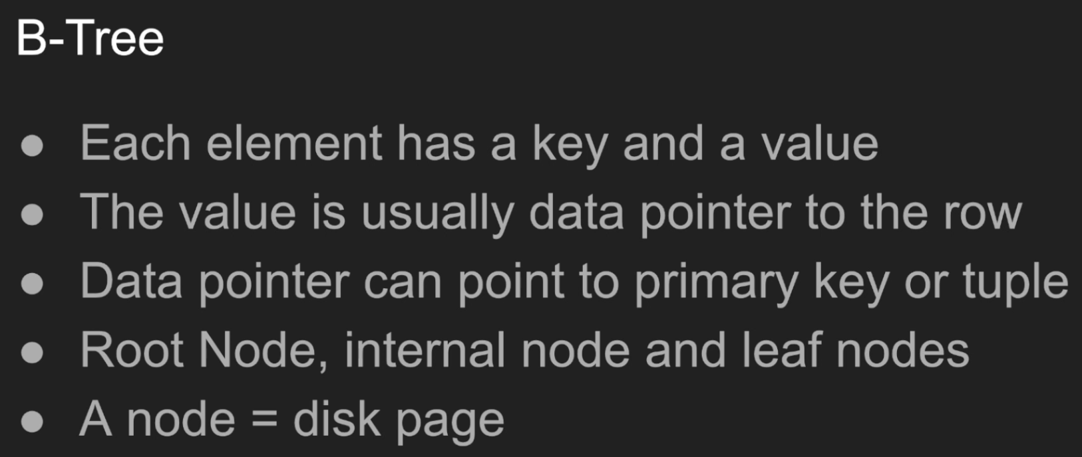

In order to find a particular item, we need to scan the entire table. And that's the original problem that that spurs the rest of the discussions here.Meet Beatrice. So Beatrice is a balanced data structure for fast traversal. So the goal is to minimize the search space. I don't want to do all these io's to find my rows. Right. Did that rhyme? I think it did. So what? B-tree has a. B-tree has a set of nodes. And I want you to focus on this word nodes. Right. I'm going to reference the paper, the B3 paper written by those two folks in 1970. A b-tree consists of nodes. Okay. And a b-tree have a degree. We call this degree M by default, and you can choose what degree your tree is right. And the choice of how how big, how small really changes the whole equation. And databases pick that automatically, by the way, for you. You don't have to do and you can't configure this, to be honest. So this degree is basically correspond to the number of child nodes each node can have. I said some in this case because not all nodes can have children and I don't really care about these details. These are all theoretical stuff. We don't really care about it, to be honest. We really care about the essence of the tree. To me, the traversal aspect of this node and a node has up to n minus one elements. So if if your node has M children, then the, the it has what we call M minus one elements, right? So if it have five children it must have four. If it have three children must have two elements. So you might say what is an element? This is a good question. So each element has a key and a value, very critical thing. So we have nodes. Nodes have child nodes and each node in in it inside it has elements. And these elements correspond of keys and a value, a key value. The value here is usually the pointer to the row. It's called a data pointer. They call it the value. Sometimes in the in the paper it's referred to as Alpha I. Right. So if you read the paper, I've referenced the paper in the show notes here for you to check it out. And the slides will be in the show notes as well, guys, So you can take a look at that in the description. The value has the data pointer to the row, and the key itself is what you're searching for. And we're going to show an example to clarify all that stuff. So the data pointer, this is this is where databases can shine. Each database system does this differently. A data pointer, which is the value here, can either point to the primary key. If you have a secondary index or a point directly to the tuple secondary indexes in a.B in MySQL and Oracle I believe point to the primary key. Well, while in Postgres all secondary indexes point to the tuple directly and just that I talked about the this in my YouTube channel discussing how Uber moved from Postgres to MySQL. And that is one of the reasons. One tiny reasons. Uh, check out that video if you're interested. Just just type in YouTube, Uber, Uber, MySQL. Hussein you're going to find the video. It's very, very interesting read. So there's also this concept of root node and internal node and a leaf. An a leaf node as well. Right? And we're going to describe what all these means. Like the root node is, is very self descriptive, right? It's the first node at the top. Internal nodes are below it and the leaf nodes that are the at the end, right, there is no child, they don't have children. A very important concept here and note is equal a disk page here in databases. Most databases I know in computer science, they give you this, this, this contrived example where, oh, a degree of three or degree of five and they have some put some values here that doesn't really correspond to anything practical. Right. But practically a node is a complete page. So if a page is eight K, you better find a way to fit eight k worth of elements in it, right? So that's what we try to think here.

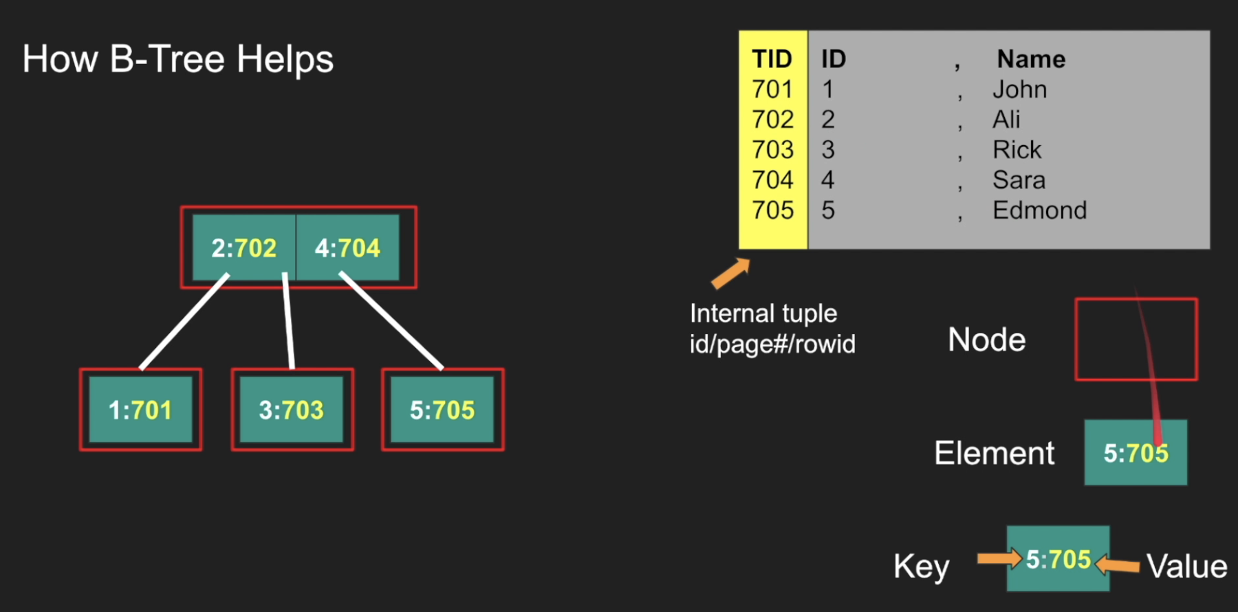

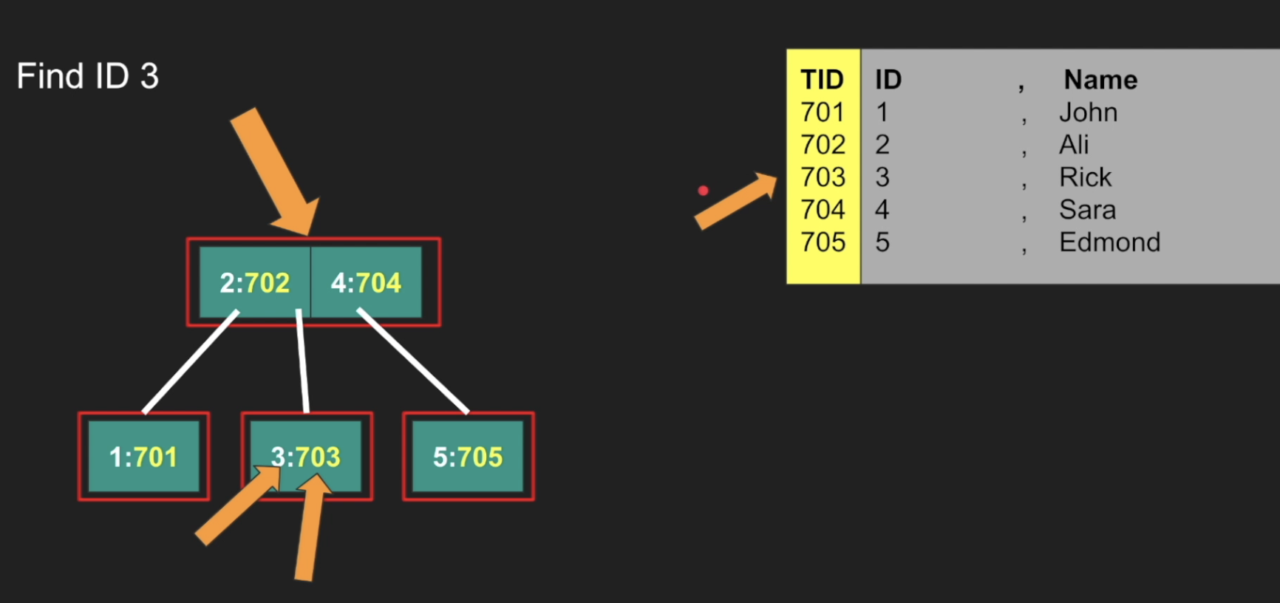

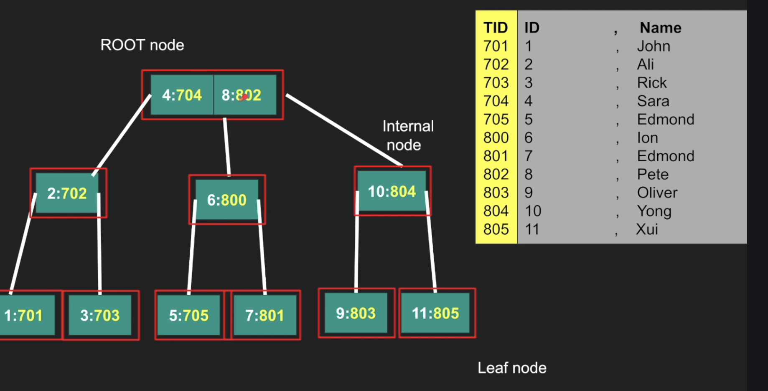

So let's take an example. So here's my table here and you can see that I added another column here to correspond to the internal tuple ID or sometimes some people call it our ID row ID, The page number sometimes is baked into the tuple ID for for simplicity reasons. But here's here's the tuple ID, It's an internal. It doesn't show it. Right. This is the physical, not the logical primary key or logical field that you have. And this is just the name. So now one choice and this is what Postgres does, is actually that, right? This is my b-tree here. Let's look at the definitions here. The node is this red thing, so this is one node and it has two elements and this node has three children. And because it has three children, how many elements should it have? Three minus one, which is two, right? So if it has M, that's M minus one. If it has K children, it has K minus one. That's the definition. And each element has two things. It has a key, which is what you search for. In this case, you're creating. Let's think about this as an index. You're creating an index on this ID field, right? So we store the keys as these values, right? As these keys in the key space of things, while the value becomes the tuple that points directly to the row here. So key value also called as data pointer. And you might say I'm saying I never actually seen this before. All the b-trees I looked at there is no pair. There's only one value. And I blame the author of this, of this paper, to be honest. So like when they originally just drew the keys, although the values or the data pointer are inside, but they chose not to. And here is a blurb of that proving this. And the figure, the A which is the value pointer are not shown. Why? Beats me. It just all the papers, all the books, nobody talks about this. They just show this and it it confuses B trees from B plus B plus trees, which is very confusing because that's not the actual representation of the tree. To me. That is the actual representation of the actual tree on disk, if you think about it. Right. So anyway, because why am I why am I hammering on this point is because it's very critical to understand that the keys and the values exist in all nodes in a B tree structure. And that is important for memory efficiency. So let's read through all this stuff right here. So one more thing here. So this root node has a value, has has a two elements, two and four. Right. And. Elements. Nodes that is less than two goes to the left of the that element. Right. This is the children. Child nodes between the two and four goes here. Child nodes greater than four goes to the right. Right. And that's that's why the trick is that it has to be n minus one for this to work. Let's search for ID number three. So first searching for ID number three. You're going to read this node, which is almost one single on disk. And think of this really on a real production database. This is going to have a lot of elements, to be honest. It's not just one, okay? So it's just going to have thousands of elements because we want to fit it in single page. So there's so much stuff we can put here. Okay. And then I'm going to read this and I'm going to ask my question, Where is ID number three? Well, three is between 2 and 4. So I just eliminated this and I just eliminated this. So I'm only going to pull the pointer, the page pointer or the something called the child pointer to this row. Right. So I'm going to take so there is another thing that I didn't show here, but it's shown as a graphic here, right? Which is this pointer. So there is there is another value that we store here, which takes space. I'm putting it all the way here. So pull, go there and I just found three. Now I'm not finding three for the sake of three, I really want 7 or 3. Right? So if I find 7 or 3, I jump and get the value and even even we're not really 7 or 3 is useless here because you're going to do a full table scan to find 7 or 3. There is more information in 7 or 3 that tells the database which page actually to pull. Pull. It's not it's not going to fetch the entire table. It's going to fetch the exact page, which has 7 or 3. So it can have more than seven or it can have 7 or 2, 7 or 1 anything nearby. Right? So finding one similar one is less than two goes to the left. I cancel these right and then get 701 jump there. Five very simple. Go here, jump and then go to seven and five. We can add and delete keys very similarly. And I took this from University of San Francisco. I just animated this with a JavaScript, right? Just adding elements, right? I'm adding elements from 1 to 11 and you can see value one, add two, and this is a degree of three by the way. Right? Which means it can have up to three children and up to three minus one, two elements. Sorry. So we have one and two add three. We split the root and then go here. As you as we add, we can see we're splitting the pages. And that split also has a cost, right? That's why you want you don't want to split pages so often. That's why the value should be so large that you don't really need to split as often. Okay. And and these the order of elements here also matter. If they are these are random. The inserts will be slower if you think about it because you will the randomness will will cause the pages to be stored in an unordered manner. And if you added a new element that is has to go into the page or in an order fashion, then you have to split the page. Split the page is expensive. So this is just a side effect of things. So this is how you add it. All right? And I'm not going to go through the actual theory of adding and deleting and splitting. Really. It's not. It's not I'm not interested in that. So here is the same tree that we're looking at that we just added animated. And it's very critical to understand this is the internal nodes right in the middle. These are leaf nodes and these are root nodes, right? We can follow this tree. Essentially. It was like, okay, the ten is greater than then. That's why you see the values of ten here, right? And then nine is less than ten and 11 is greater than ten. So so you can search very efficiently here. And imagine this is expanded to thousands and thousands and thousands of nodes. Right. You can see the value of them.

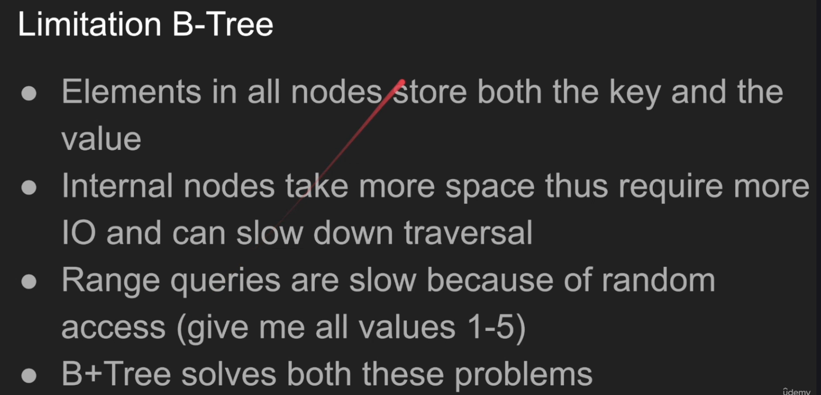

Okay. What's the limitations of B-trees? B-trees are not perfect and that's why they was a variation was created to solve these limitations. So. Well, the first problem is elements and all nodes store both the keys and the values. Right. And because we store the key and the value in every single node, then you can only store so many elements. Because let's go back here and see here's why. If I'm reading this node right. From reading this note or this page because they are effectively the same thing in a database, then you're going to put pull keys for and eight and their corresponding values. So if you're searching for the key one you really just use the key. You didn't use the values so you wasted precious memory space. That you didn't really use if you think about it. So alternatively. I can. If I'm storing the values in the page in the node, then these values are not just this is this. This could be up to 64 bit. So or some people store goods. So think twice when you create an index on a on a Uuid or a string because that puppy exists right here. Right. Like if you create, for example, a primary key right on a string field, then this string values are stored on everyone B plus three. Store them on a lifter. Which are we going to discuss? But but they are stored. And when they are stored, they take more space. More space means I can fit less elements. In a page or in a note. And if I felt this element, I mean, I need to read more. Right? Because I need to. I need to put more nodes. More nodes mean more pages. More pages means more IO. More IO means slow. So that's the trickier elements in all nodes. So both key and well. So they take more space, thus require more IO and can slow down the traversal. Right. So that's the trick here. So we might say say well what else. If we don't store the value you need to store the value at some point. Right. Well we're we're going to talk about that. Another limitation of the B-tree is range. Queries are slow because of the random access. Right. Because you're jumping back and forth if you can if you if you if you ask, you give me all the values between 1 and 5. And I'm going to show you an example in a minute. Then we're going to jump all over the place to find one, and then find two and find three and find four, and then five. Five. Right. I have to do five different traversals to find these values. Not necessarily. It might be a little bit less if you were lucky, but that's that's what I need to go. It's almost random, right? Despite them being very tight tucked next to each other, the the keys. Right. Give me all the should be keys, not values. But you get my point. I'm searching for these values, these keys effectively. Right. But B+ tree solved both these problems. Another problem with this is like, uh, it's hard to fit internal nodes in memory when you have all these values right in, in, in each element because you have all these values, then, uh, I can't really fit stuff in memory, especially like, I don't know if I have like a primary key on a, on a Uuid field or on a string field, right. Then it becomes very expensive to store this index or this B-tree in memory because it costs a lot right to traverse. Let's take an example of why B-trees can be bad for range queries. So I'm going to now find all the rows ID between 4 and 9 in this in this particular B-tree. So I'm looking for four and nine. I'm, I want I want to pull all these rows so I can look up Pete, Edmund, Ian, Edmund, Sarah. And so what I'm going to do is, okay, let's search number four. Oh, we're lucky we found number four. Okay. Let's find let's find number five. Where is five? Well, five is between 4 and 8. So we jump to this data pointer a child pointer and find to this page page pointer and get this six or well five is actually less than six. So let's jump another io. So one io two three io. We found five okay. Let's find let's go ahead and find a six. Well six. We just actually read it in a minute ago. So it's in memory hot right. Unless we had to throw it back into the disk for, uh, for LRU reasons. Least recently used cache. Like if we throw it back, but it's there. Okay, we found six. So how about seven? Go and find seven. We found it. All right. How about eight? Uh, eight is. Oh, there you go. It's up on the road. How about nine? Nine is in this side. Go here. We read this page and then go on. And then to the left this is nine. And then we find the value of nine. So look at how what how what we have done to find this. And you might look at this and say it's not that bad, but we thrashed the index to look for these five values. Despite them technically being next to each other. They are sorted. They are next to each other. Right. And that's another thing that the B+ trees solved. Another thing B+ tree solve is like it tries not to put values in these kind of hot searches. It tries to to make this as slim as possible, to search and pushes all this, all the data to the leaves, as we can see in the minute.

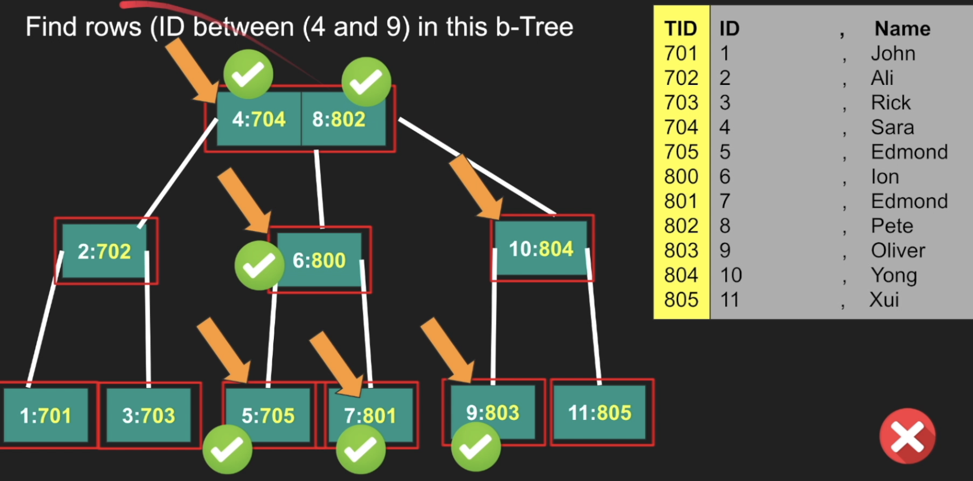

B+ Tree:

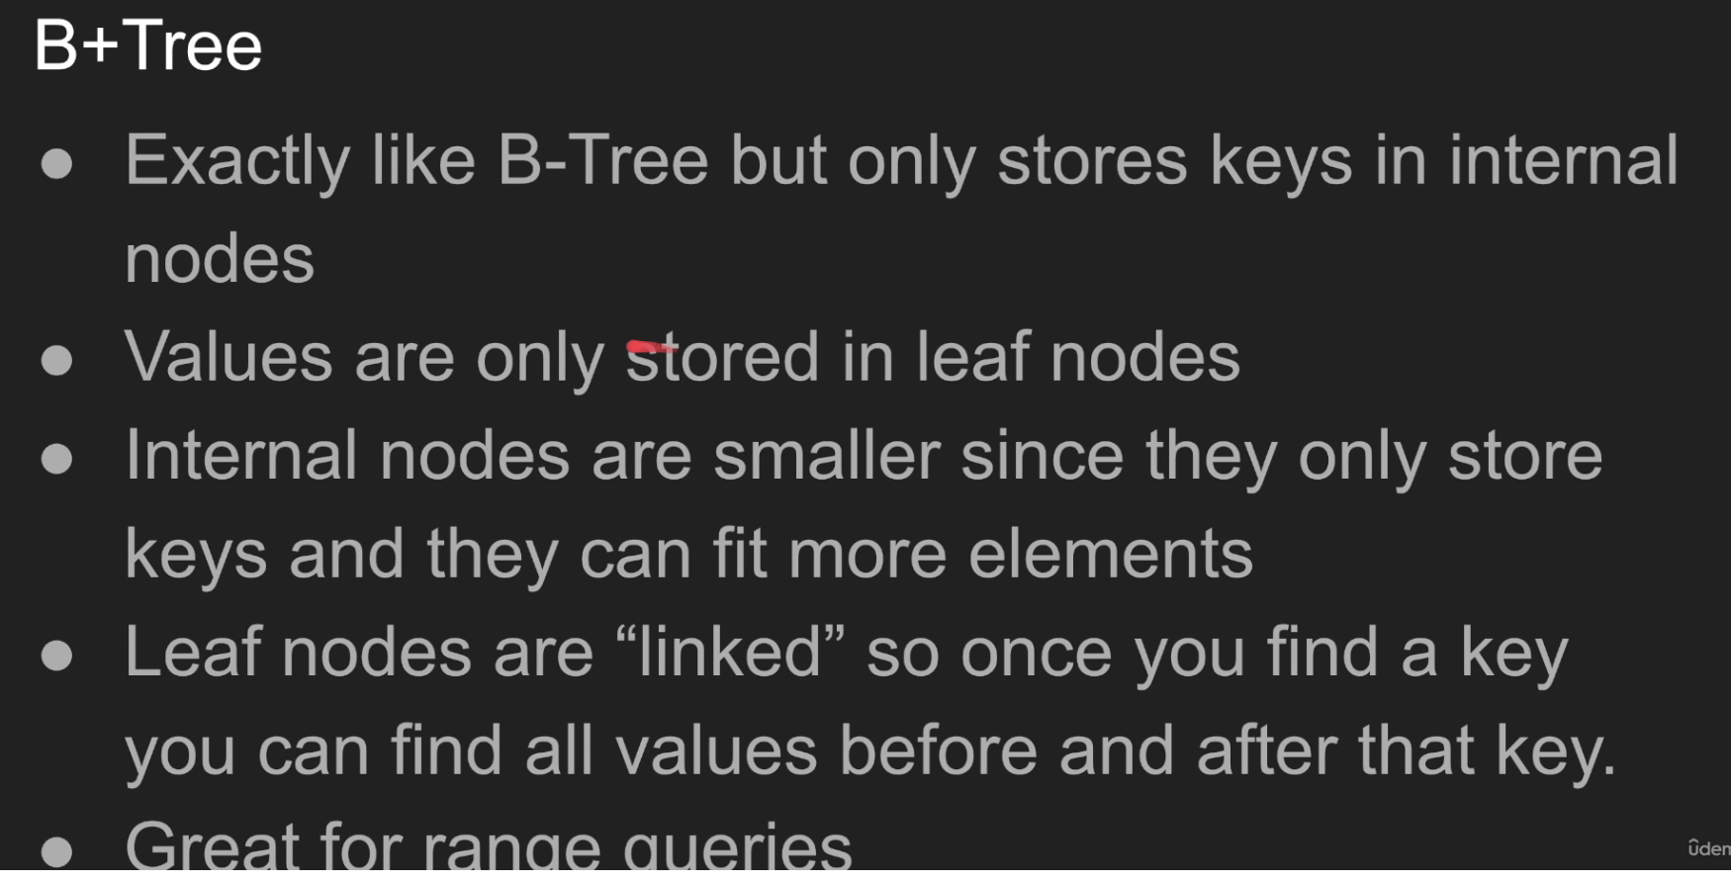

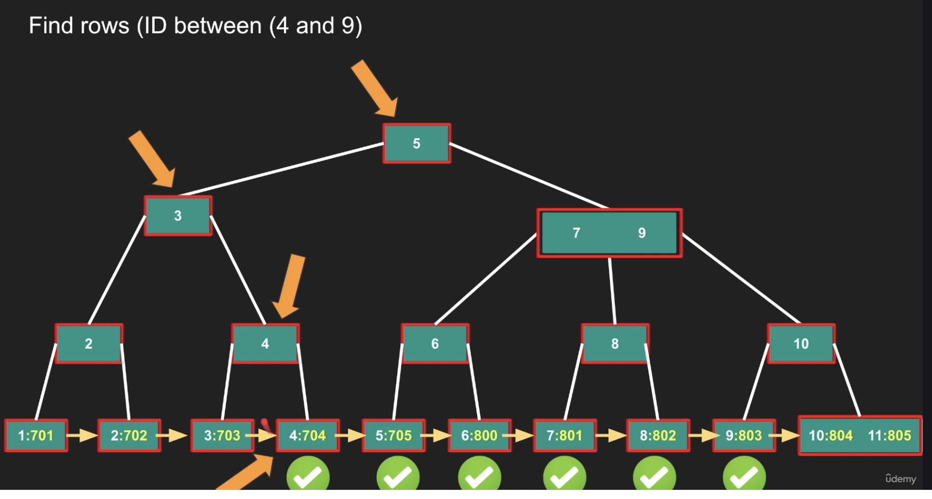

So B plus threes. It's exactly like B three, but only stores the keys in internal nodes and obviously the root as well right. For some reason I think internal nodes also kind of include the root. I believe there is there is a little bit of a nuance of difference, but who cares. It's the same thing right? Uh, if we think about this, values are only stored in leaf nodes. Very critical here. So now these internal nodes and the root node are slim, which means I can fit more keys in my nodes. Right. Because I don't need this stinking data pages and values anymore. I just need to store my beautiful keys. Right? So 1IO to fetch one node, right? Which is one single page will give me way more elements, way more keys than it would have gave me if it was a simple B-tree, because I had to burden, I have the burden of the actual, plus the values and the data pointer, which most of them will be tossed unfortunately, during this traversal. So internal nodes are smaller since they only store keys and and they can fit more elements as I as I discussed. Here's another important things. But not not all databases actually implement this, but it's very interesting. Leaf nodes are linked. That's what help range queries by the way. They are linked each. So because all the values are stored in the leaf nodes they are also linked. Each one points to the next leaf node, each one points to the next leaf node, and so on. So once you find a key, you just found everything after it and everything before it. That helps range queries so much. Great for it's great for range queries. Here is a B-tree of a degree three. So look at that. So you can see now we only storing the key truly just the keys here. Right. And the page pointers right. Which is these white arrows. So here's the value of five. To the left is three, to the right is anything greater than five, which is a beautiful node which has a value of seven and nine. Right. Seven to the left is six, to the right is ten. In between there is eight and so on. So you can see that the values the keys are kind of duped. They are duplicated. And we have to do it because the leaf nodes should have everything we need. We need everything in the leafs including the values. So there are duplicates all the time. Not all of them are duplicated, right? Like 11 is not up here, right? But some of them are and that's okay. So that's a cost that have been proven to be very minimum. Right. To the to the, to the, to the value we get out of this structure. So now look at this. If I find value one, if I find the key one I can find the value. And there is a nice leaf pointer that pointing me to the next sorted key directly. So you can just jump directly to the next one and the next one. And when you look at this, this looks really terrible in a database perspective, because a single node is a single page, right? As we discussed and in a single page we have one element only. That's a complete waste. Our pages in actual database speak or large. So you're going to see so many things here, not just one element. This is a terrible example, but I can't draw a B-tree of a degree, I don't know, 1024. It's very, very hard to draw, right. It's just doesn't fit here. But think of this. This have a lot of elements. And as a result, one read gives you one a lot of elements and their values. And also you get a pointer to the next one, which has a rich set of other elements that are next to each other. Let's take an example. Find rows. Same example that we did for the B-tree, but this is for the B+ tree. Find all the rows between 4 and 9. So okay, let's find four. We start for four. Just start for 111 of them okay. For I'm going to read this row 1I0 right okay. Four is less than five. So I'm going to take this I just eliminated half the tree. More than that really I can find three okay. Three is four is greater than three. So I'm going to take this then okay. Here is four right. But really this is still an internal node. So I have to take four is equal to four. So I also go to the right. That's one of the condition I forgot to mention. If it's greater or equal go to the right then we just reached here four. But guess what. You find four. You find five. You find six. You can seven and eight and nine. And if you're lucky, all of this is just a single I o right. Because this is just five elements. Even if it's like most of the time, like four, 400 or 500 can fit in a single page. It really depends on the data pointer. What is this type? If it's a short integer like I don't know, four bytes, right? Then it can fit. You can fit a lot of elements there. If it's a good or a Uuid or a string or a blob, I don't know why would you index a blob, but that would be really terrible. You can't fit much stuff there.

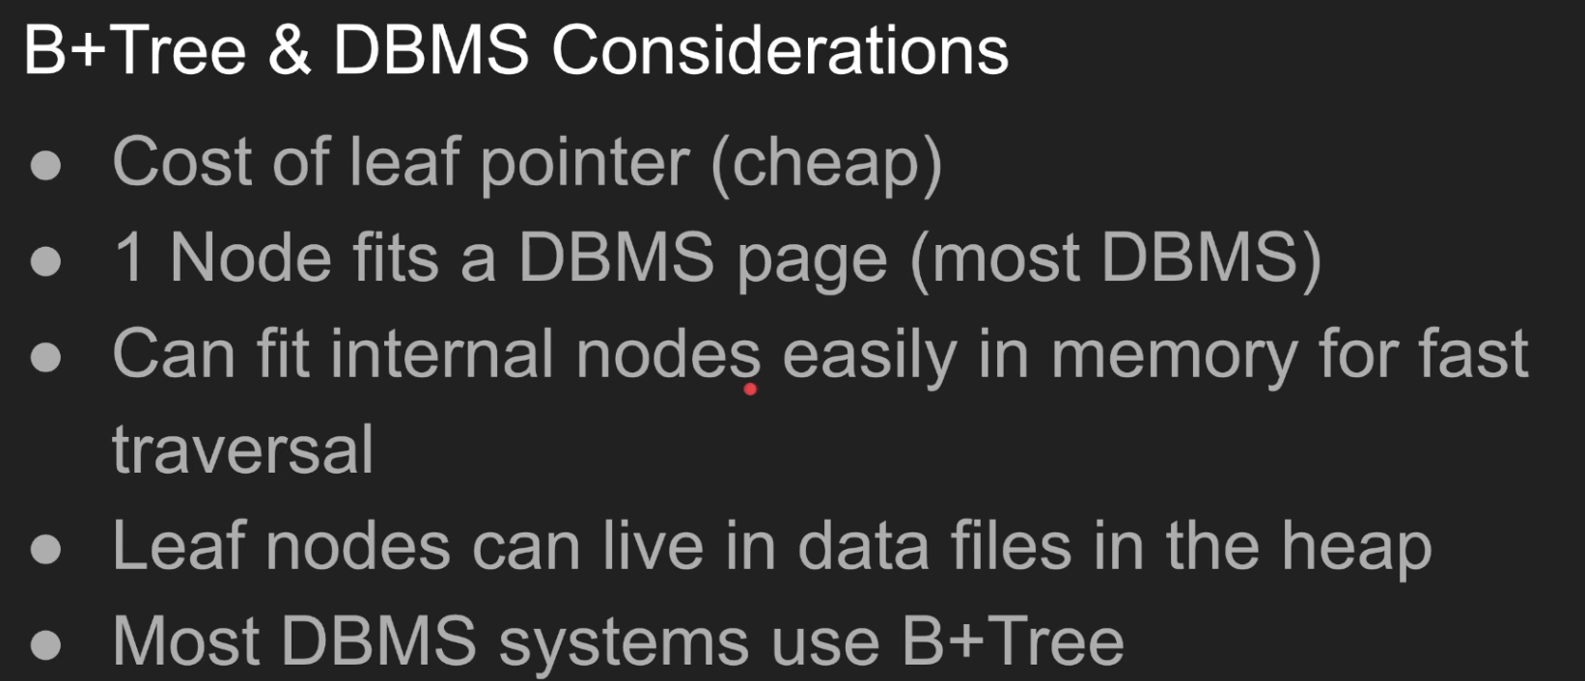

Partitioning:

Partitioning in PostgreSQL is a powerful feature used to **divide a large table into smaller, more manageable pieces**, called **partitions**, to improve **performance**, **manageability**, and **scalability**.

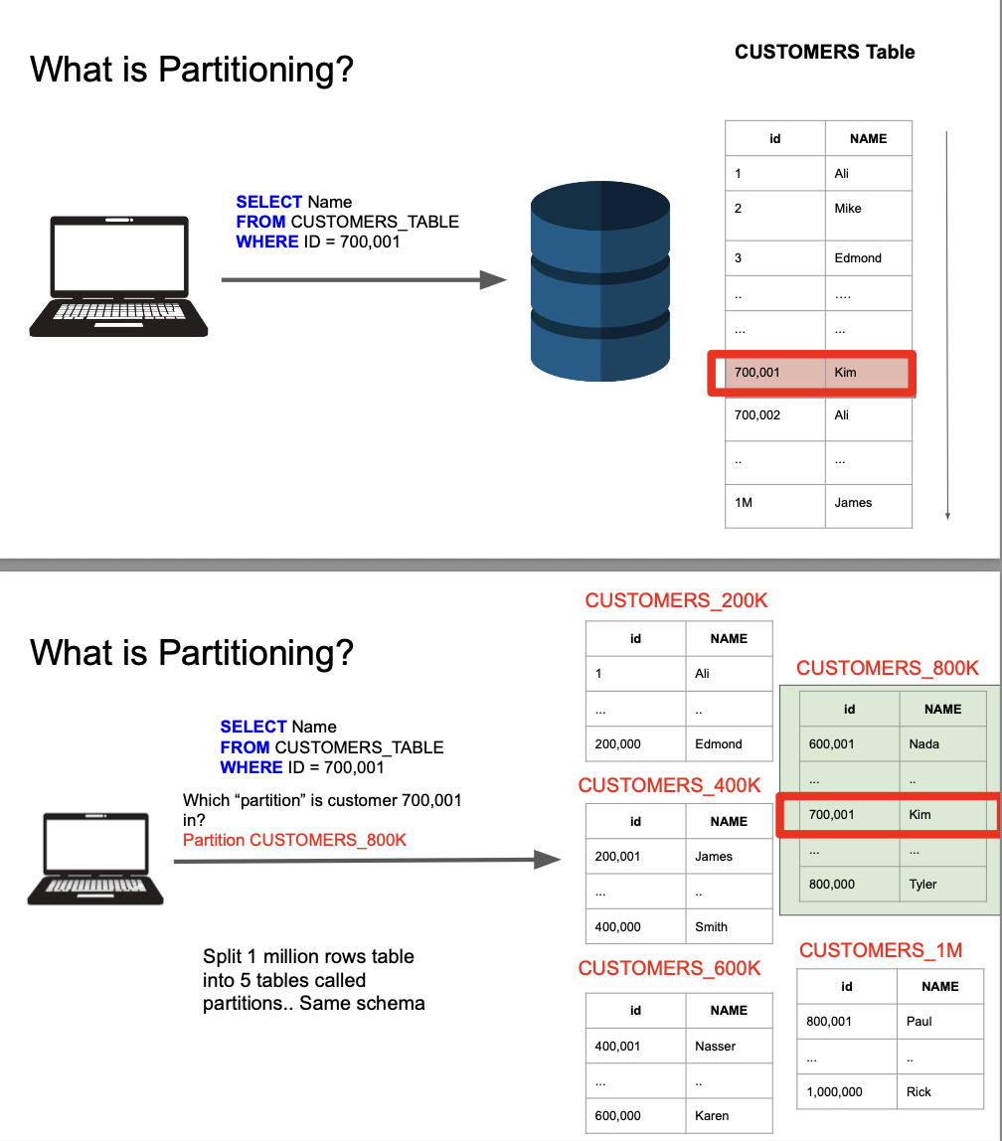

So let's say we have a beautiful customer table here. This is like, I don't know, 1 million row of data. 1 million is not that big, guys, by the way. But if I want to pick the name of a customer with this particular ID 701. Right. So you're going to do select name from customer tables where ID equals 700,001. So what the database will do is, well, if you have an index on the on that table, we're going to use the index and then we're going to land on that particular row on the disk. Right. Or if we don't have it, we're going to do a sequential scan, which is the worst thing we can do. But we have to scan all these rows until we find the rows we we're looking for, regardless whether you're using an index or sequential scan scanning 100 a million row is a lot, right? And multiply that by 10 or 1000 billion rows, that's going to slow things down. Index Large tables are always slow to query regardless. Right? So what do we do? Partitioning is the idea here is break the table down into smaller pieces so we know we all only work with so many rows instead of larger set of rows. So that's the one idea. Let's break out this 1 million rows into five partitions, five tables, partitions are nothing but a table and we're going to name them customers. 200 K customers, 400 K customers, 600 K customers, 800 K and customers, one 1 million. So that means basically these are the customers between 1 and 200. These are the customers between 201 and 400 customers, between 401 and 600 and so on. You get the idea, right? So that's just how we partitioned it. And then the database magically you're going to attach this partition to the to the to the main table, which is customers table. So customers table is just almost like a parent or inheritance. It doesn't have any data. That actual data exists on this table. So now what I do is I'm going to do the same exact query select name from customers table where ID equals 701. And the first question is I'm going to send that query What do we do? Where does this ID exist? And that's a very quick check by the database. It's like 701. Which table should I query? This, this, this, this or this? It's very easy because which partition is Customer 701. We have the definitions in this partition. There is metadata attached with it where oh 700 is between 800 and 1 million, which is, which is I mean 608 hundred. So that's exactly the table we need to query. So partition customers 800 K, we hit that table immediately. So now I'm working only with 200,000 rows, which is beautiful. I always say I tweet that the other day the the quickest way to query a table with a billion rows is to avoid querying a table with a billion rows. And that's what the database do. They just try to as much as possible to avoid querying this much data and work with smaller set of data. That's the trick here. All right. So now once I have this, if I have an index even better, right, I'm going to use the index and then land on customer 700,001, which is. Kim in this case.

Horizontal vs Vertical Partitioning:

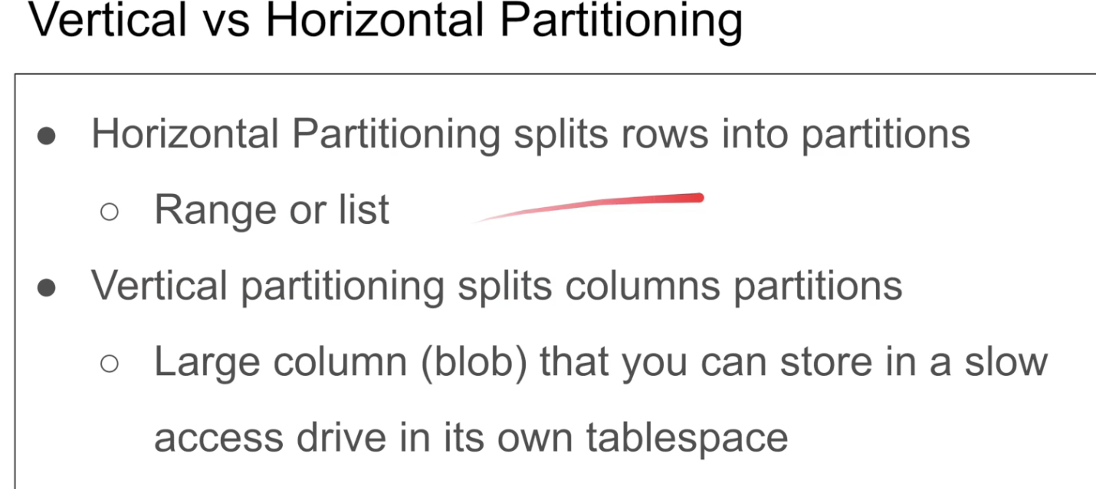

Suppose If I have blob column and I don’t query much then in that case vertical partitioning is used

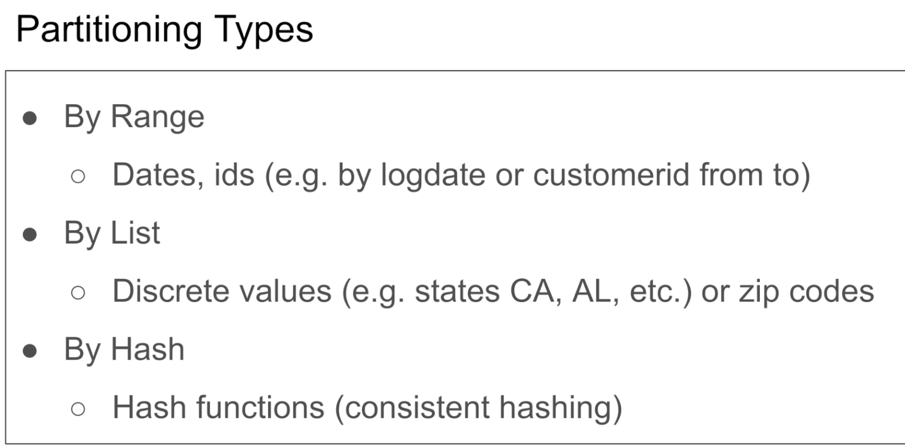

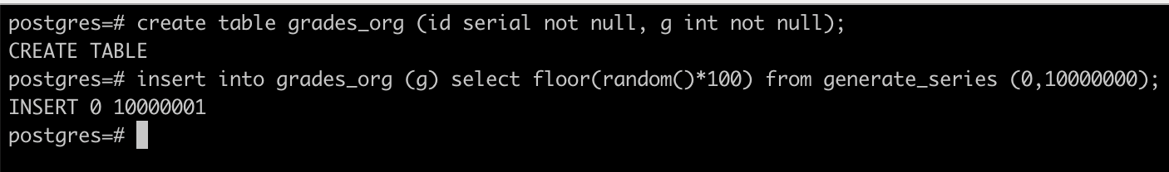



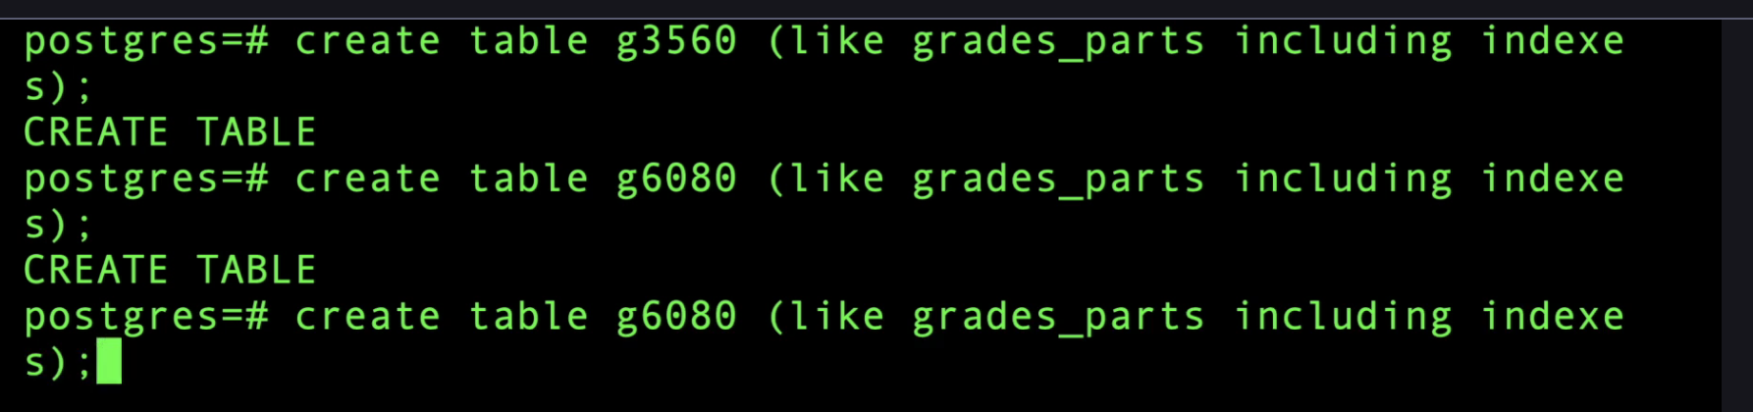



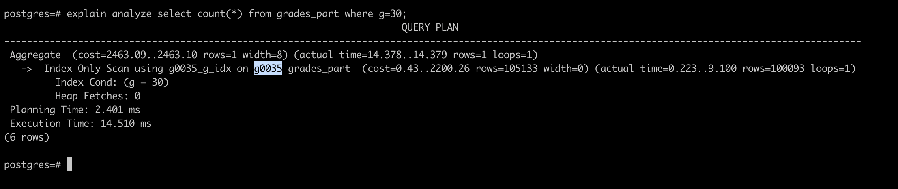

Need to make sure enable_partition_pruning is on

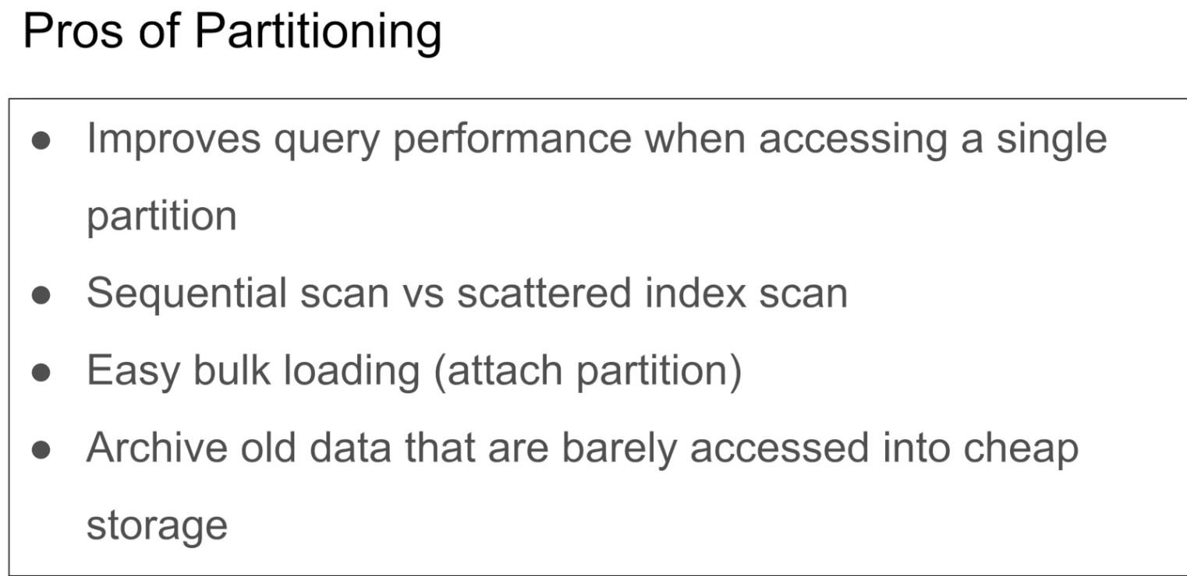

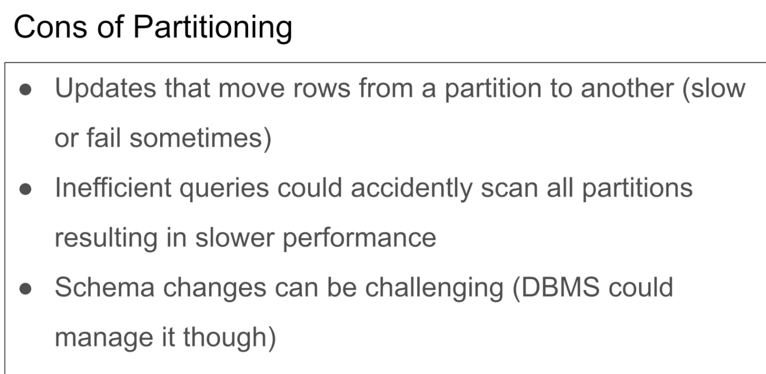

Multicolumn partitioning  
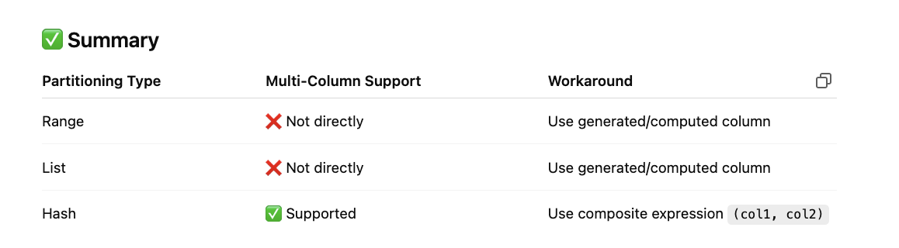

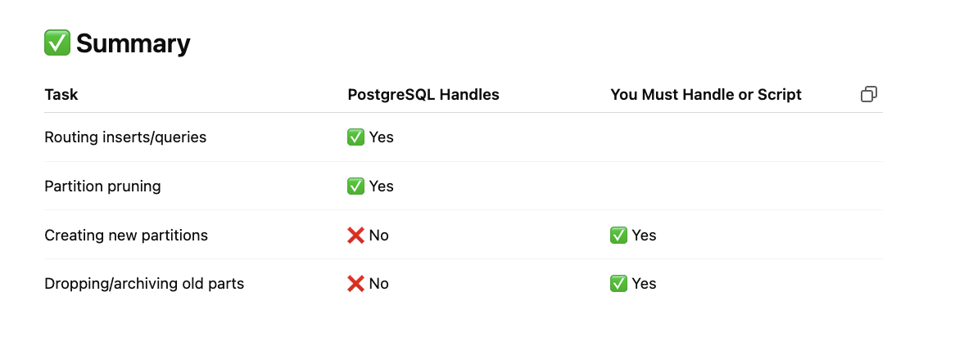

Shrading:

Sharding is a process of segmenting the data into partitions that are spread on multiple database instances. This is essentially to speed up, query and scale the system.

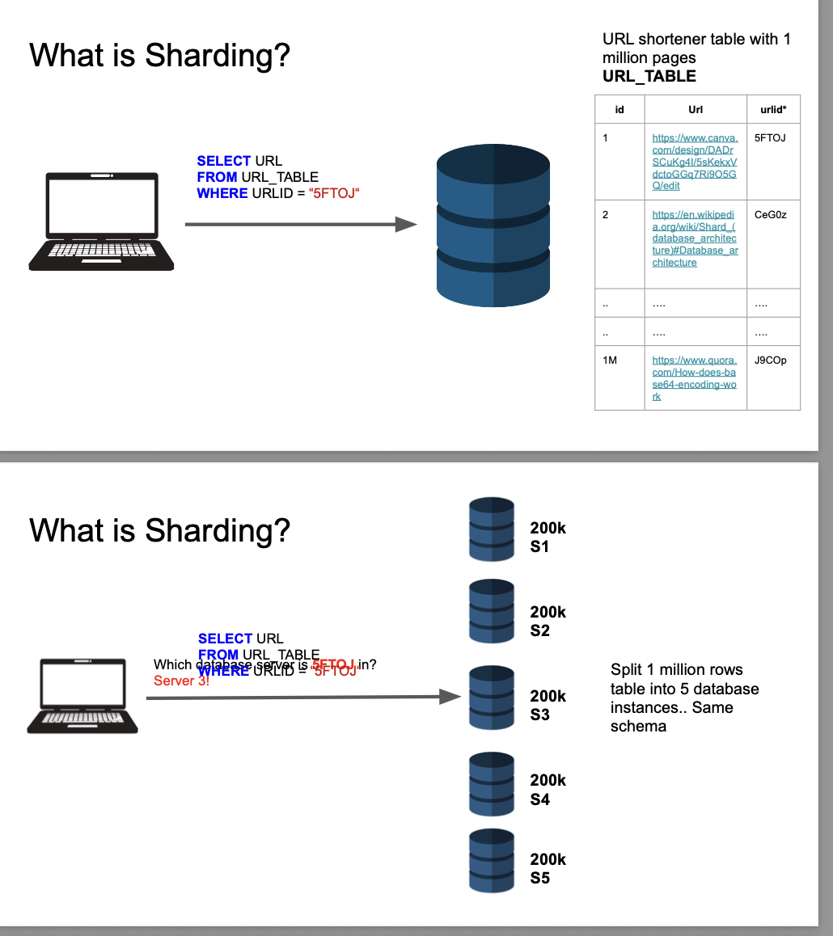

**Sharding in PostgreSQL** refers to distributing data across **multiple servers or database instances** so that each handles a portion ("shard") of the total dataset. This allows PostgreSQL to **scale horizontally**—useful when a single server can’t handle the volume of data or traffic.

**🧩 How Sharding Works in PostgreSQL**

Sharding divides your data based on a **shard key**, such as customer_id, region, or a hash of an ID. Each shard stores a portion of the data and can be queried independently or as part of a coordinated query.

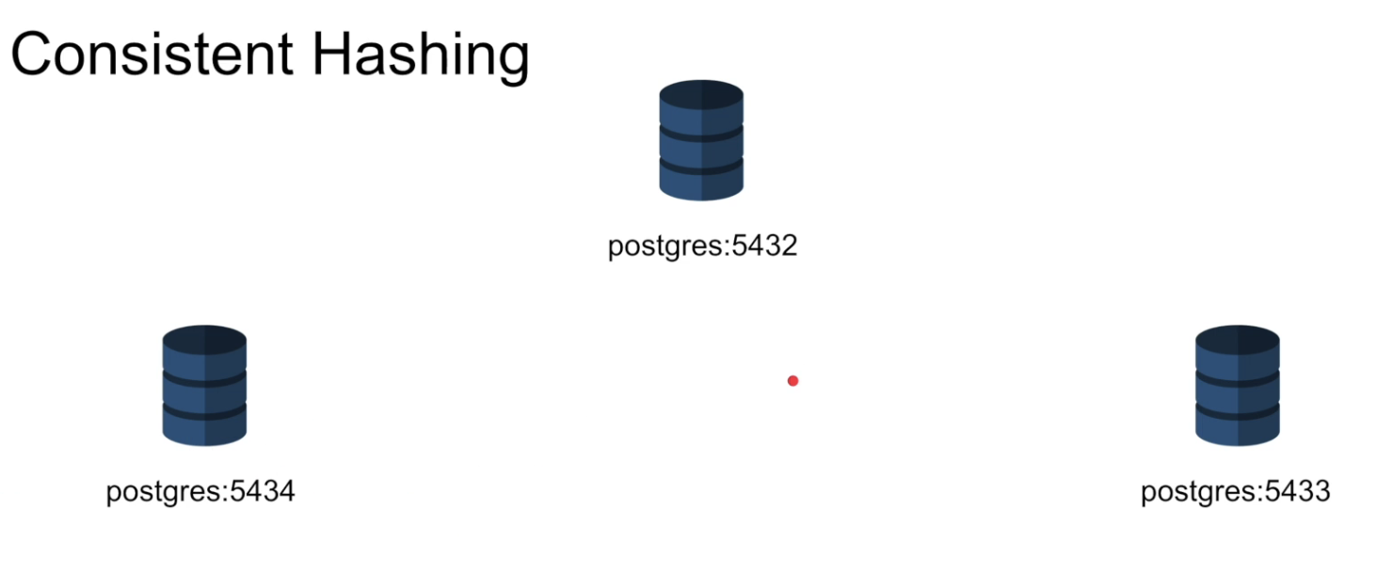

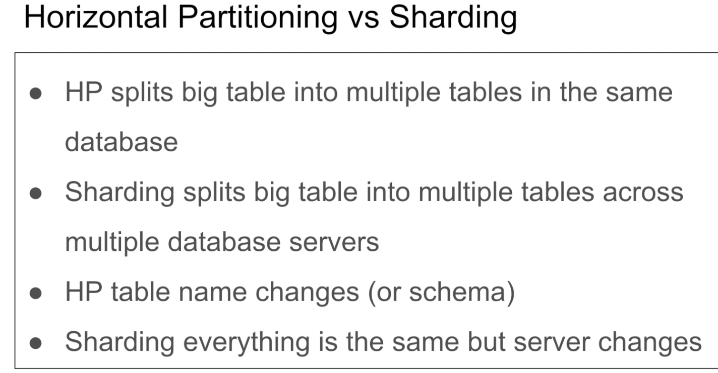

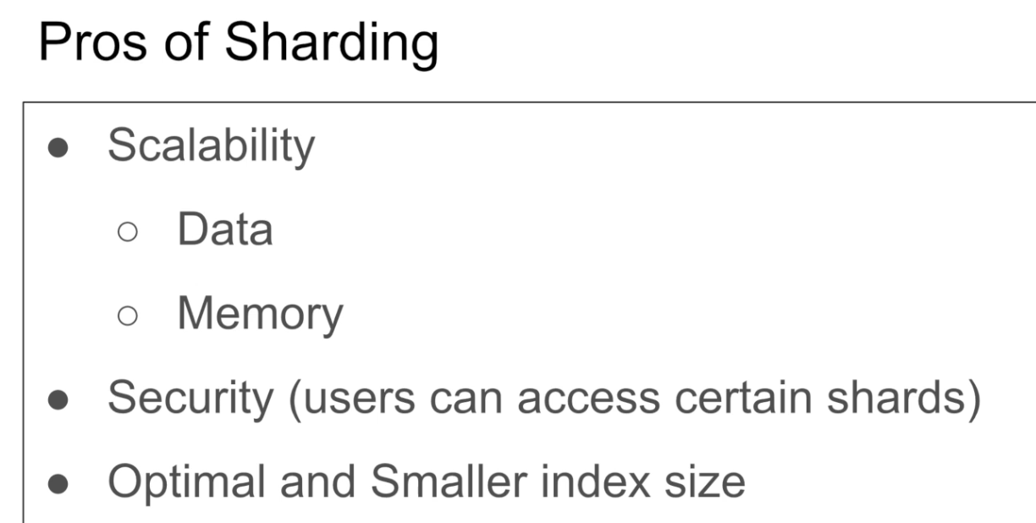

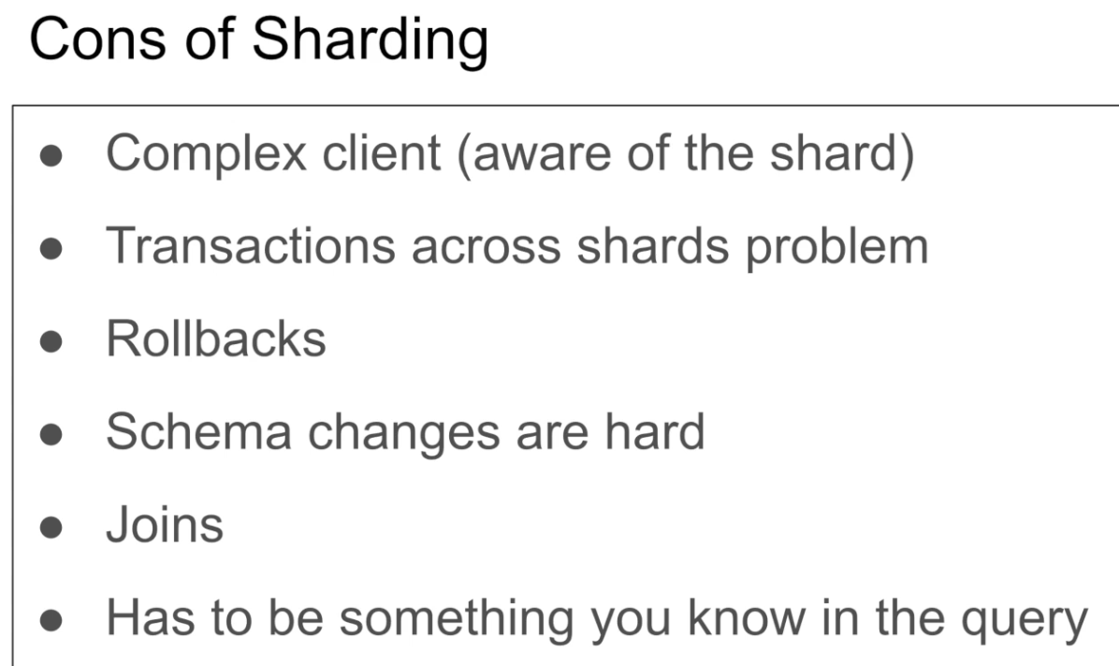

Exclusive Lock:

So think of an exclusive lock as following. I wanted to read a piece of data in my database. Think of it like a column or a row. But I want to make sure that when I read this value or when I want to update this value, nobody is connected and nobody is attempting to read this value for security reason, for consistency reasons. You know, I want to acquire an exclusive privileges on this value, on this column, on this row, so that if anybody tried to read that value, they'll get an error. So you know what? So that's that's the idea of an exclusive lock. So I, I will be the only one essentially as a connection.

Shared Lock:

The shared lock, on the other hand, is actually the opposite of that is when I want to read a value from the database. When I read a certain value, I want to make sure that nobody changes that. So if I am reading my balance in a bank, right, I want to make sure I'm doing reporting, I'm doing a huge query. I want to acquire a shared look and says, Hey, database, please, I'm acquiring a shared lock on this row. So if anybody is trying to edit that value, just make them fail.

So exclusive lock General, I want to obtain a lock on a value so I am the only one who will allow to edit it. Shared lock. I want to acquire a shared lock on or a read lock on a value so it doesn't change. So another thing I want to explain before we're going to do the example is when I try to obtain an exclusive lock, there must not be any shared lock acquired on that value.

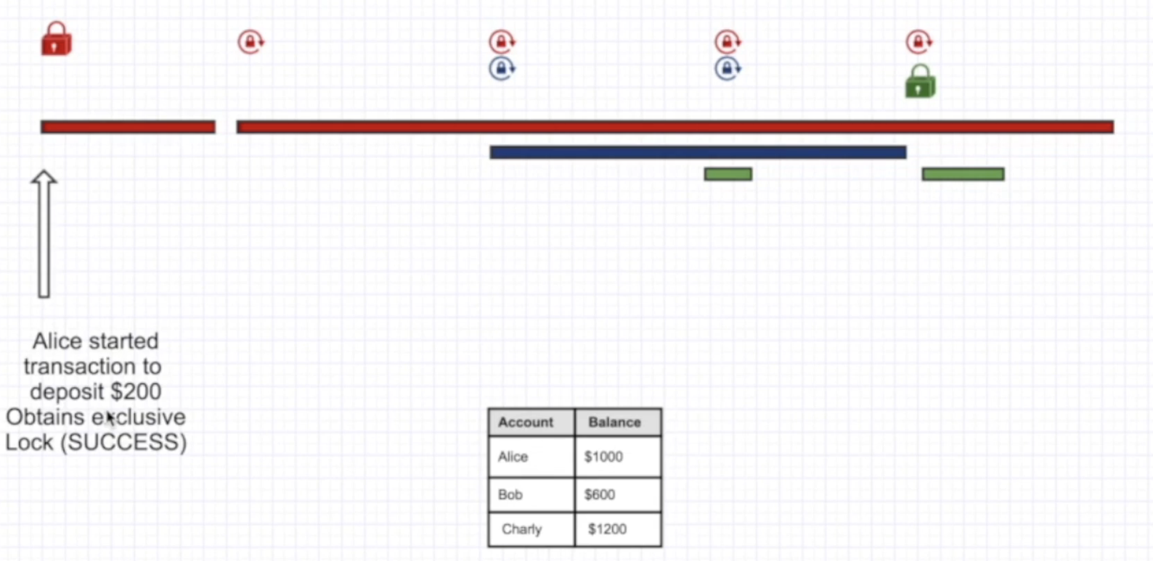

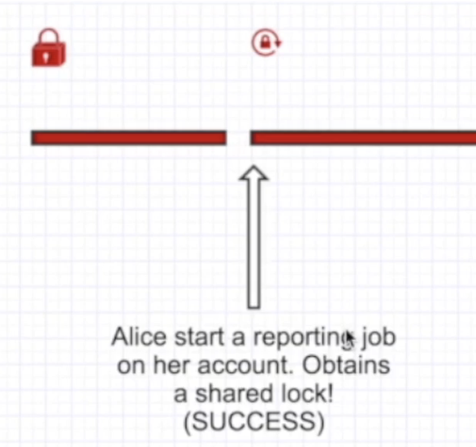 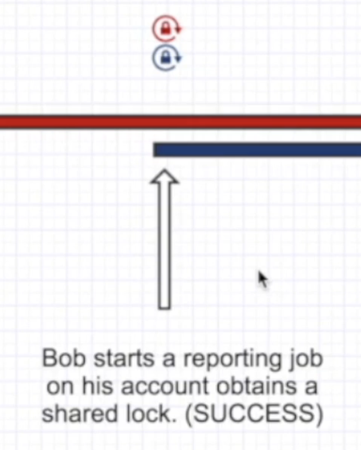

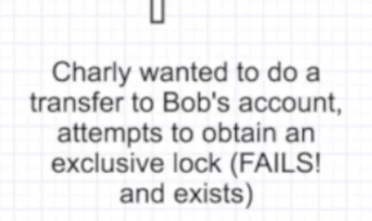 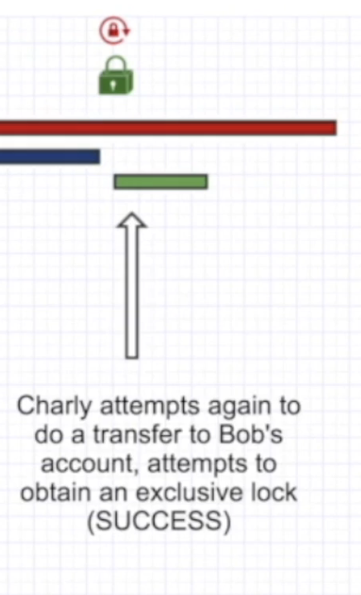

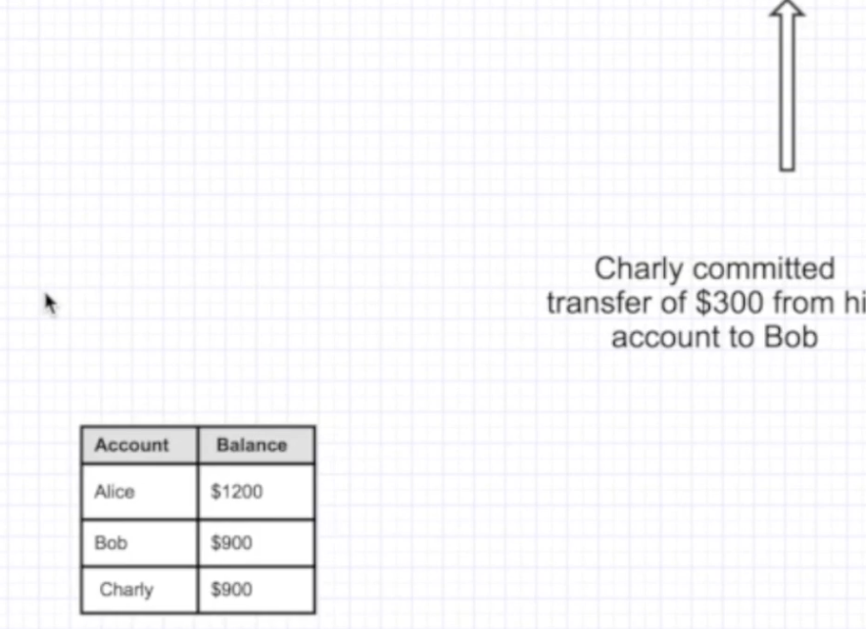

Does that make sense? So they are linked actually together. And the opposite. If I want to obtain a shared lock, there must not be any exclusive lock obtained. So these two are exactly the opposite of each other. So you can have, as let's say, for example, I have like seven shared lock on on the balance, on a certain value, that means nobody can acquire an exclusive lock on that value. So nobody can edit it as a sense, you know. So that's the idea. Read or write lock. That makes sense. Let's jump to an example, guys. All right. So here I have three people Alice, Bob and Charlie. Alice is red, Bob is blue, Charlie is green. And we're going to start This is the timeline from left to right. And then we're going to start with Alice started the transaction trying to deposit a $200 on her account, right? So in order to do that, she needs obviously to do an update statement. Right? To do that, you need to acquire an exclusive lock. And guess what? She's the only one since she's that she's the only one that is connected right now. So she she will basically acquire tries to acquire an exclusive lock and guess what? It succeeds because nobody else acquired any shared lock. So they're good. You know, it's just like move, move on And and she acquired the exclusive lock. Now she is guaranteeing that hey I'm on about edited and that's good. That's good because I don't want people reading bad value right. Because I'm about to update this balance. So don't ever try to read my balance right now because it's going to change if you read. Then make decisions based on that. It's going to be bad. All right. So you're going to acquire that and then say, okay, I'm going to depose it. So the next transaction is essentially transaction going to come in and then you're going to increase her balance by 200. Very, very quick and then commit the transaction and then her transaction finished, you know, just that short period of time. And then she turned around Alice and then starts another long running transaction. Look at that. It's a long transaction. Looks like it's a job reporting job on her balance. She's doing reading. She's just doing reading operations. So a read operation is acquiring shared log. So what she says here is, Hey guys, I am going to acquire a shared lock on my balance account, so don't try to change it. Please don't try to mess with it. Don't try to update it because you can't. Because I just acquired a shared lock so nobody can acquire an exclusive lock on her account now because she just had a shared lock there. Okay, Make sense. So, okay, she she's doing her thing reading all these tables and doing the reporting. So very long transaction when Bob started at another reporting job on his account. So that's a completely different thing, right? So they acquired a shared lock. Bob acquired a shared lock on his account. So on this value, while while Alice acquired a Sherlock Sherlock on this value makes sense. All right. So that's succeeded. We have a lock for Bob. We have a shared lock for Alice, and then we're continuing. So something is going to happen here. What is the green thing? What is going on? Charlie? Charlie, what are you going to do? Charlie wants to do a transfer to Bob's account. Bob, It's your lucky day, dude. Bob's account attempt to obtain an exclusive lock but fails. Why? Because he wants to do a transfer right from his account of a $300. I didn't write it there, but trying to do a $300 a transfer from Charlie's account from his account to Bob's account. So in order to do that, he needs to acquire the exclusive lock. So is anyone. I want to update that. Guys, I don't want you to change that. So but we try to acquire an exclusive lock on Bob's account and he says, Oh, fails. Why? Because Bob has already acquired a shared lock. He's doing something. He's doing his thing. Bob is doing his job. He's reading all these tables, he's doing the thing. So he asked us to to to create a shared lock so nobody changes his account. So guess what? Charlie just failed his transaction. He cannot do that. And that's actually good. We don't want people editing while other people are reading. It's just so that's is dangerous, especially with banking systems. So guess what? After a while, Bob completes his transaction, his job, his reading job, and he says, You know what? I'm done. So he releases that shared lock so he's no longer acquiring shared lock. Afterwards, Charlie attempts again to acquire exclusive love, and this time he succeeds. He says, okay, I'm going to since I just succeeded, let me quickly go ahead and acquire the exclusive lock and then commit the 300 bucks from Charlie's account to Bob. Right. So that's a general the differences between exclusive lock and shared lock. And there's another example that I didn't mention here is that while while there is an exclusive lock, nobody can read. So. You can you can think of this that let's jump to the disadvantages and advantages of all this thing is shared lock and exclusive lock was introduced to to ensure consistency in the system as you can see. Right. I want to be consistent. When I read this value, I wanted this value to always be the same. That's a shared lock exclusive. When I want to attempt, when I want to write something, I want no body to be connected, right? So next time they connect, they read the latest value and exclusive lock and shared lock. In general, they are very useful to obtain consistency, especially with banking first. And the second thing is with configurations. If like you have a central configuration system and you're it's a critical configuration system obviously, and you're making changes to it, you don't want others reading stale configuration. You want people to you want to kick people out from the connection from the database and only let them read when you are done editing essentially. Right? So, so this, this way all the clients will always read the latest and greatest configuration value. So that's one of the benefits disadvantages of that. Obviously concurrency suffers as a result. You can see like people. There are chances where you get failures, obviously all the time, especially in banking system. You can see if you go to Bank of America, sometimes you can see those grayed out. You can do any transactions at night sometimes like at midnight, because they're doing their job reporting and they're doing all this shared logs. So you can't really obtain exclusive lock at that time. But there are times that you cannot do your transactions. The concurrency cannot be achieved because of these locks, but in the same time they are very critical to ensure consistency. All right, guys, this is in a nutshell, exclusive lock versus shared lock. I'm going to see you in the next one. Have a good day.

Deadlock:

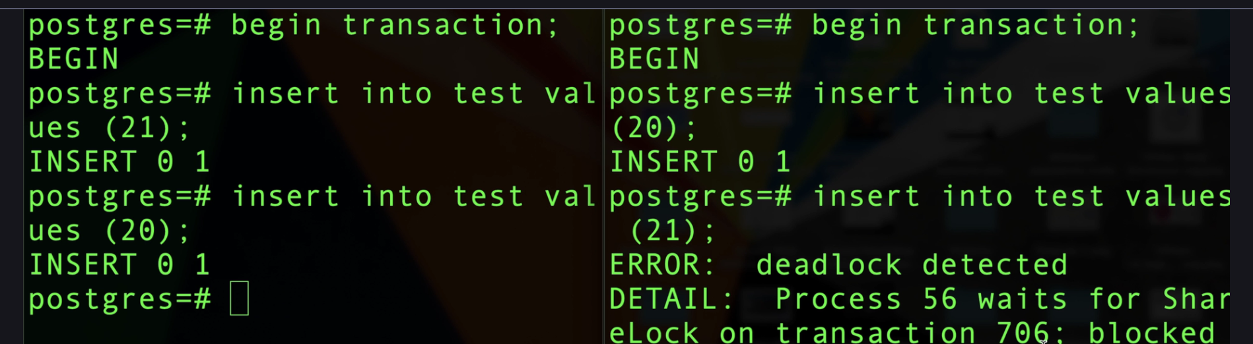

DB’s mostly handle deadlock efficiently

A **deadlock in PostgreSQL** (or any database) occurs when **two or more transactions block each other indefinitely** because each one holds a lock that the other needs in order to proceed.

**🔄 Simple Example of a Deadlock**

1. **Transaction A** locks **Row 1** and wants **Row 2**.
2. **Transaction B** locks **Row 2** and wants **Row 1**.

Neither can proceed because they’re **waiting on each other** — this is a **deadlock**.

Double Booking Problem:

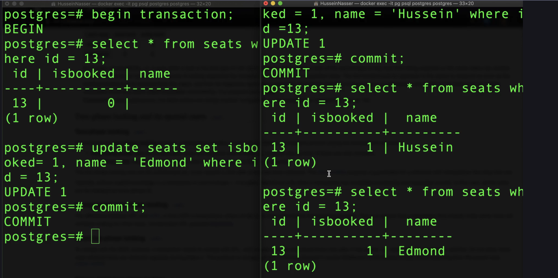

For update will lock and will not allow other transaction to happen

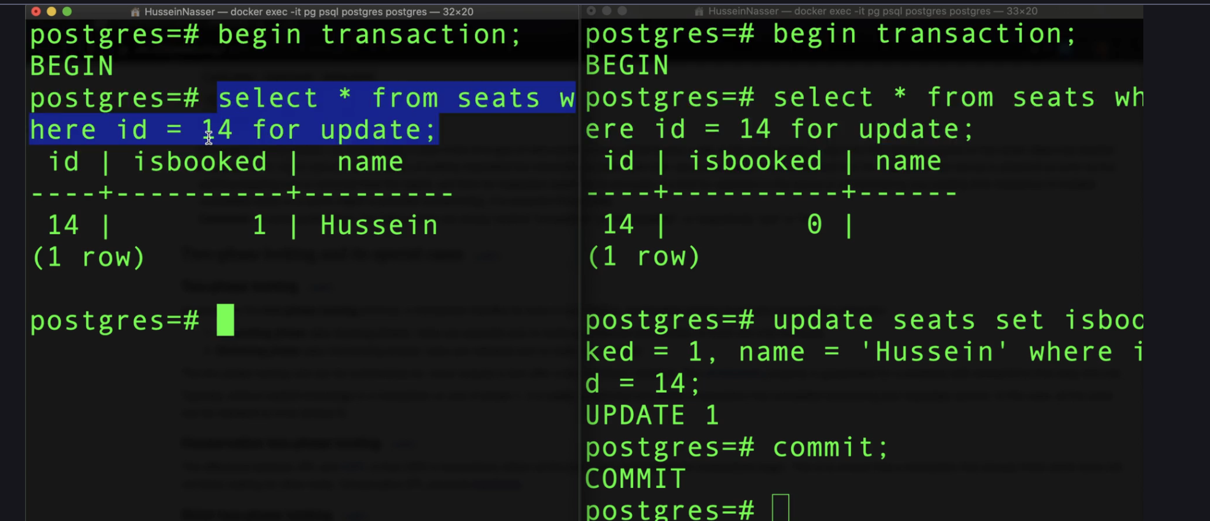

Double Booking Alternate Approach:

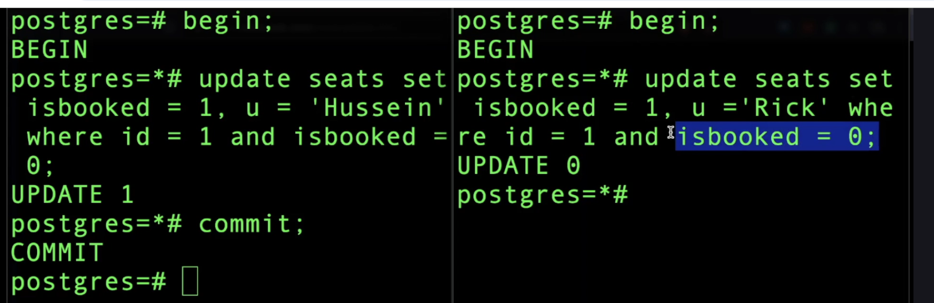

When left query execute first it lock the row and will not allow any other transaction update and once commited isbooker become 1 and there is no update on right query

Offset: Offset by design means fetch and drop the first x number of rows. Limit with offset is a costly operation as it has scan even records mentioned in offset and then discard

Connection Pooling:

Connection. Pooling is a pattern of creating a pool of available connection, usually TCP and allow multiple clients to share this pool of connections. This is useful when we have limited connection to db

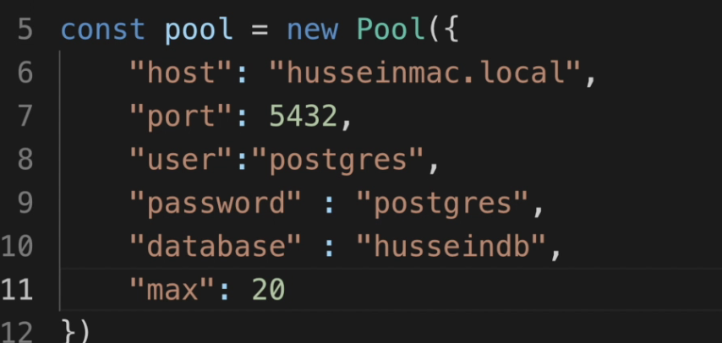

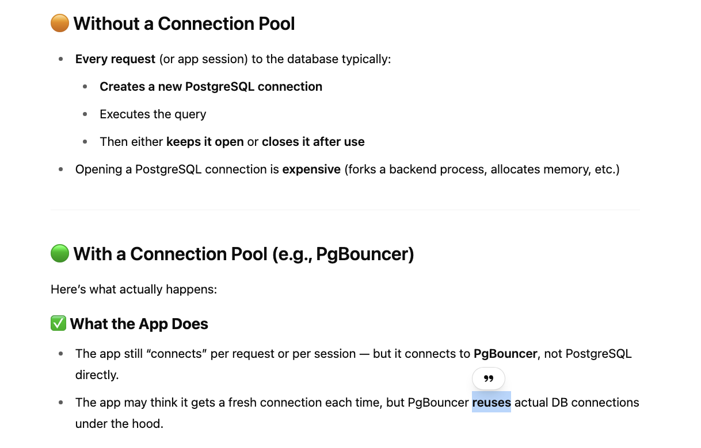

Replication:

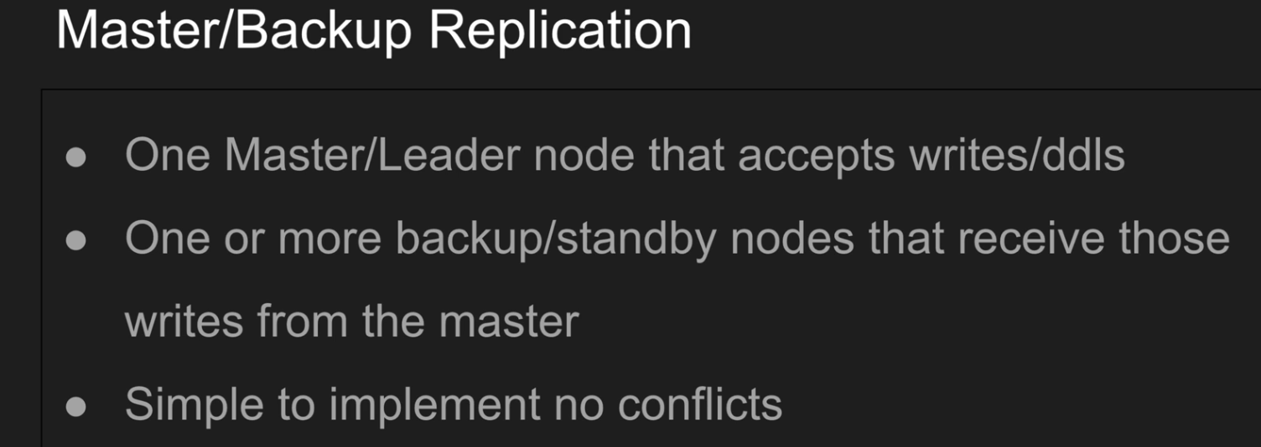

You're asking about **master-backup replication** in PostgreSQL — often referred to as **primary-standby replication**. This setup is crucial for **high availability**, **disaster recovery**, and **read scaling**.

Here’s a breakdown of what it is and how to set it up.

**🧩 What is Master-Backup (Primary-Standby) Replication?**

In PostgreSQL:

* **Primary (Master)**: The main writable database.
* **Standby (Replica / Backup)**: A read-only copy that continuously replicates changes from the primary.

Changes are sent using **WAL (Write-Ahead Log)** shipping or **streaming replication**.

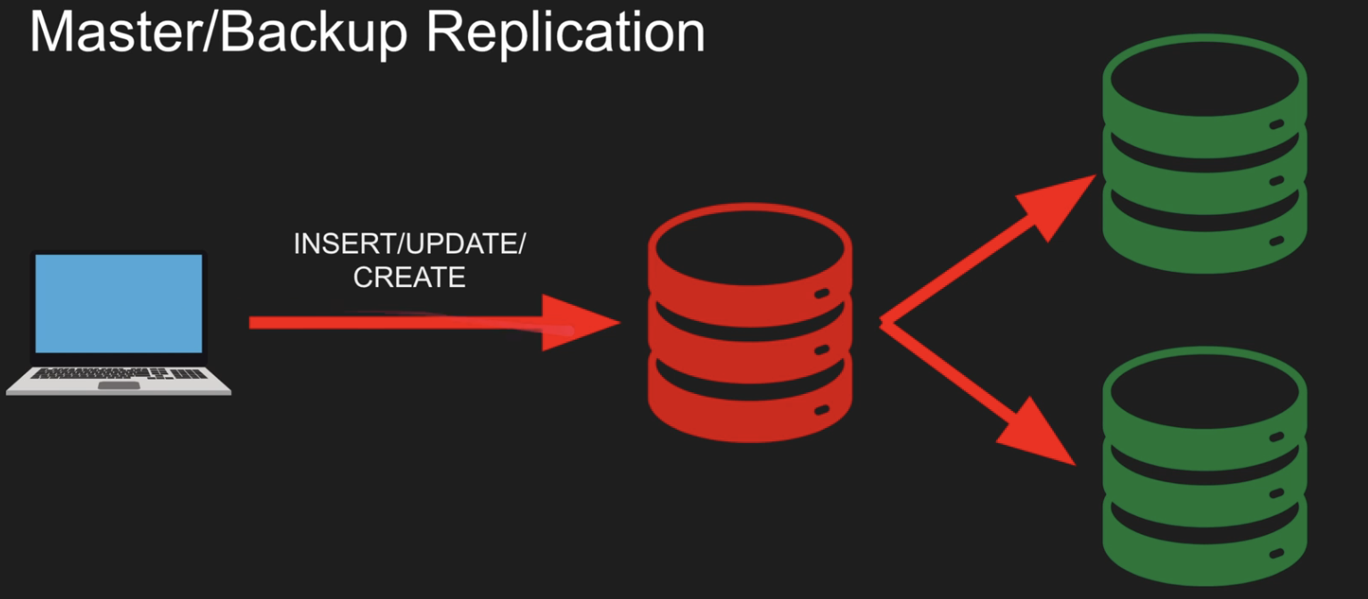

Multi-master replication:

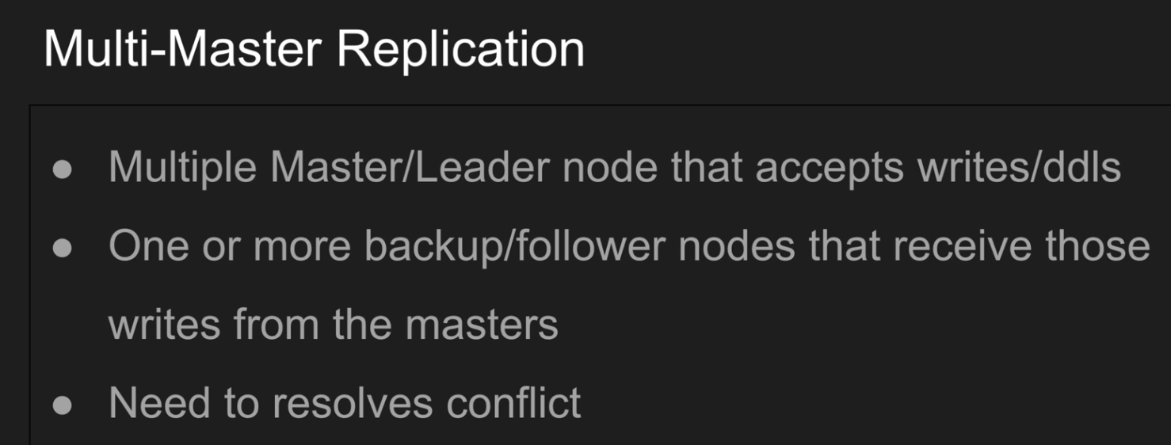

**Multi-master replication in PostgreSQL** means having **two or more nodes that can accept writes independently**, and changes are **replicated bidirectionally** among all participating nodes.

⚠️ PostgreSQL does **not support multi-master replication natively**. It requires third-party tools or extensions.

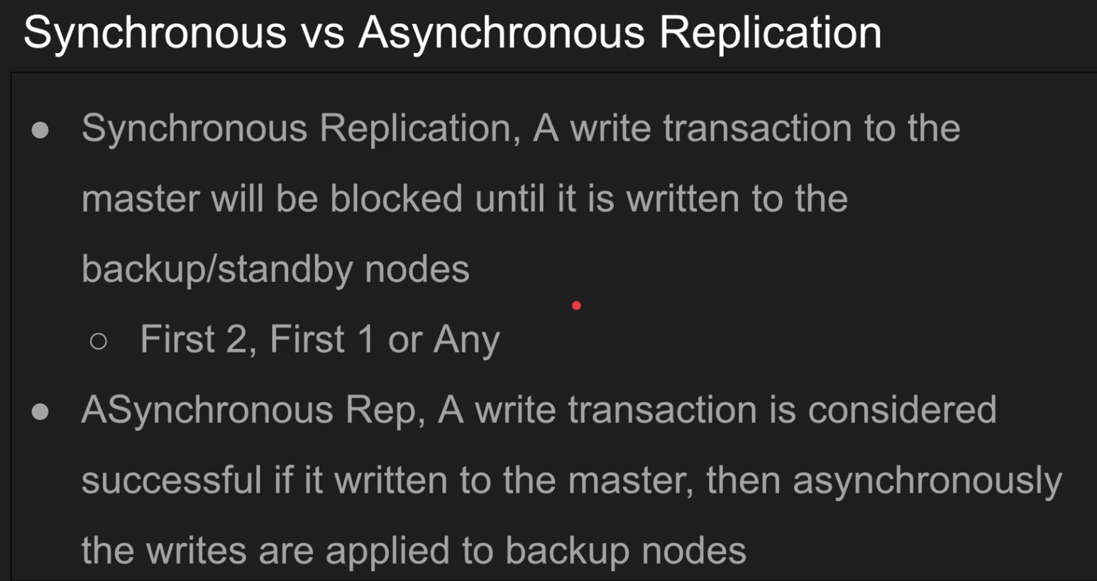

synchronous replication also forces you to commit to the child replicas or the standby replicas before the client can be unblocked.

Asynchronous replication is what by default? Some of the default is like, okay, once you write to my master, I'm done, the client is done. You just can't unblock to the client. This is done. But the database now now has to do more work on a background. Process that writes periodically to those standby replicas. This obviously. He all of a sudden now you have faster throughput. I have faster writes but the back end I have a little bit some puppet processes that are doing this asynchronous jobs and that could eat off the CPU and do a lot of work, right?

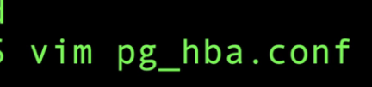

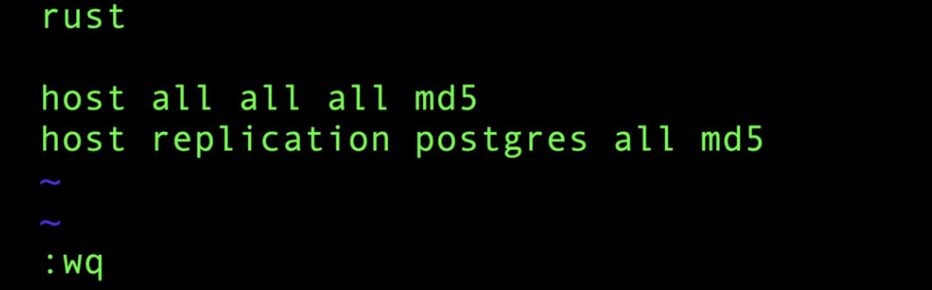

In master

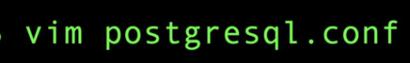



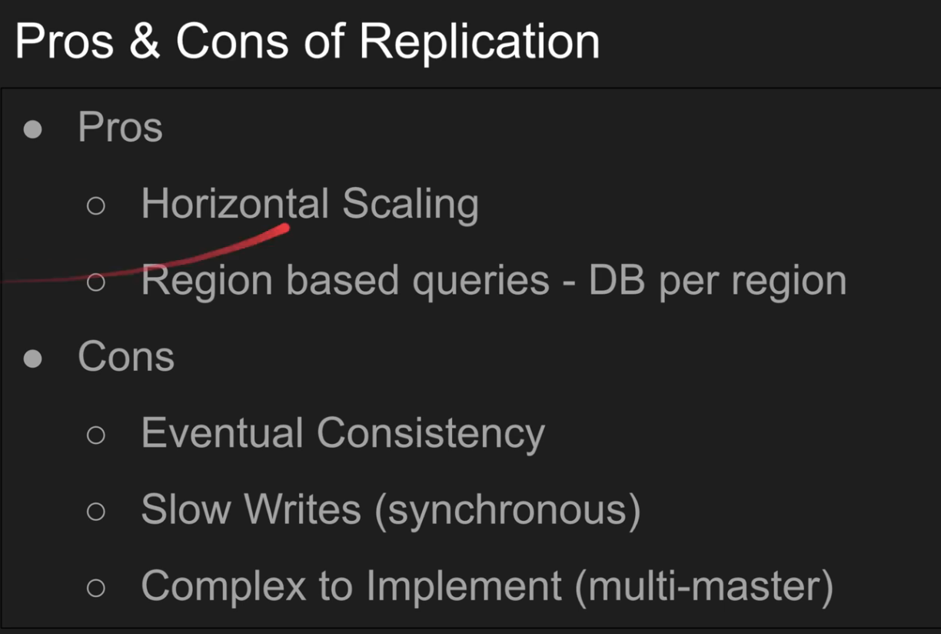

Database Engine:

A **database engine** (or **database management system engine**) is the **core software component** that handles the **storage, retrieval, update, and deletion of data** in a database.

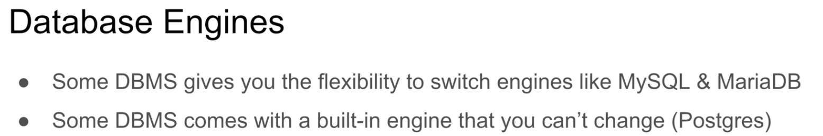

Server & Client Side Cursor:

You have client side, right? If you execute, you pull everything to the client. Right? And then if the server side, you leave everything on the server. But you will have to do some round trip going back and forth to fetch the results. Okay.

Cost in explain analyse is an arbitrary value it does’t have any unit, higher the value, higher the cost

WAL:

**WAL is a mechanism where all changes to the database are first written to a log file before they’re written to the actual data files.**

This ensures that:

* If the database crashes, PostgreSQL can **replay the WAL** to recover to a consistent state.
* It supports features like **crash recovery**, **replication**, and **point-in-time recovery** (PITR).

**🔁 How WAL Works (Step-by-Step)**

1. A user runs a query that modifies data (INSERT, UPDATE, DELETE).
2. PostgreSQL writes a **WAL record** describing that change to a WAL file on disk (pg_wal/ directory).
3. Only after WAL is safely stored does PostgreSQL apply the change to the actual table/index files (in memory or on disk).
4. On crash, PostgreSQL replays WAL to recover.

🔐 This guarantees that no committed transaction is lost, even if the server crashes immediately after.

Postgres Architecture:

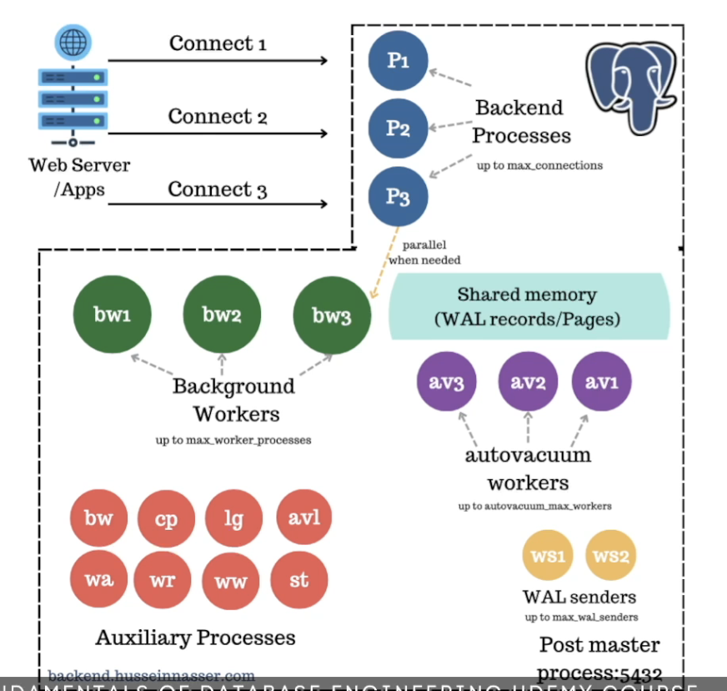

So the first process is basically the postmaster. That's the listener. And clients connect to this listener effectively.

What is important here is the understanding that every client that connects gets its own back end process.

What is important here is the understanding that every client that connects gets its own back end process.So the background process, they are limited by something called the max worker process a very interesting

Auxiliary means that's a new word I learned because English is not my first language. So learning a lot of stuff here. So auxiliary is like something that is a side. Process that helps things right? It's a stand by side processes helper.

Auxiliary means that's a new word I learned because English is not my first language. So learning a lot of stuff here. So auxiliary is like something that is a side. Process that helps things right? It's a stand by side processes helper.Background writers only writes to the OS. It says hey, right. You know the OS, actually, when you say write, it lies to you. It doesn't immediately write to disk. It writes to its own file system cache. And the reason it does that because if I'm updating a file, like I say, updated one byte in a file and I save.

(CP) The check pointers job is to actually say, you know what, all the wall changes that we did, all the pages we have, let's flush everything to disk, not to the OS. It will use a specific flag called the O underscore direct and says, hey OS, I'm going straight to disk. I'm flushing everything to disk.

Lg(Logging)

AVL Autovacuum launchers and autovacuum workers. So what is vacuum? Right? Vacuum? We talked about the architecture of Postgres being tuple based like it's a it's updates and deletes and inserts are all inserts right. So you you would get this bloat eventually where you have 100 tuples representing the same row. But. All the transactions that needed those old tuples for, uh, multiversion concurrency control reasons or done or committed, they those tuples have zero reasons to exist. Vacuum cleans those up.

The wall writer is the responsible for writing the wall records and flush them to desk, you might say.

Pessimestic Concurrency Control

So lock the row. So other person want to update another field of the same row. They can't. They and you can define what that means. Can't. What does that mean? You can fail or you can make them wait. And that's what locks do. What? This model is called pessimistic because you are so pessimistic that you don't trust anyone. You just say, I'm going to lock this thing and I'm just going to prevent anyone from changing this thing. And I don't care if anyone didn't because someone you might you might just go through the whole transaction and nobody actually tries to touch your.

Optimistic Concurrency Control So that's optimistic. Concurrency control. So what does that mean? That means if you update a row, just just do your own thing and then commit. But during the commit, we're going to do a slight teeny beanie check at the commit level. We're going to say if the row change underneath you, we're going to fail your transaction.

How indexing Works:

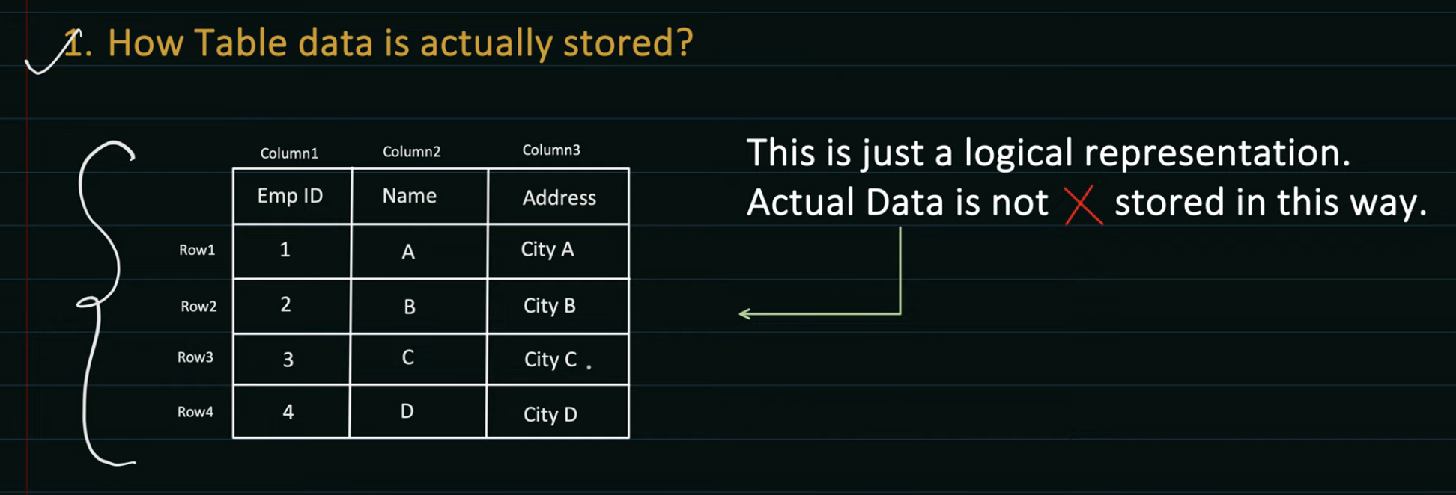

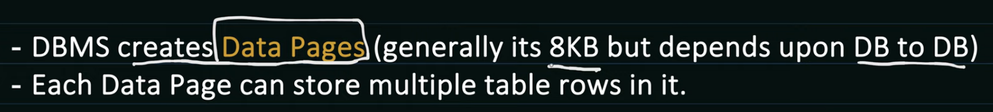

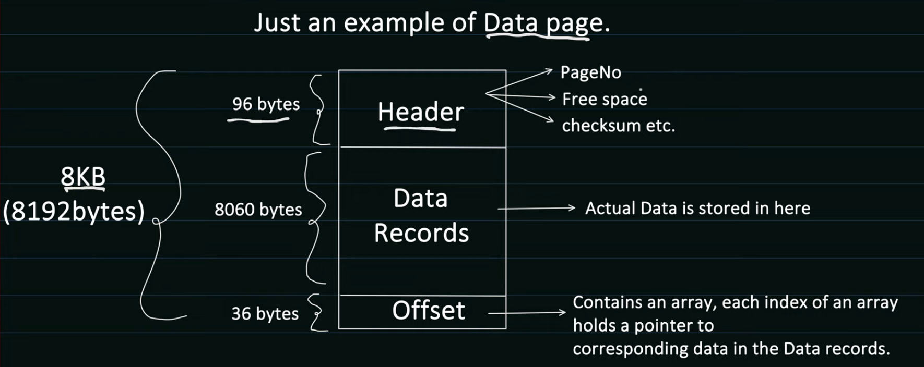

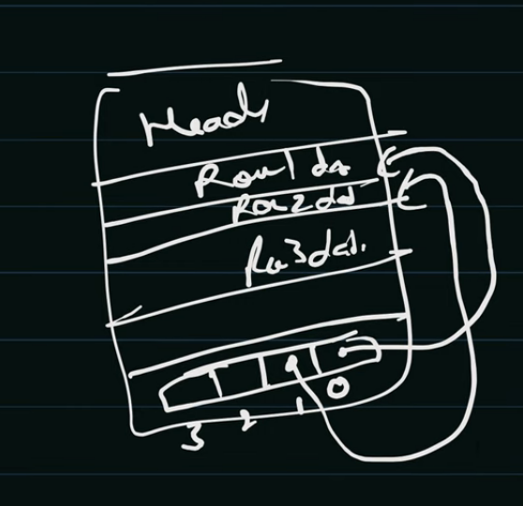

Data is stored in datapages

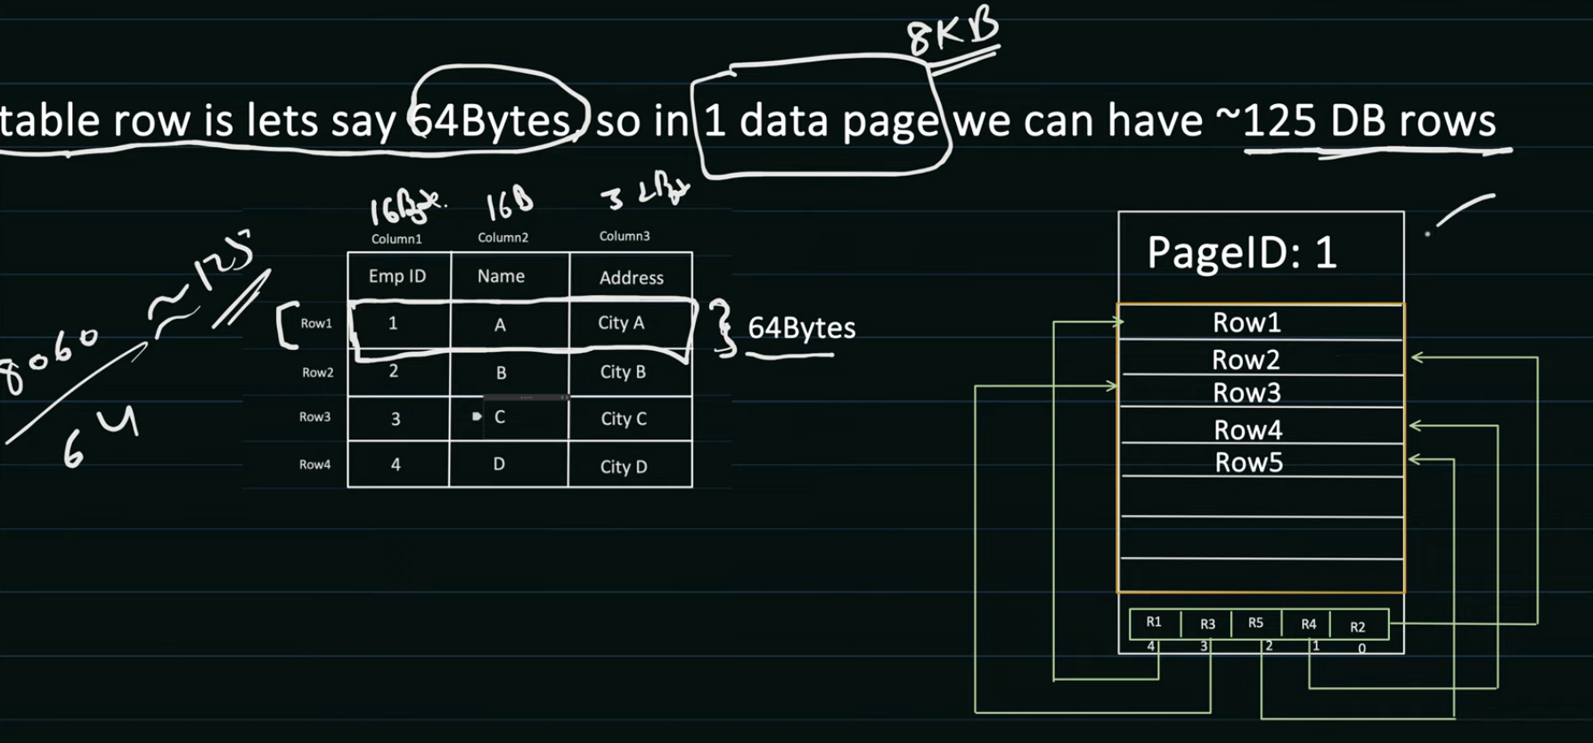

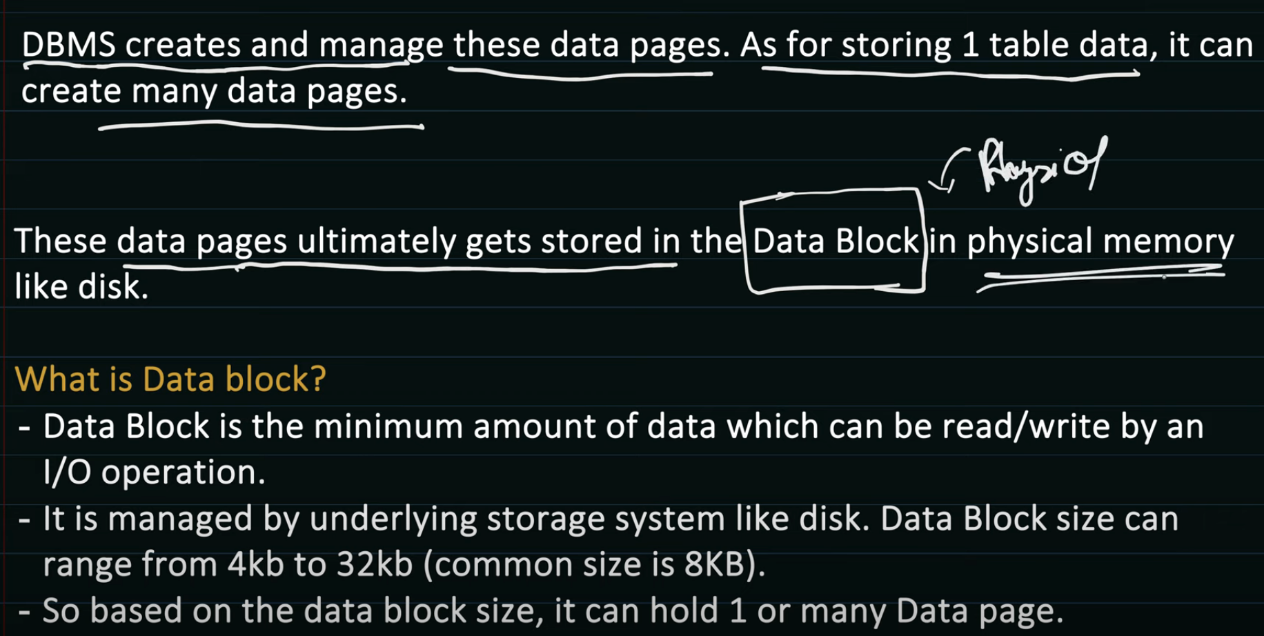

Database has no control over where data block is stored in disk, that’s y it maintains mapping

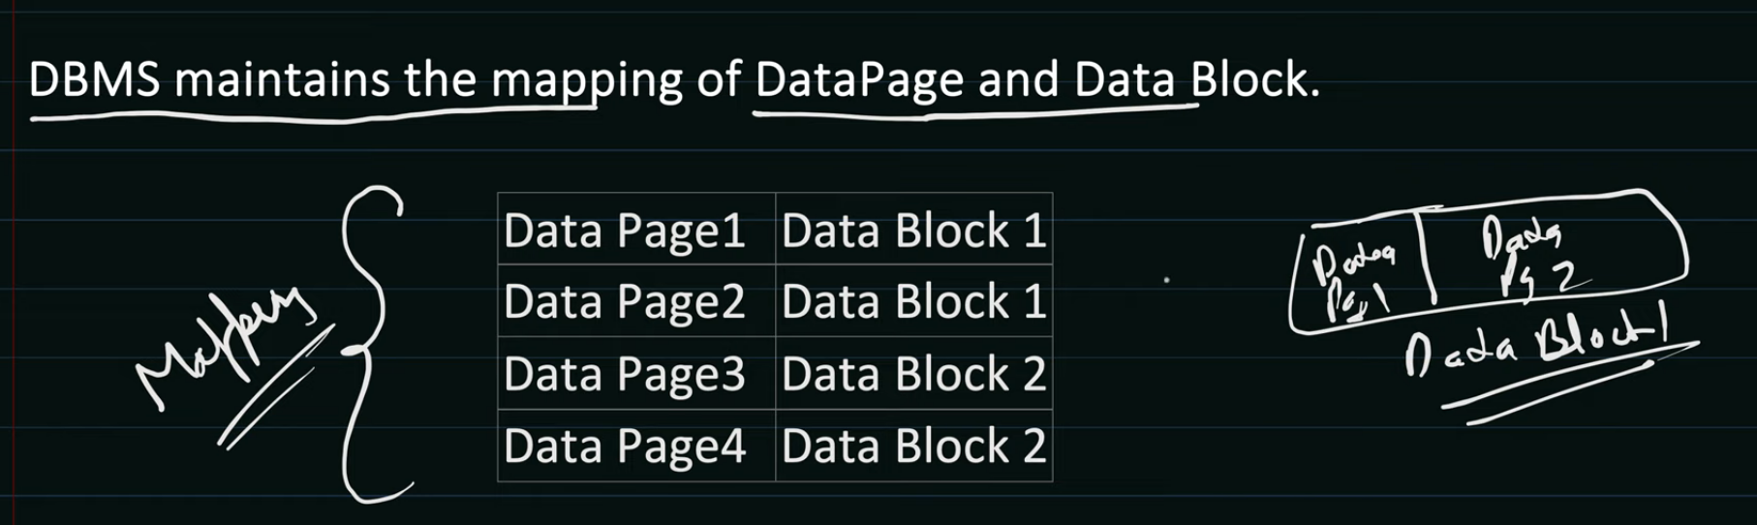

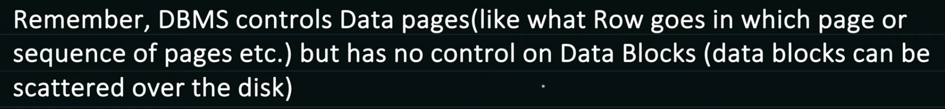

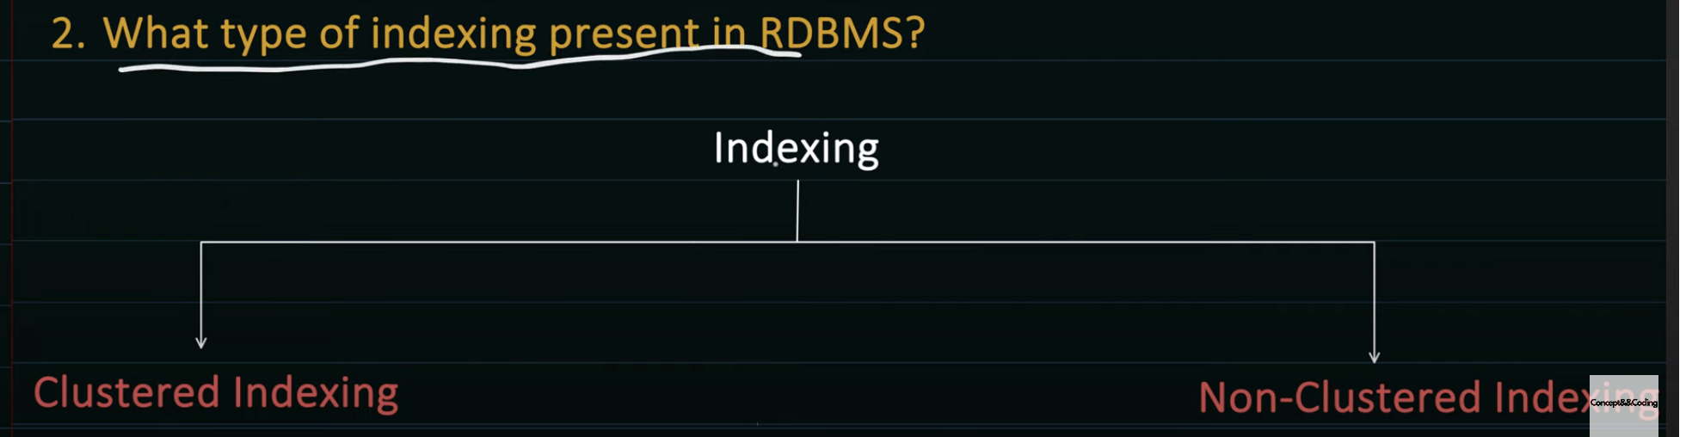

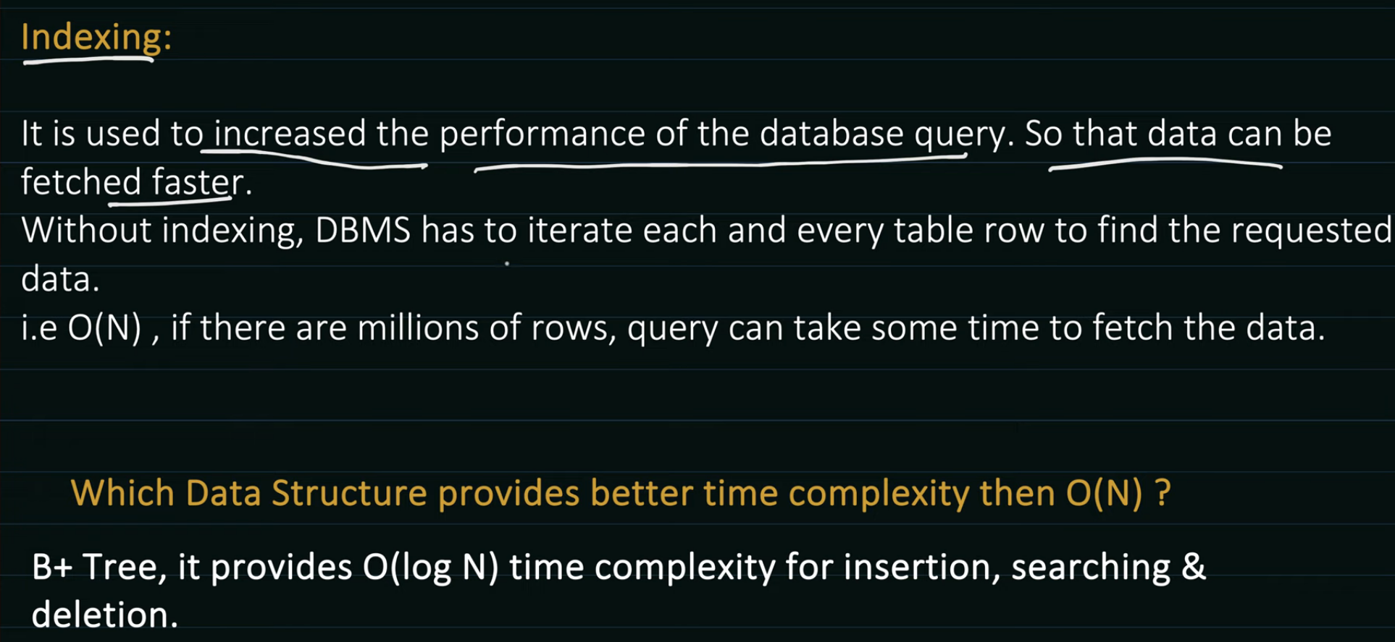

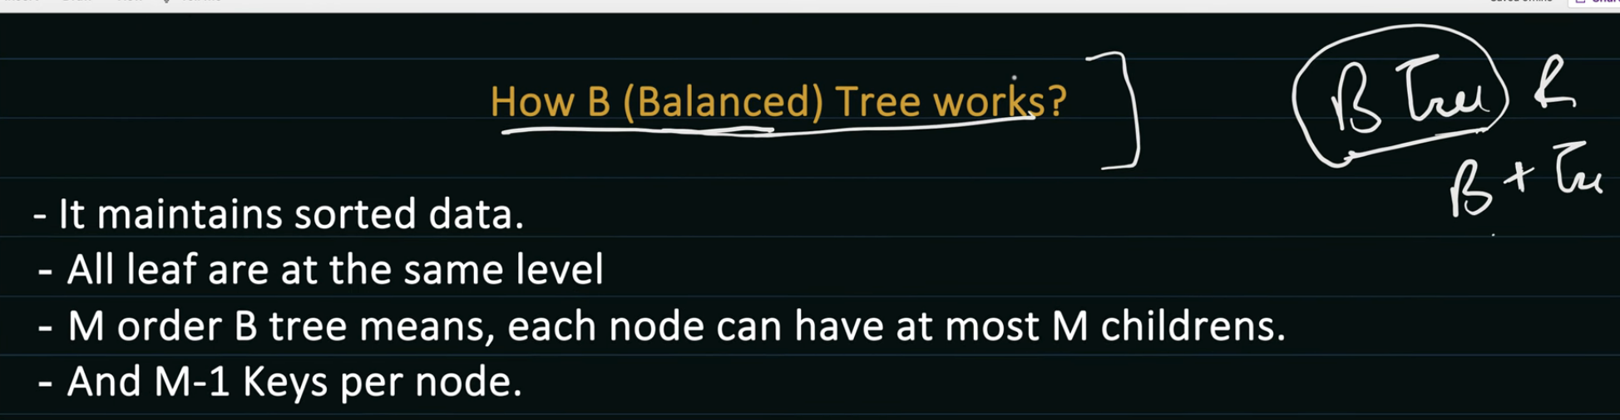

2 order b tree means, each node will have atmost 2 children

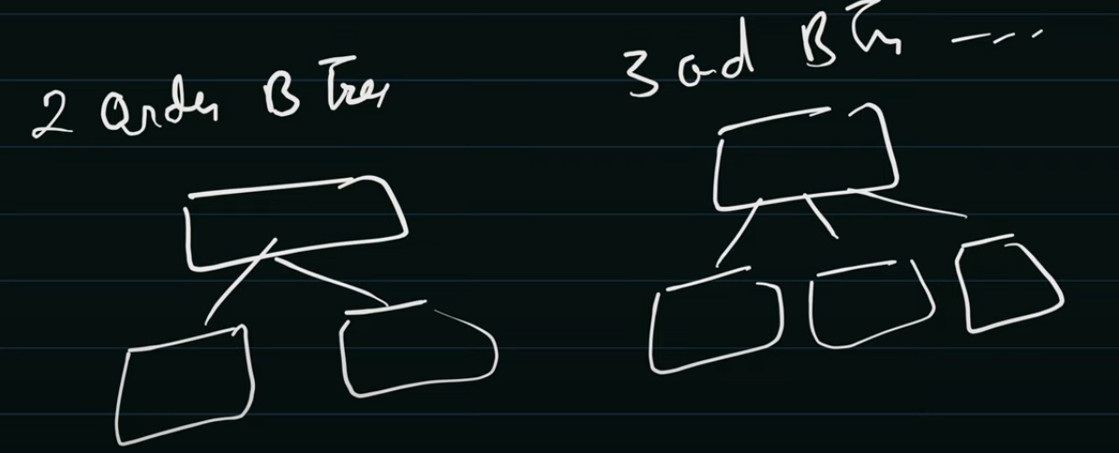

M Node will have (M-1) keys

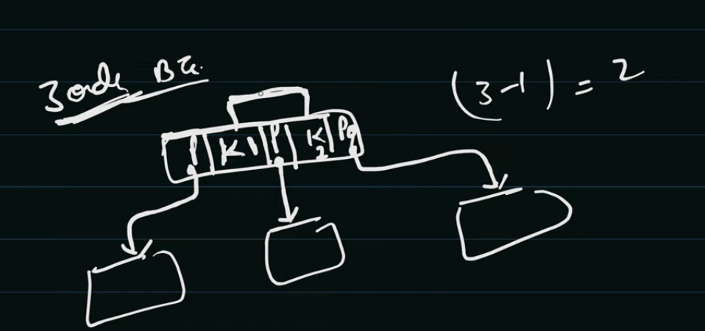

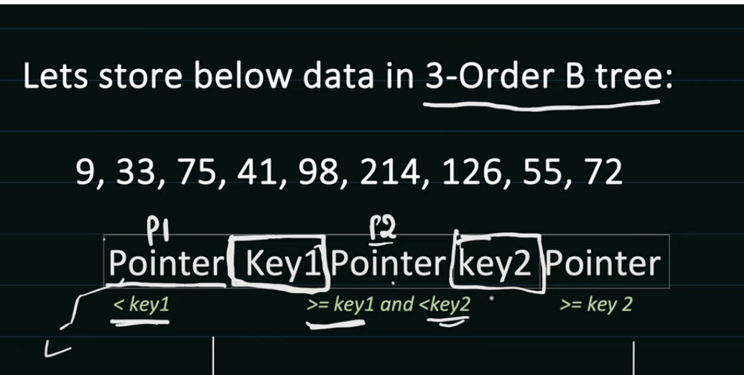

Pointer 1 will point to data having value less than key 1, Pointer 2 will point to data greater than equal to key1 and less than key 2

First in insert 9 as key 1 and then it inserts 33 now both keys are filled, as it 3 order, we have only 2 keys, when 75 comes it will take middle value and take it to the parent node as this is the first parent, 33 become root node

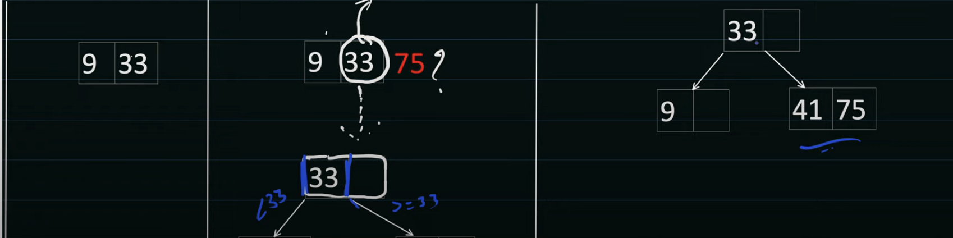

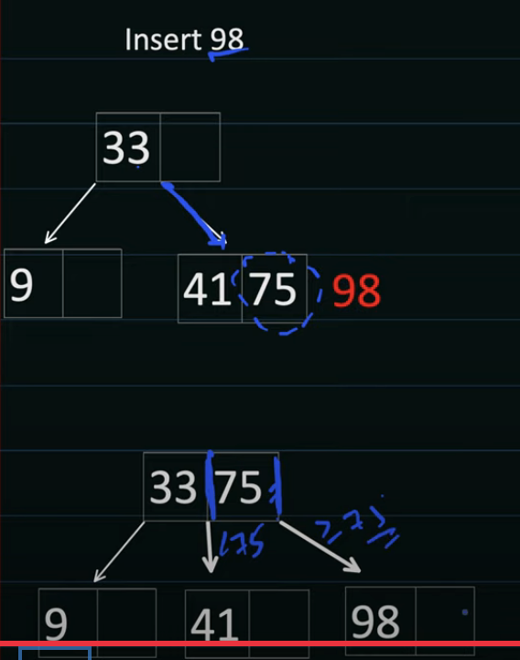 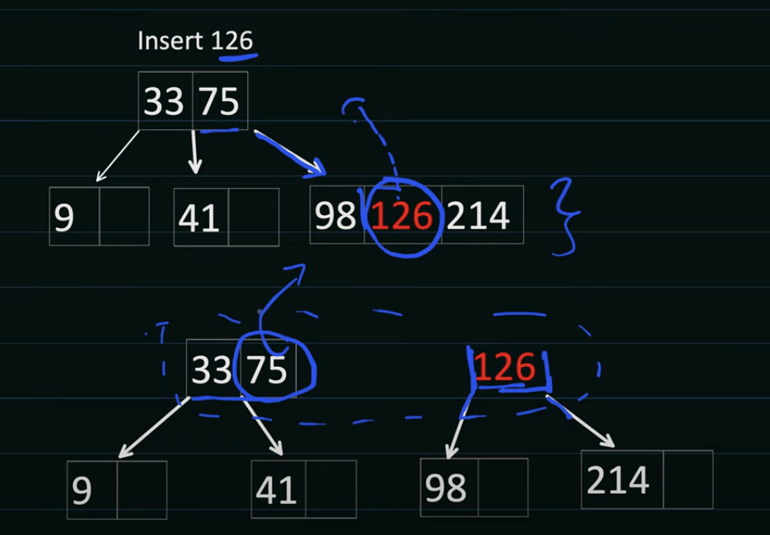

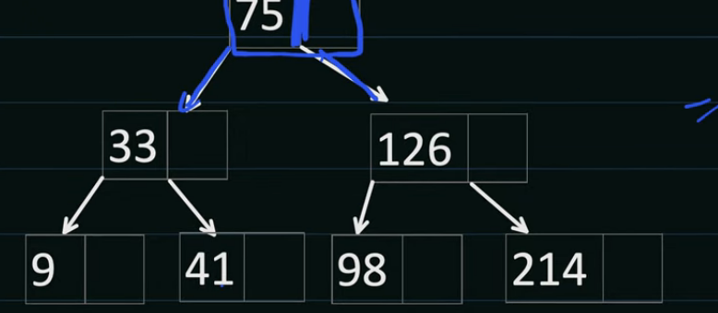

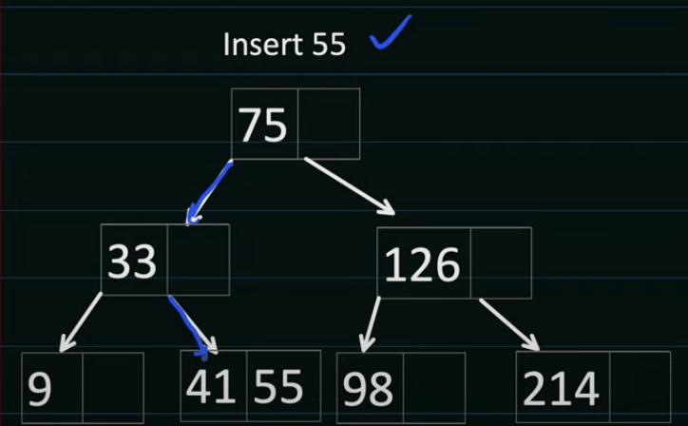 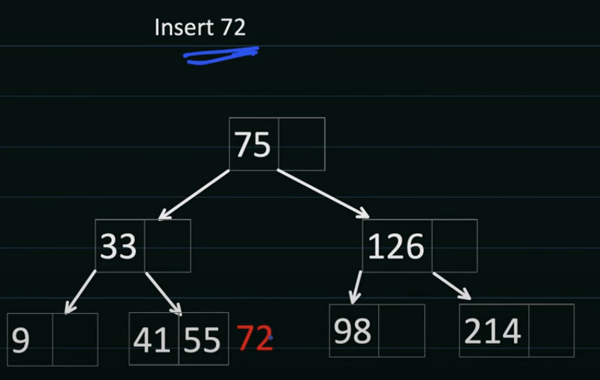

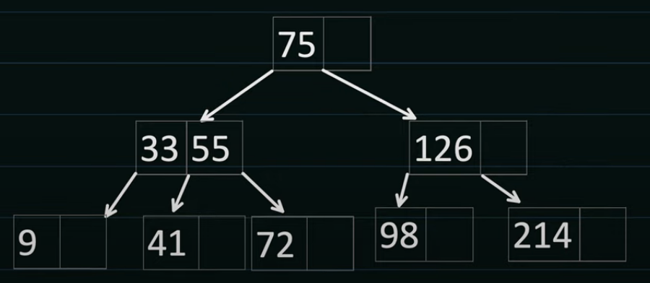

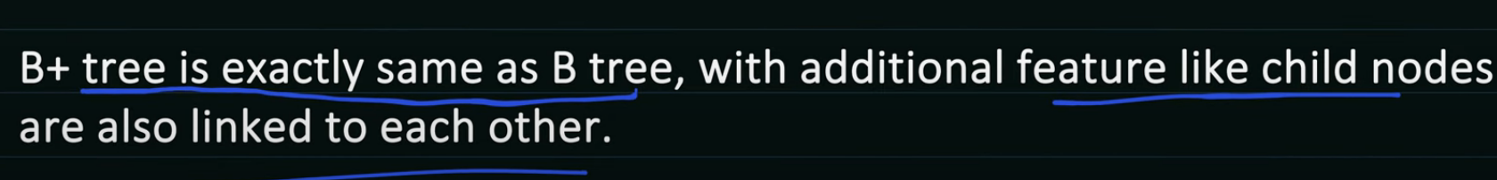

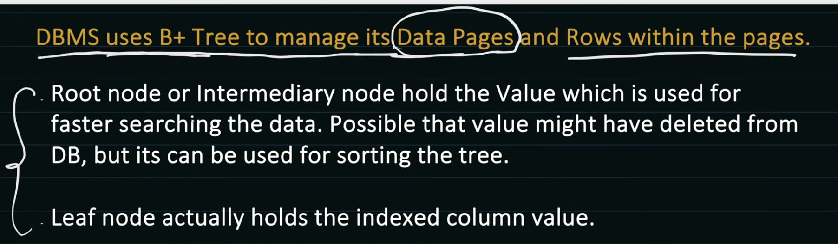

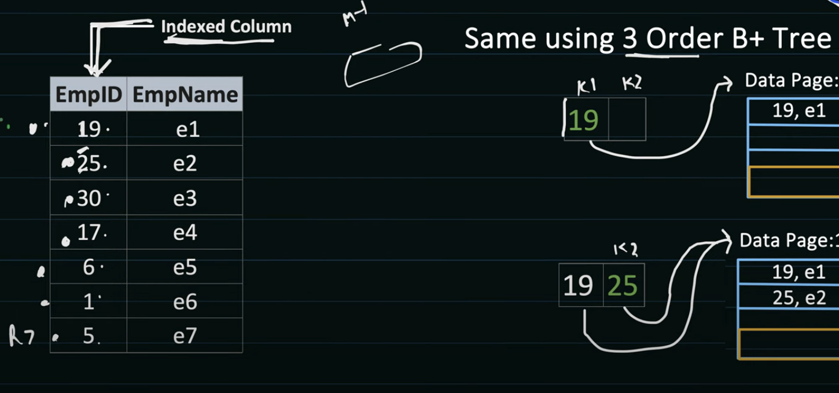

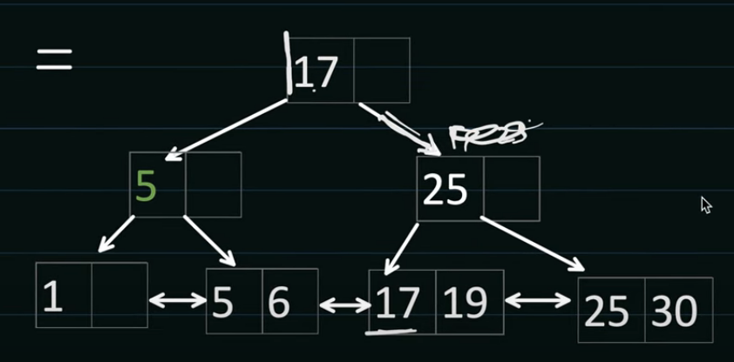

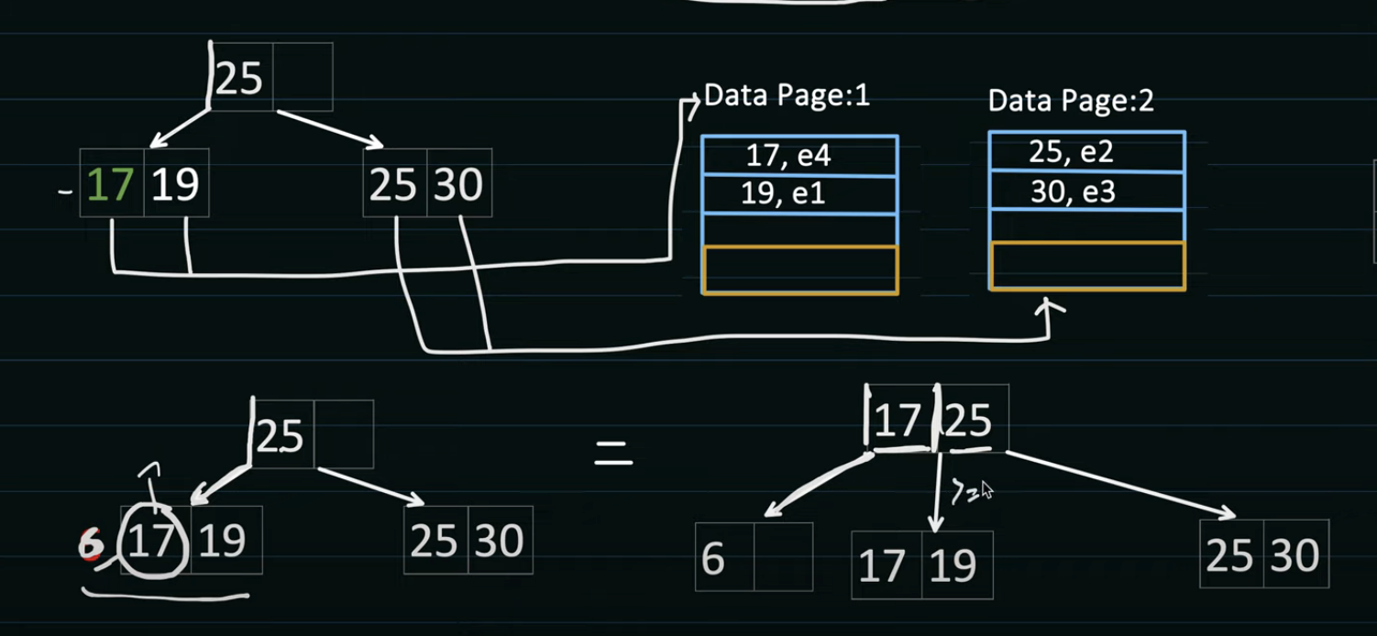

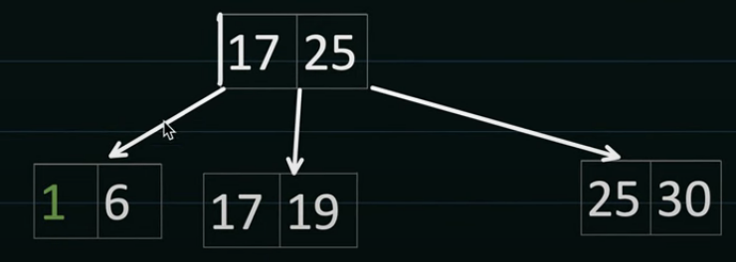

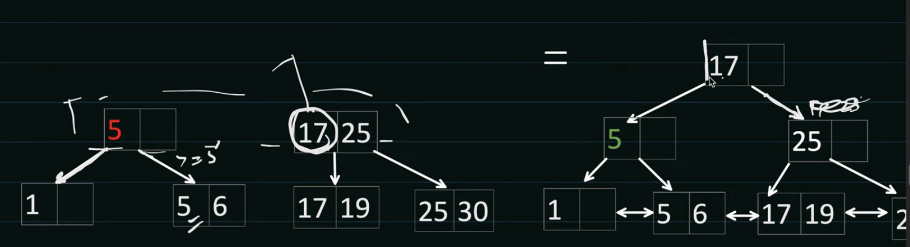

In btree along with key it also holds reference to page

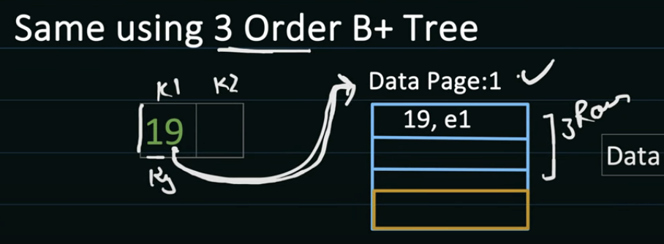

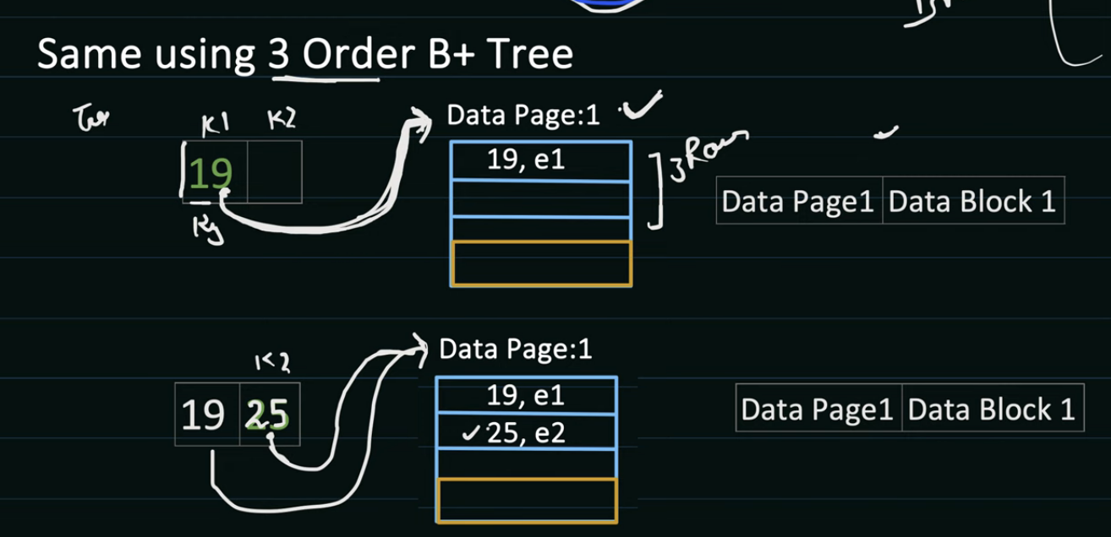

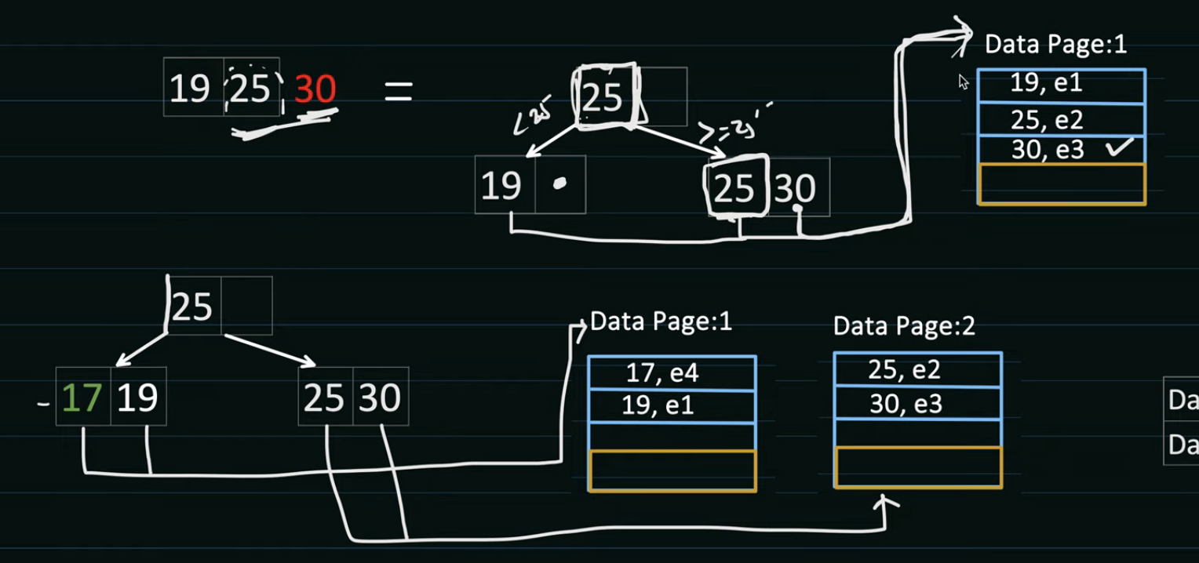

How data is inserted in correct page?

First after getting added to Btree it checks it adjacent key and to that page it gets added

But if page is full it will do page splitting

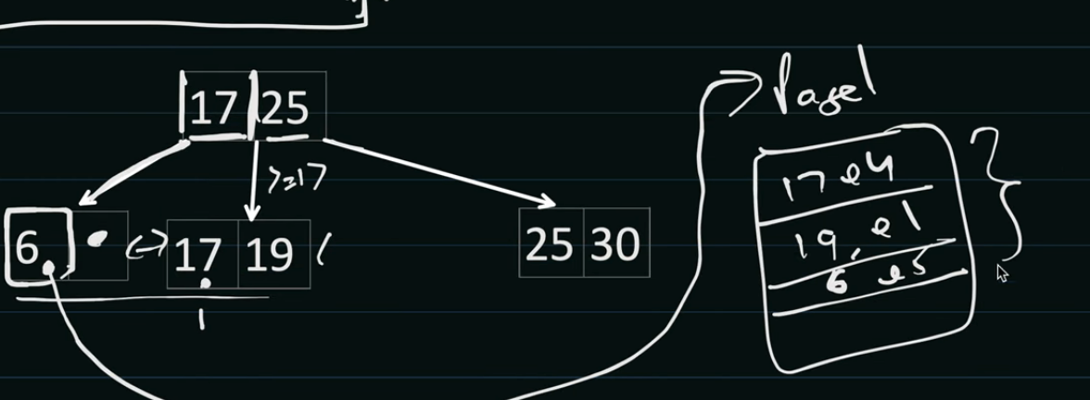

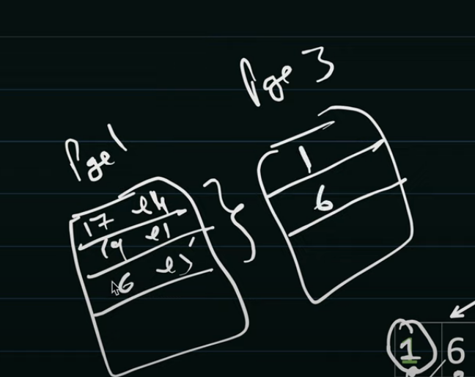

Clustered Index:

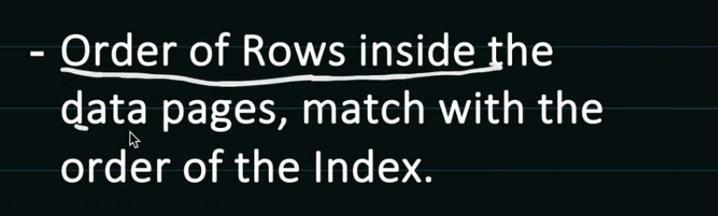

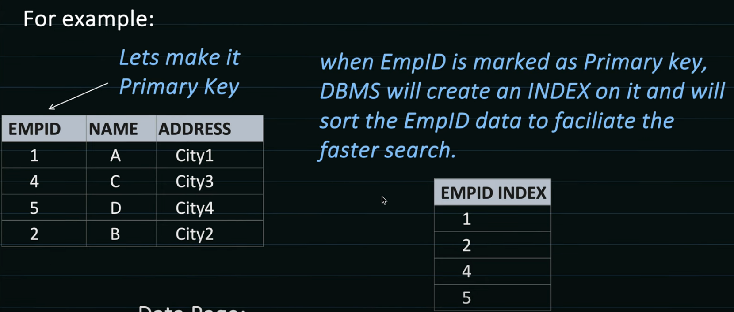

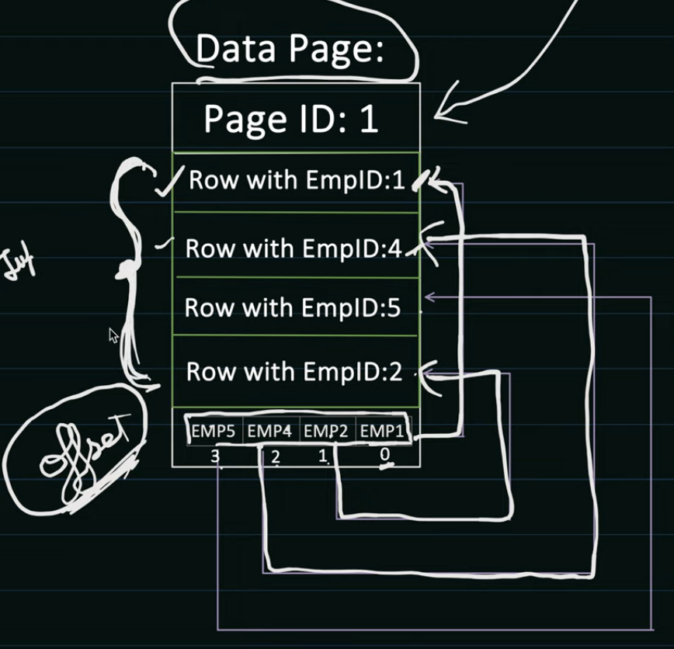

Here offset maintains order hence it is clustered indexing

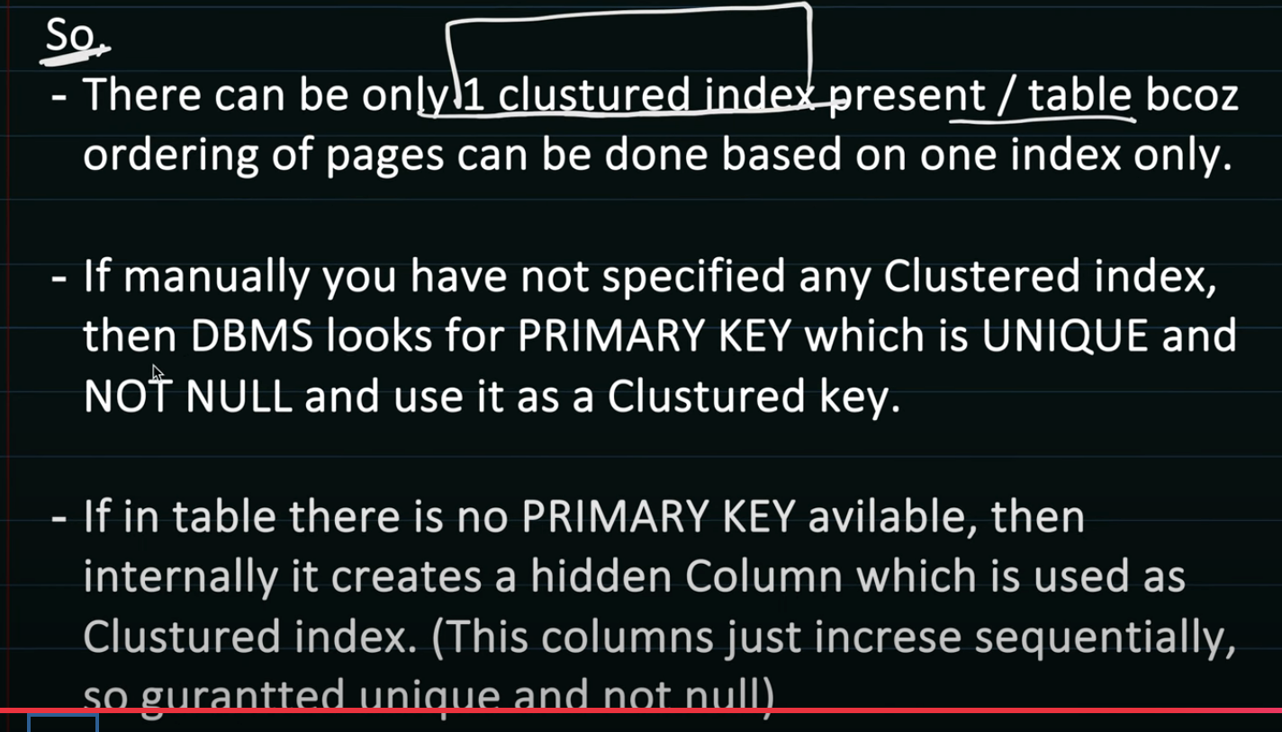 A **secondary index** in a database (including PostgreSQL) is any index that is **not the primary key index**. It provides an **additional access path** to the data to speed up queries on columns **other than the primary key**.

**🔍 What Is a Secondary Index?**

* A **primary index** is built on the **primary key** — it uniquely identifies rows.
* A **secondary index** is built on **any other column or combination of columns** to make querying faster.
* Unlike the primary index, it **doesn't enforce uniqueness** (unless you make it unique).

Non-Clustered Index / Secondary Index:

Orderning of offset will not be based on secondary index

There can be many secondary index

B+ tree gets stored as datastructure in index pages, so if we many secondary indices then size become large

So searching a record

* first it finds index page and loads index in memory
* traverse b+ tree find data page
* find datablock from data page mapping
* load that datablock and read data

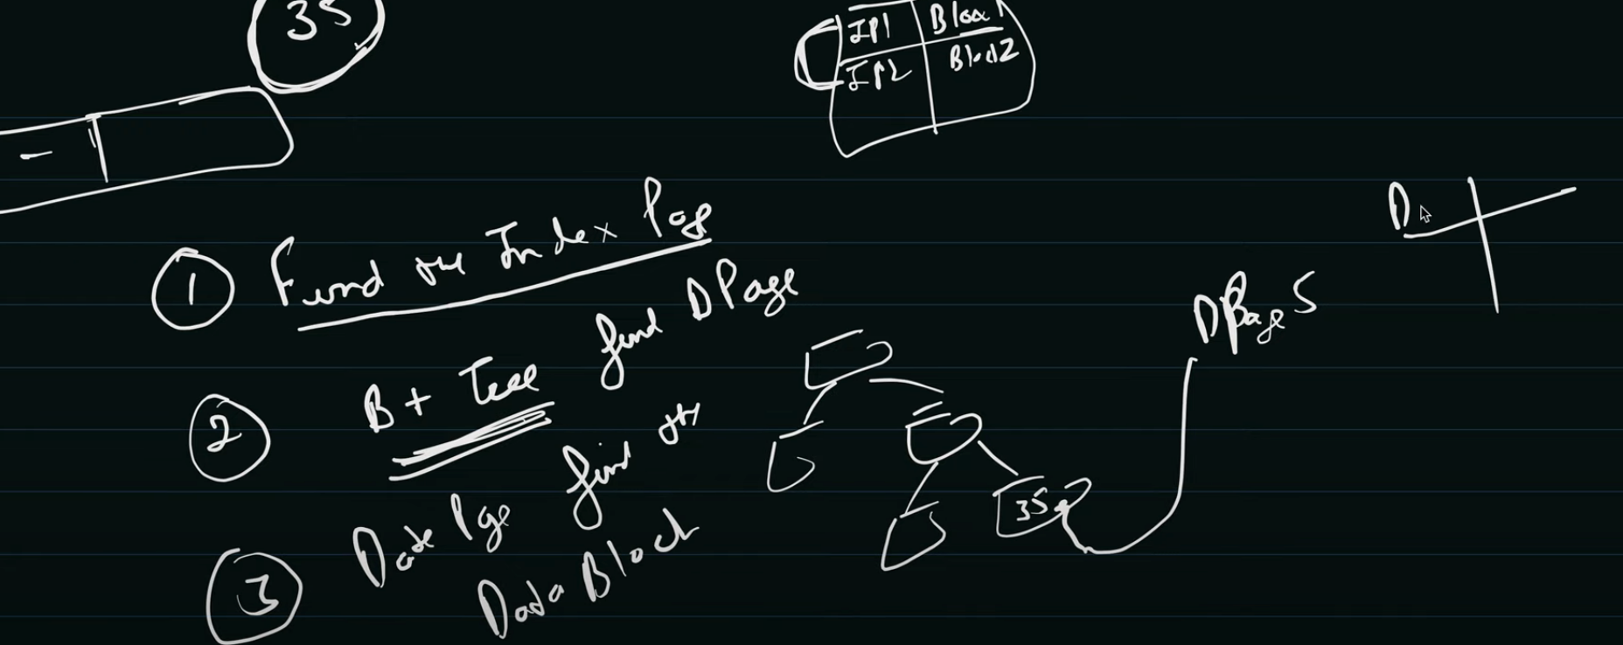

Distributed Concurrency Control:

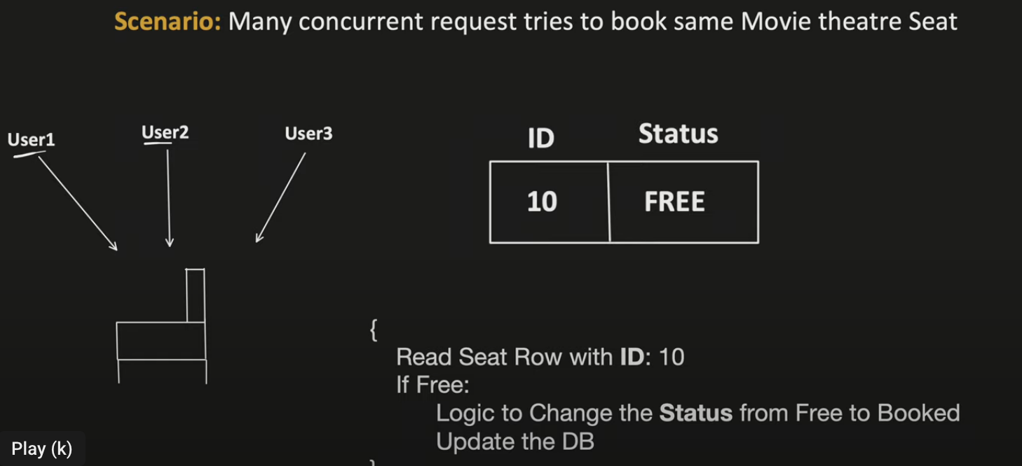

Transaction:

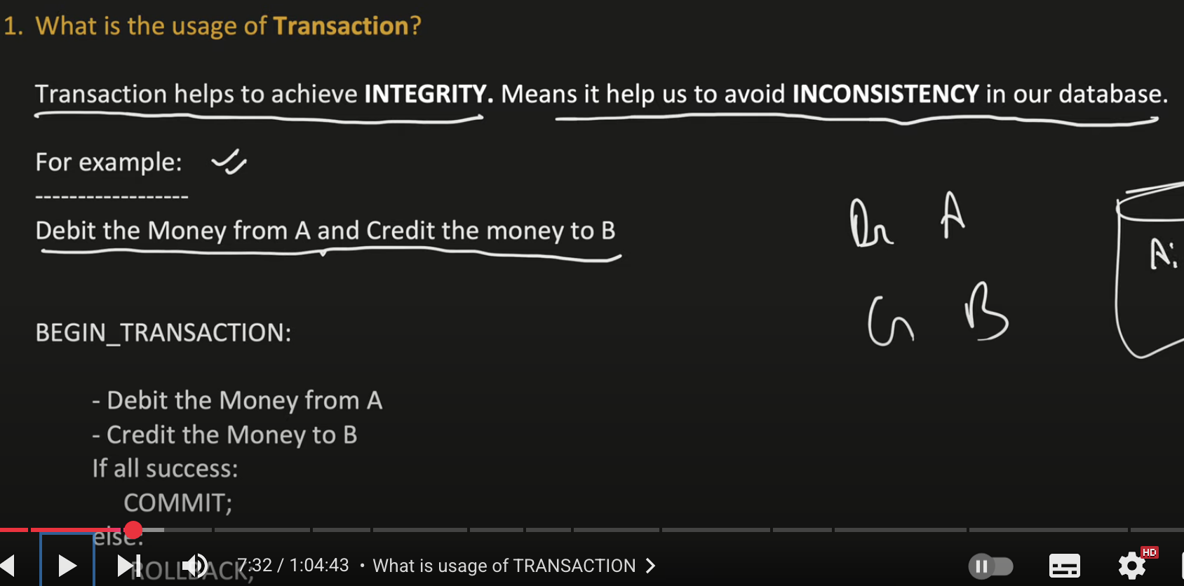

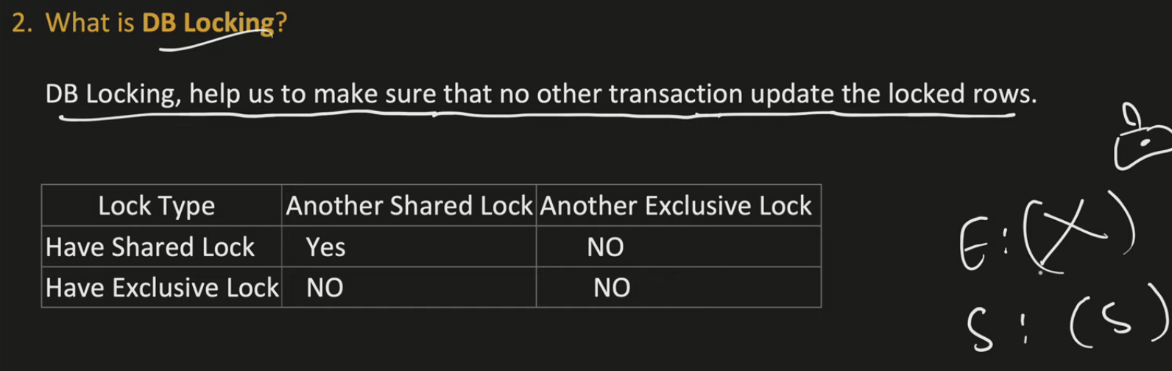

Shared Lock: suppose T1 has taken shared lock, if another transaction tried to update then it won’t happen, but T2 can only read

Exclusive Lock: suppose T1 has taken exclusive lock, any other transaction can’t read or update data

**LOCKS ARE APPLICABLE TO ROWS NOT TABLES**

Isolation Tells how much concurrency your DB can handle

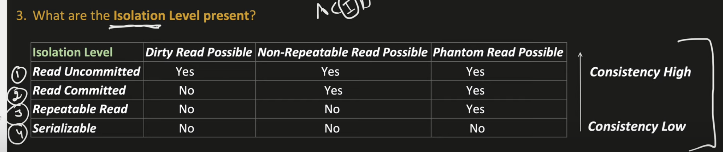

Dirty Read:

Suppose transaction B has started and updated the record but hasn’t commited when Transaction A reads that records, it gets updated value, suppose if Transaction B has failed and it’s rolled back we get dirty reads

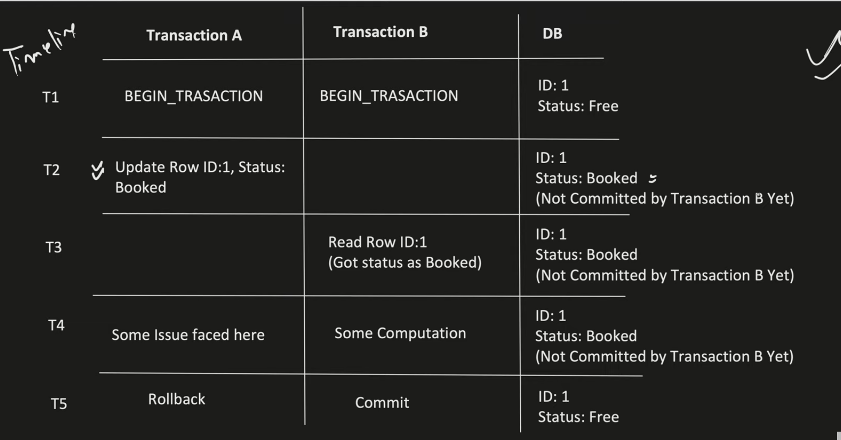

Non-repeatable reads:



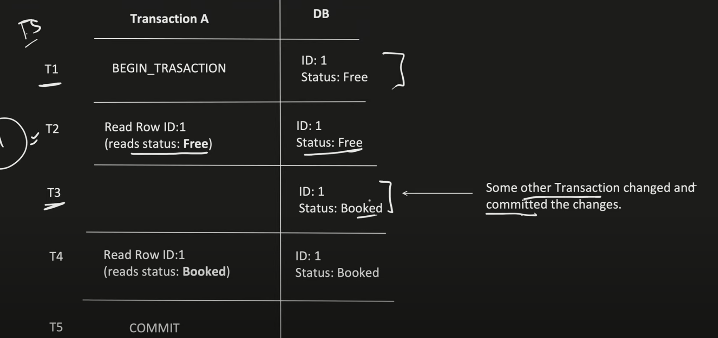

Phantom:

A **phantom read** is a phenomenon in database transactions where **new rows appear (or disappear)** in a query result **between two executions of the same query within a single transaction**.

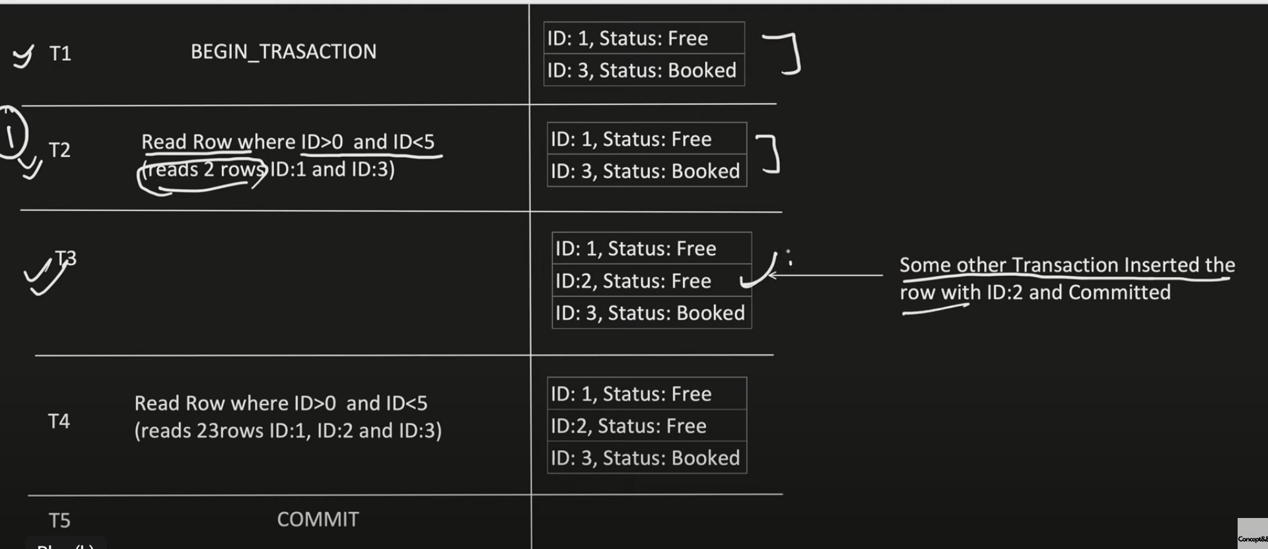

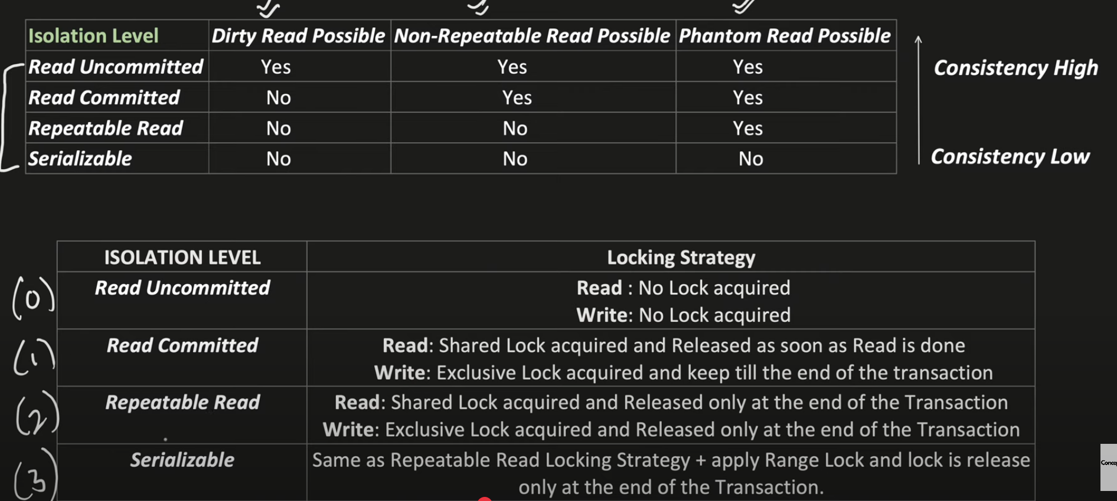

It’s concurrency not consistency

Isolation level – 0 Read Uncommited- is best suited for only read and no write

Read Committed: With read committed non-repeatable happens because suppose t1 has begun the transaction is reading and it has got shared lock, as soon as reading is done, lock is released so now t2 can acquire exclusive lock and update record and then it updates, now if t1 reads again it gets updated data

Phantom Reads in Repeatable read:

What is a "gap" in locking?

* Imagine your table rows are ordered by some key (like employee ID or name).
* Between any two existing rows (say row #1 and row #2), there is a **gap**-a place where new rows **could be inserted**.
* Even if rows look like consecutive numbers (1, 2, 3), the database internally treats the space **between** these rows as a gap where new rows might appear.

Why does this matter for phantom reads?

* **Repeatable Read locks only the rows it reads** (rows #1, #2, #3).
* It **does NOT lock the gaps between these rows**.
* So, another transaction can insert a **new row with a key that fits between #1 and #2**, or after #3.
* When the first transaction re-runs the query, it sees this **new row** - the phantom.

Simple analogy:

* Think of a bookshelf with books numbered 1, 2, and 3.
* You put a sticky note on books 1, 2, and 3 (locking those books).
* But you don't block the empty spaces between books.
* Someone else comes along and puts a new book between books 1 and 2.
* When you look again, you see this new book - even though you had sticky notes on the original books.

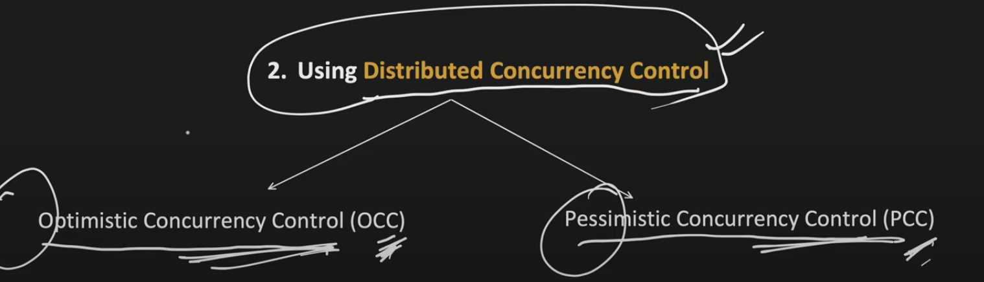

OCC offers more concurrency allows isolation level above repeatable read

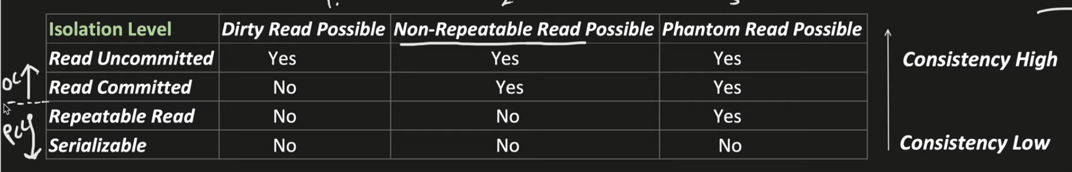

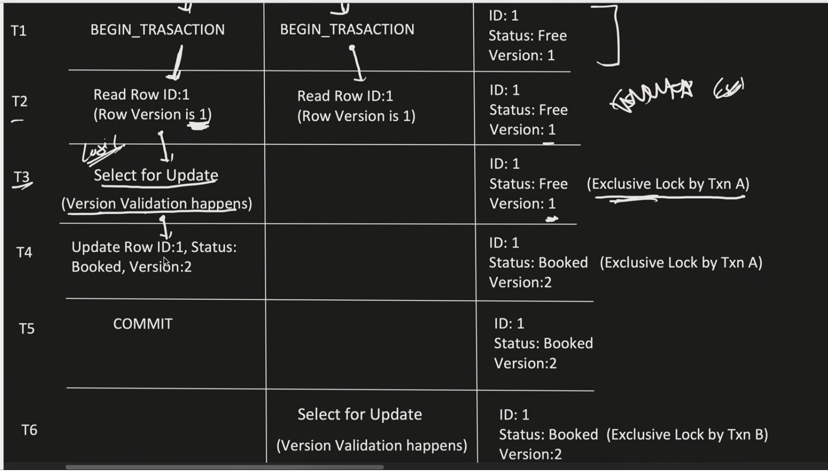



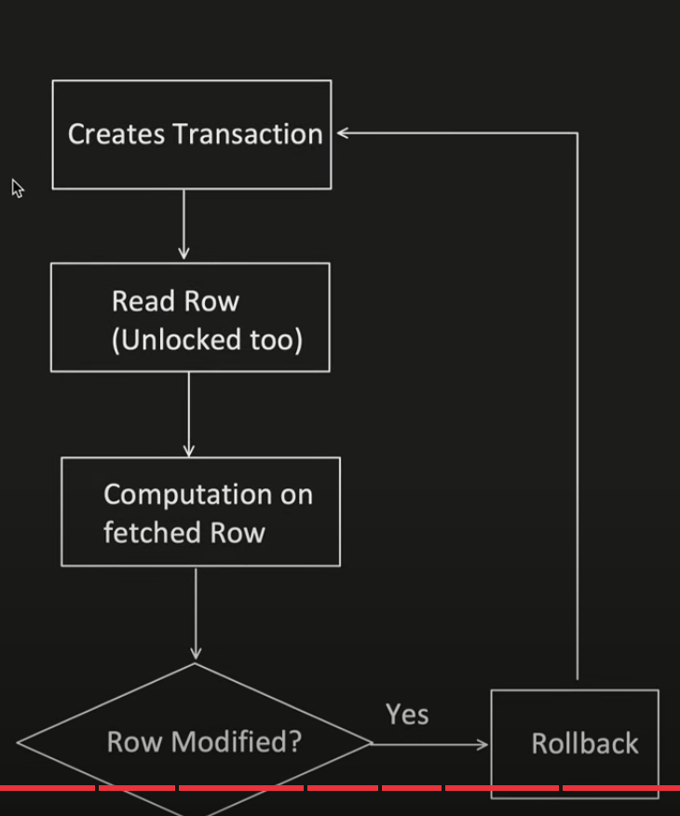

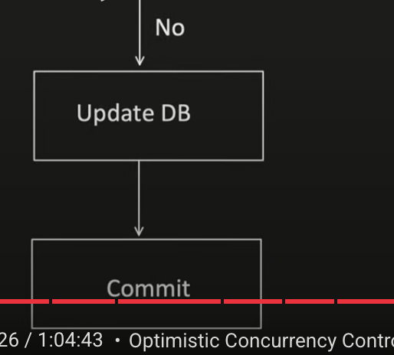

In pessimistic concurrency if transaction A has started with update then transaction B will never be able to update

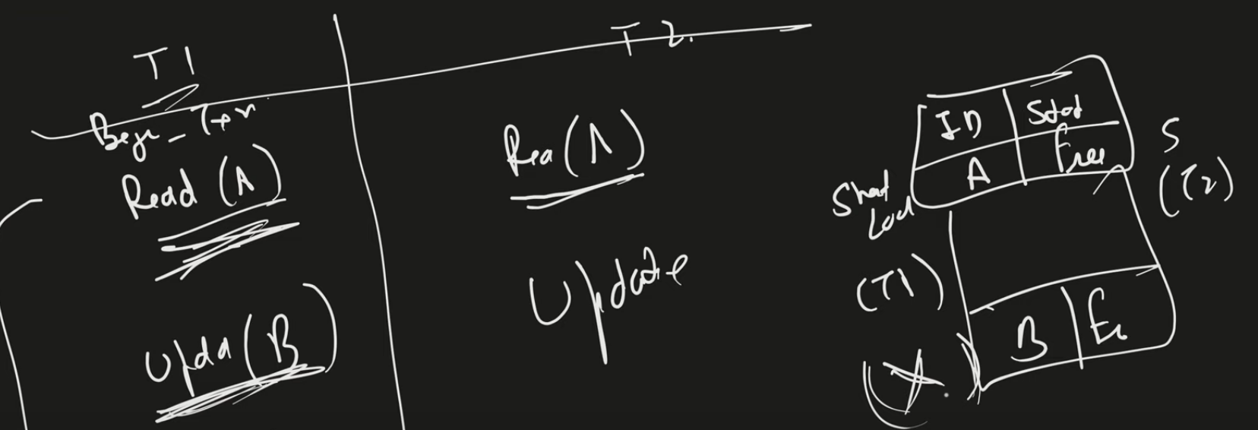

In pessimistic dead lock might happen

